Slide 1 - Intro - 1

Slide notes
Welcome to the PCI Compliance and Security Awareness course.

Slide 2 - Intro - 2
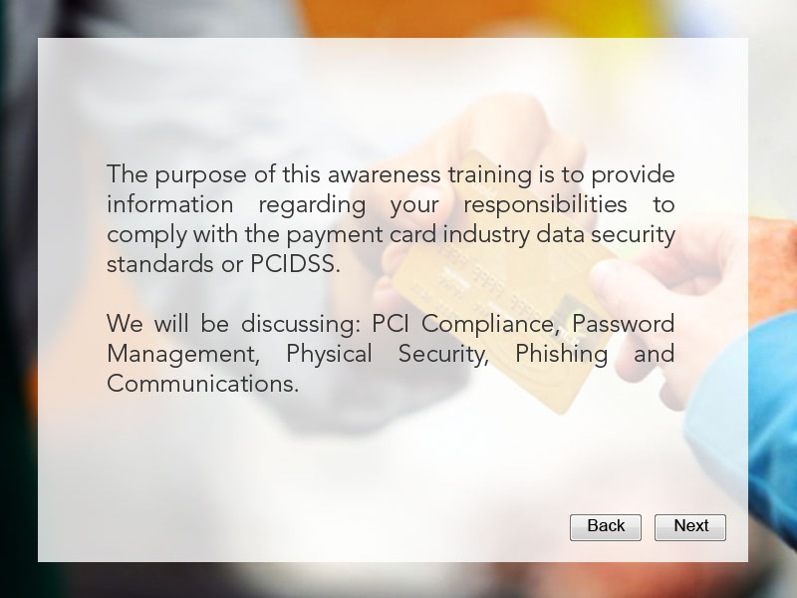
Slide notes
The purpose of this awareness training is to provide information regarding your responsibilities to comply with the payment card industry data security standards or PCIDSS.

We will be discussing: PCI Compliance, Password Management, Physical Security, Phishing and Communications.

Slide 3 - Main Menu (Audio)
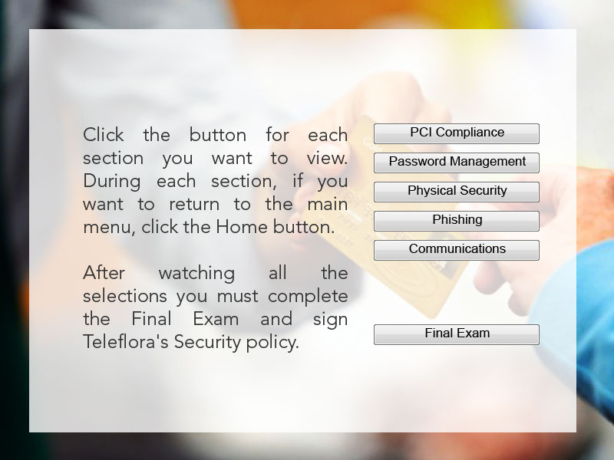
Slide notes
Click the button for each section you want to view. During each section, if you want to return to the main menu, click the Home button. After watching all sections you must complete the Final Exam and sign Teleflora's Security policy.

Slide 4 - Main Menu (No Audio)
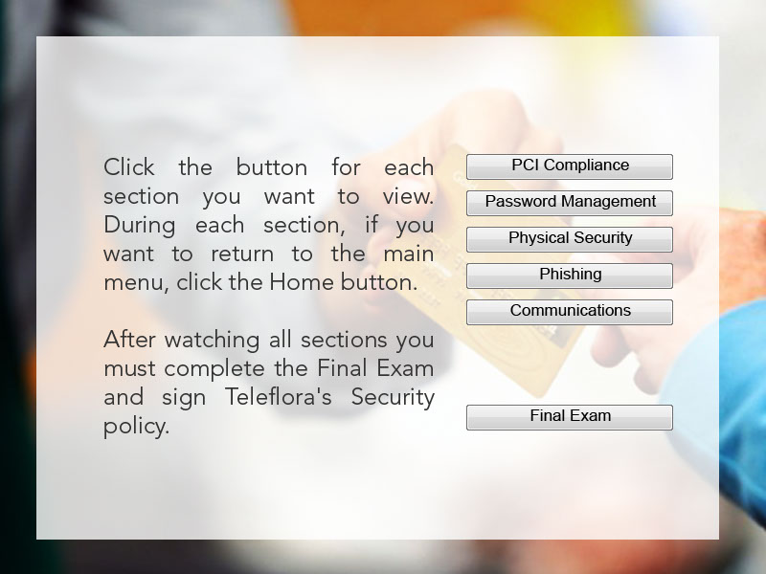
Slide notes

Slide 5 - PCI Compliance - 1
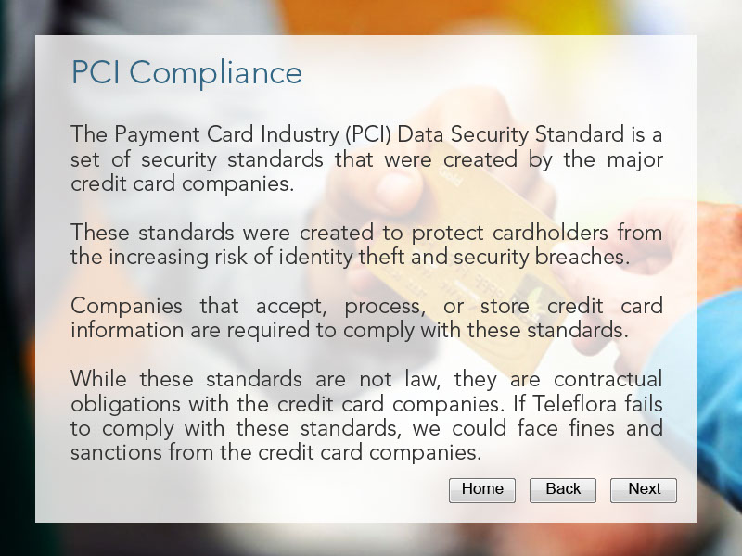
Slide notes
The Payment Card Industry (PCI) Data Security Standard is a set of security standards that were created by the major credit card companies.

These standards were created to protect cardholders from the increasing risk of identity theft and security breaches.

Companies that accept, process, or store credit card information are required to comply with these standards.

While these standards are not law, they are contractual obligations with the credit card companies. If Teleflora fails to comply with these standards, we could face fines and sanctions from the credit card companies.

Slide 6 - PCI Compliance - 2
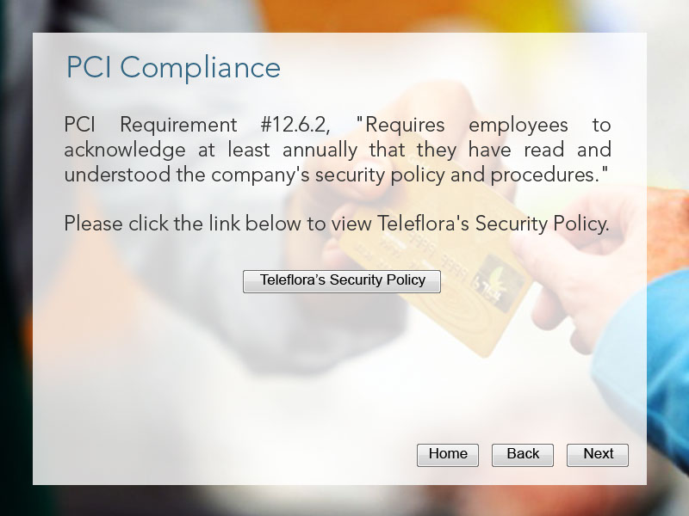
Slide notes
PCI Requirement #12.6.2, "Requires employees to acknowledge at least annually that they have read and understood the company's security policy and procedures."

Please click the link below to view Teleflora's Security Policy.

Slide 7 - PCI Compliance - 3
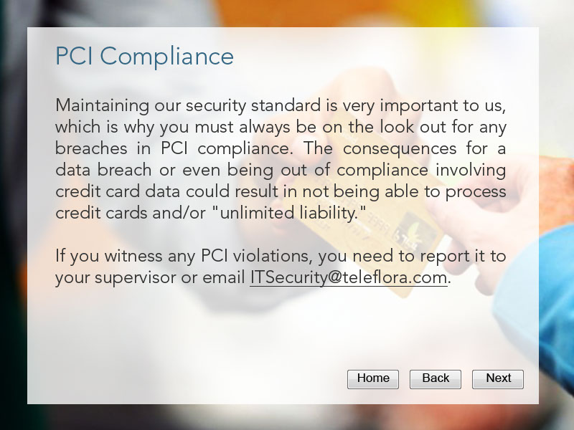
Slide notes
Maintaining our security standard is very important to us, which is why you must always be on the look out for any breaches in PCI compliance. The consequences for a data breach or even being out of compliance involving credit card data could result in not being able to process credit cards and/or "unlimited liability."

If you witness any PCI violations, you need to report it to your supervisor immediately.

Slide 8 - Password Management - 1
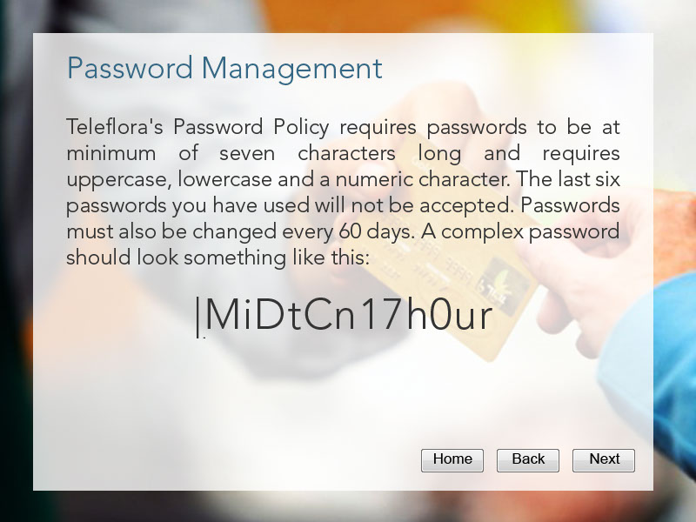
Slide notes
Teleflora's Password Policy requires passwords to be at minimum of seven characters long and requires uppercase, lowercase and a numeric character. The last six passwords you have used will not be accepted. Passwords must also be changed every 60 days. A complex password should look something like this:

Slide 9 - Password Management - 2
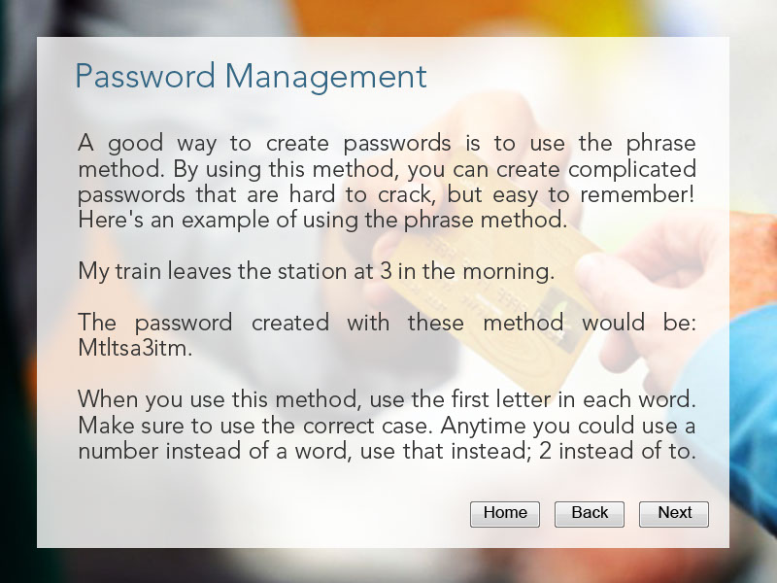
Slide notes
A good way to create passwords is to use the phrase method. By using this method, you can create complicated passwords that are hard to crack, but easy to remember! Here's an example of using the phrase method.

My train leaves the station at 3 in the morning.

The password created with these phrase would be: M t l t s a 3 i t m .

When you use this method, use the first letter in each word. Make sure to use the correct case. Anytime you could use a number instead of a word, use that instead; the number 2 instead of to. Be sure to also include ending punctuation.

Slide 10 - Password Management - 3
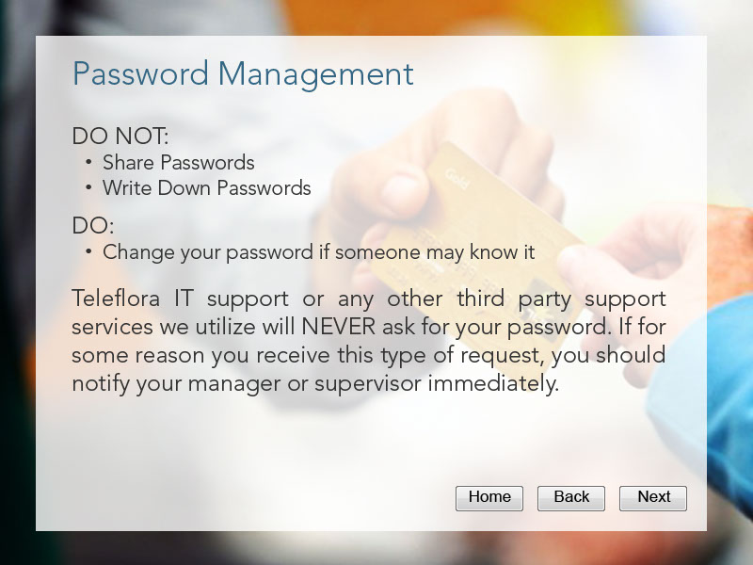
Slide notes
Your passwords are meant to be confidential. Do NOT share or write down passwords. If you think that someone might know your password, the first thing you should do is change it as soon as possible!

Teleflora IT support or any other third party support services we utilize will never ask for your username and password. If for some reason you receive this type of request, you should notify your manager or supervisor immediately.

Slide 11 - Physical Security - 1
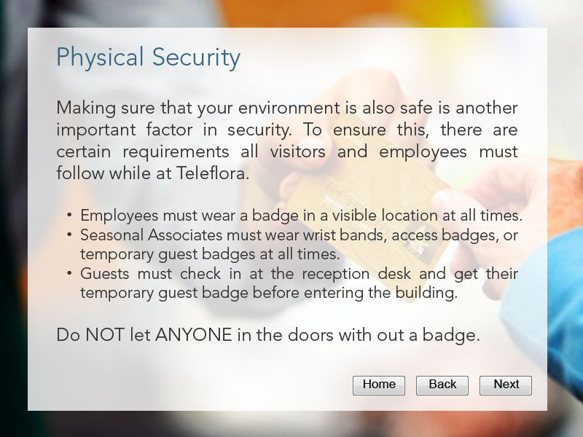
Slide notes
Making sure that your environment is also safe is another important factor in security. To ensure this, there are certain requirements all visitors and employees must follow while at Teleflora.

Employees must wear a badge in a visible location at all times.
Seasonal Associates must wear wrist bands and/or name tags at all times.
Guests must check in at the reception desk and get their temporary guest badge before entering the building.

Do not let anyone in the doors with out a badge.

Slide 12 - Physical Security - 2
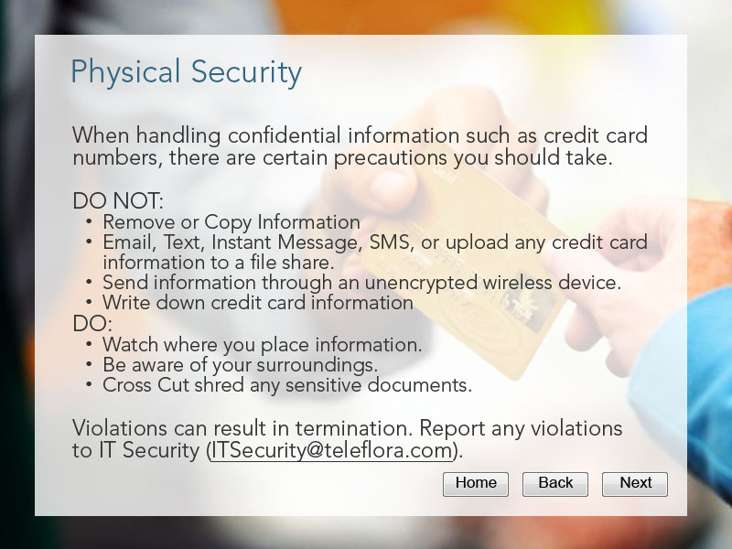
Slide notes
When handling confidential information such as credit card numbers, there are certain precautions you should take.

DO NOT:
Remove or Copy Information
Email, Text, Instant Message or SMS any credit card information.
Send any information through an unencrypted wireless device.

DO:
Watch where you place information.
Be aware of your surroundings.

Violations can result in termination.
Cross Cut shred any vital documents.

Report any violations.

Any violations can result in termination.

Slide 13 - Physical Security - 3
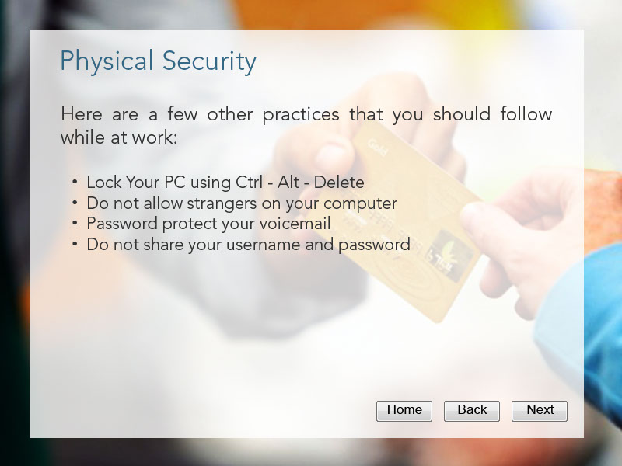
Slide notes
Here are a few other practices that you should follow while at work:

Lock Your PC when not in use by using Control - Alt - Delete.
Enable a password protected screen saver.
Do not allow strangers on your computer.
Password protect your voicemail.

Slide 14 - Phishing - 1
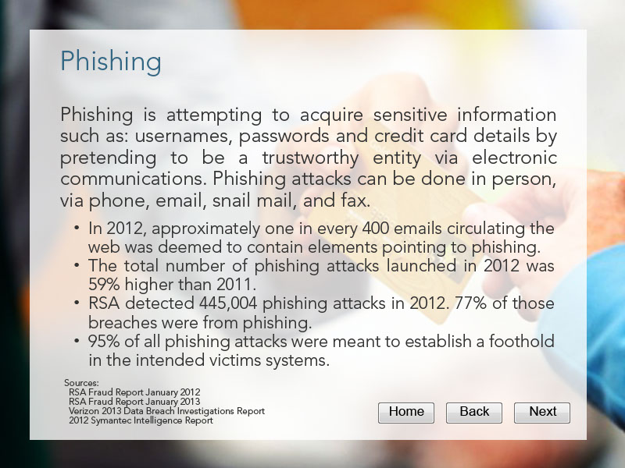
Slide notes
Phishing is attempting to acquire sensitive information such as: usernames, passwords and credit card details be pretending to be a trustworthy entity via electronic communications.

"In 2011, one in every 300 emails circulating the web was deemed to contain elements pointing to phishing.

Phishing attacks recorded through 2011 was 279,580 - a 37% increase from 2010."

Slide 15 - Phishing - 2
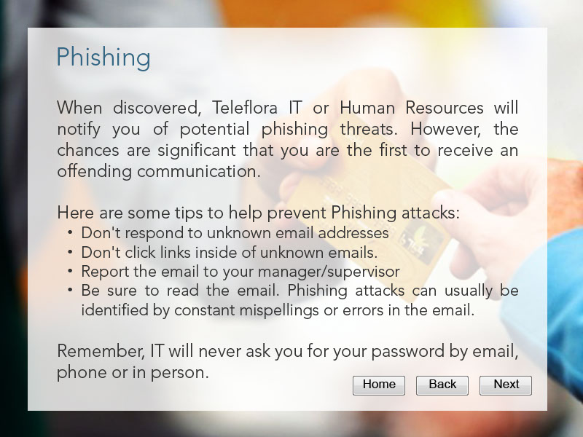
Slide notes
Here are some tips to help prevent Phishing attacks:

Pay attention to company emails. Teleflora IT will usually warn you of any potential phishing threats.
Don't respond to unknown email addresses
Don't click links inside of unknown emails.
Report the email to your manager or supervisor

Be sure to read the email. Phishing attacks can usually be identified by constant mispellings or errors in the email address.

Slide 16 - Phishing - 2
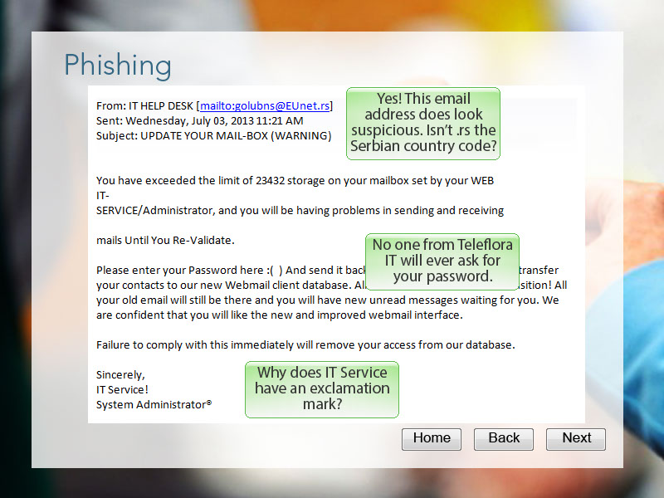
Slide notes
Can you find the points in this email that identify it as a phishing attack? Click the area you think may identify this email as a phishing attack.

Slide 17 - Phishing - 3
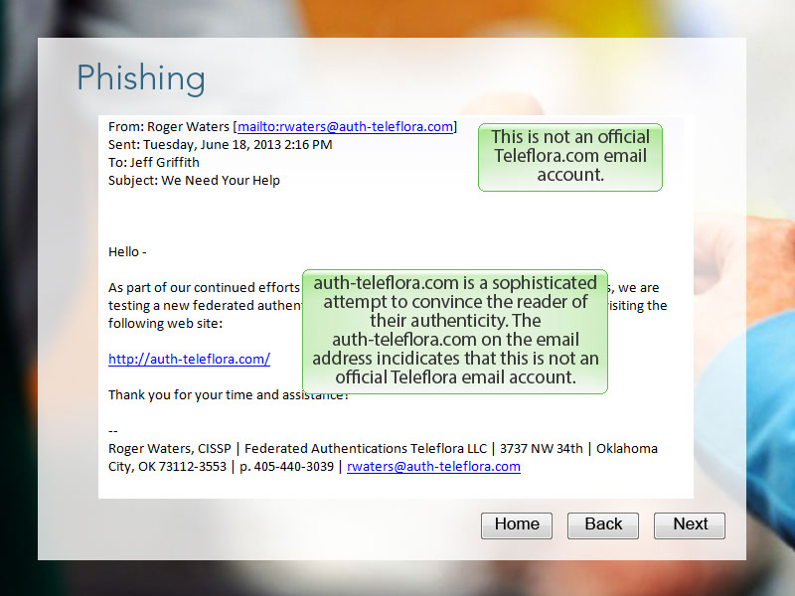
Slide notes
Can you find the points in this email that identify it as a phishing attack? Click the area you think may identify this email as a phishing attack.

Slide 18 - Communications - 1
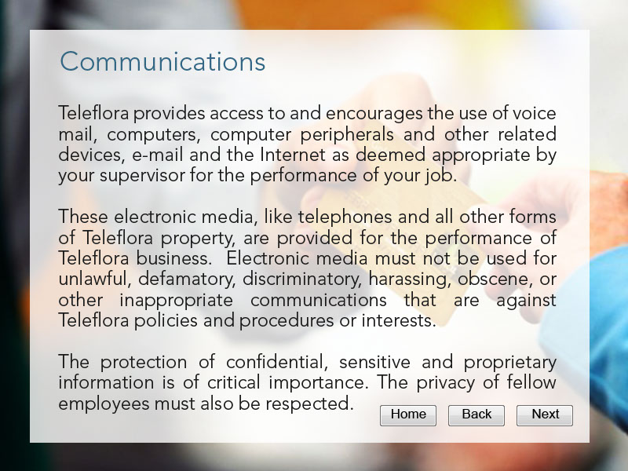
Slide notes
Teleflora provides access to and encourages the use of voice mail, computers, computer peripherals and other related devices, e-mail and the Internet as deemed appropriate by your supervisor for the performance of your job.

These electronic media, like telephones and all other forms of Teleflora property, are provided for the performance of Teleflora business. Electronic media must not be used for unlawful, defamatory, discriminatory, harassing, obscene, or other inappropriate communications that are against Teleflora policies and procedures or interests.

The protection of confidential, sensitive and proprietary information is of critical importance. The privacy of fellow employees must also be respected.

Slide 19 - Communications - 2
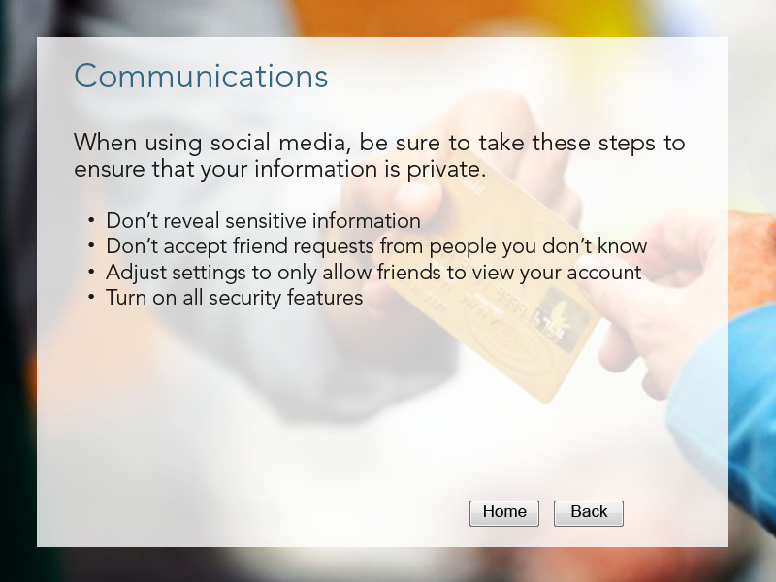
Slide notes
When using social media, be sure to take these steps to ensure that your information is private.

Don’t reveal sensitive information

Don’t accept friend requests from people you don’t know

Adjust settings to only allow friends to view your account

Turn on all security features

Slide 20 - Q1
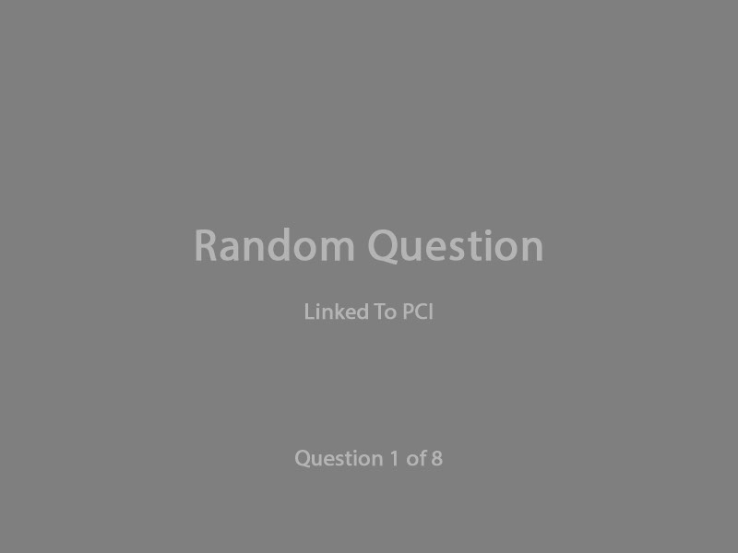
Slide notes

Slide 21 - Slide 21
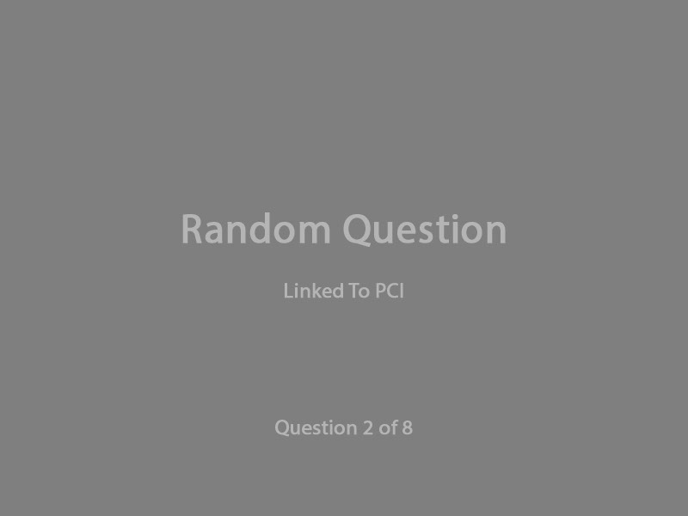
Slide notes

Slide 22 - Slide 22
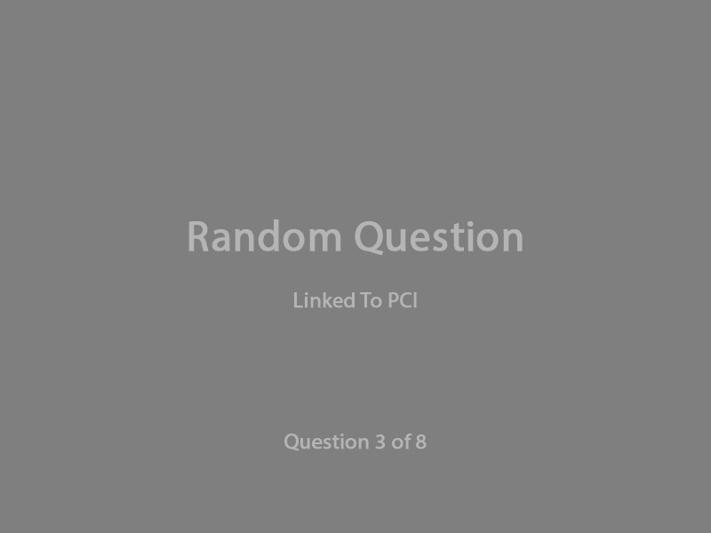
Slide notes

Slide 23 - Slide 23
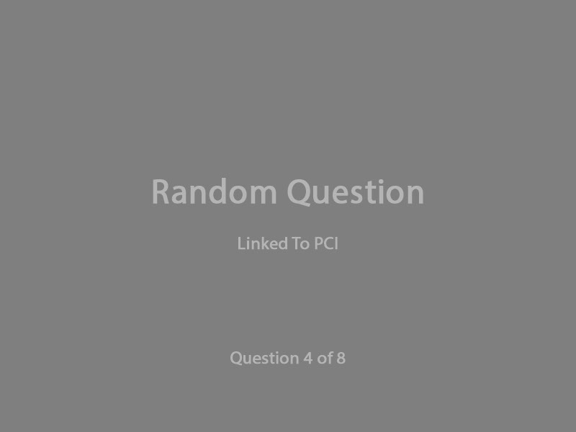
Slide notes

Slide 24 - Slide 24
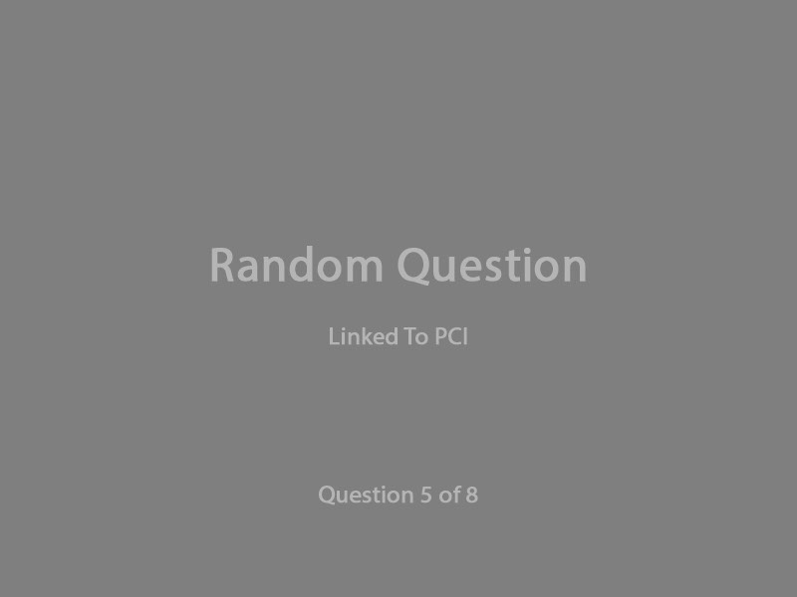
Slide notes

Slide 25 - Slide 25
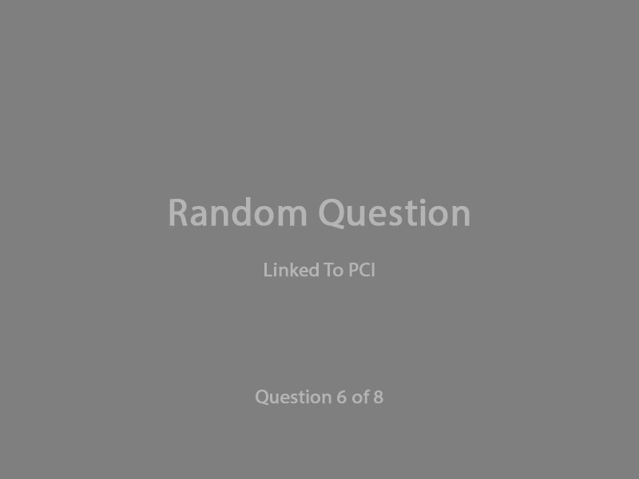
Slide notes

Slide 26 - Slide 26
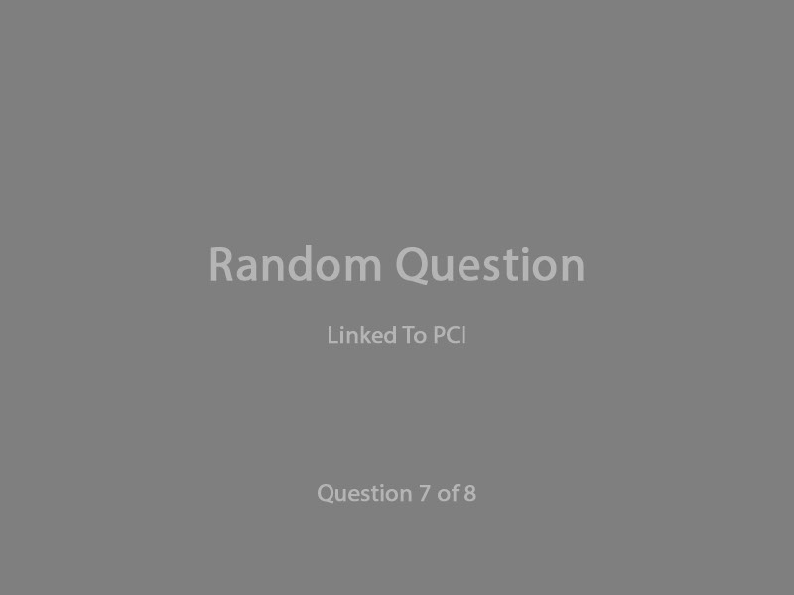
Slide notes

Slide 27 - Slide 27
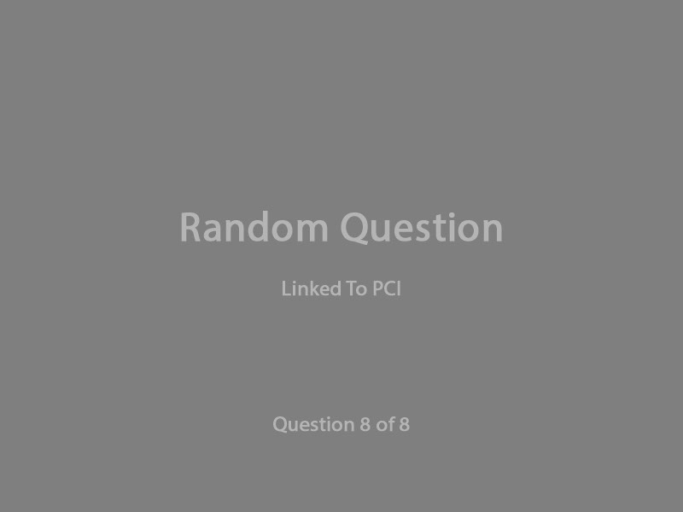
Slide notes

Slide 28 - Success
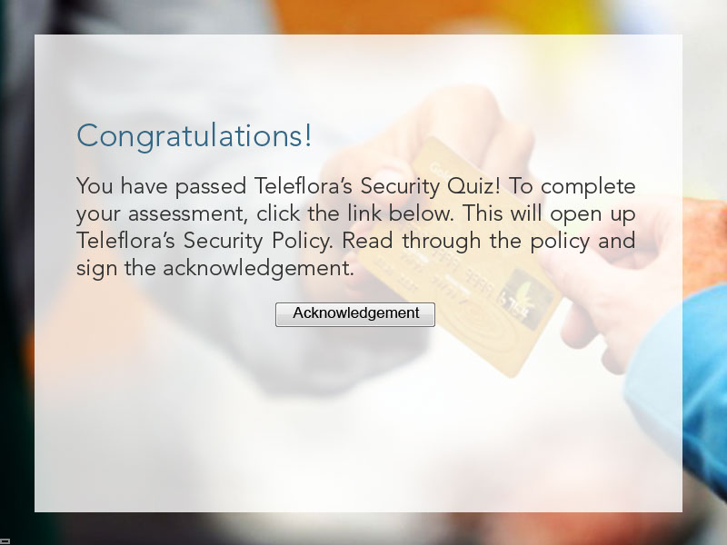
Slide notes
Congratulations! You have passed Teleflora’s Security Quiz! To complete your assessment, click the link below. This will open up Teleflora’s Security Policy. Read through the policy and sign the acknowledgement.

Slide 29 - Failure 1
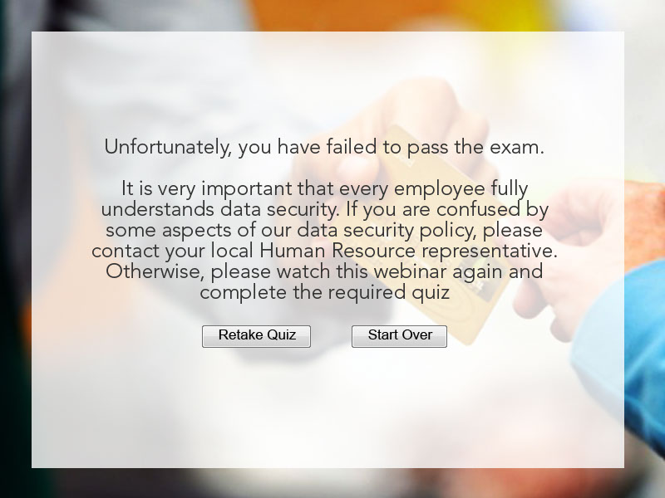
Slide notes
Unfortunately, you have failed to pass the exam.

You can attempt to take the quiz three times. After attempting the quiz three times. Click Next.

