Index

1). ACL’s. Page 6. RHCSA/RHCE V

1.1 Produce a collaborative directory using the GUI.
1.2 Produce a collaborative directory using the CLI
1.3 Give a group rw permissions.

2). IPTables. Page 11. RHCE V

2.1 Deny all requests from a network.
2.2 Setup internet connection sharing.
2.3 Change default policy on INPUT chain.

3). SELinux. Page 11. RHCE V

3.1 Set SELinux to enforcing.
3.2 Make all test requirements work with SELinux.
3.3 Install package needed for the semanage command.
3.4 Install package needed to see sealert messages.

4). HTTP/HTTPS. Page 11. RHCSA/RHCE V

4.1 Configure a virtual host.
4.2 Setup HTTPS virtual host access.
4.3 Create a password protected directory for groups.
4.4 Configure private directories.
4.6 Deploy a basic CGI application.
4.5 Configure group-managed content.
4.8 SELinux.
4.9 IPTables.
4.10 Configure host-based security. Note: httpd does not support TCPWrappers.
4.11 Password protect a directory for a single user.

5). Network services. Page 15. RHCE V

5.1 Deny network access to specified network using IPTables.
5.2 Allow access to only one network using IPTables.
5.3 Join a secret network (IP Alias).

6). DNS. Page 15. RHCE V

6.1 Install Bind.
6.1 Configure a caching-only name server.
6.2 Configure a caching-only name server to forward DNS queries.
6.3 IPTables.

Note: Candidates are not expected to configure master or slave name servers.

7). FTP. Page 16. RHCSA/RHCE V

7.1 Install vsftpd.
7.2 Configure anonymous download.
7.3 Configure so users can access their home directories for upload and download.
7.4 Configure anonymous uploads to users home directories.
7.5 SELinux.
7.6 IPTables.
7.7 Configure host-based security. TCPWrappers.
7.8 User-based security for the service.

8). User/Password Management. Page 18. RHCSA/RHCE V

8.1 Manage user accounts, Setup a password aging policy. Setup password expiration policy.

9). Windows file sharing. Page 20. RHCE V

9.1 Install Samba.
9.2 Create a samba only user.
9.3 Create a samba share.
9.35 Share home directories.
9.36 Create a directory suitable for group collaboration.
9.4 Auto mount cifs home directory.
9.5 SELinux.
9.6 Host based security configuration. Samba does not support TCPWrappers.
9.7 IPTables.

10). NFS file sharing. Page 22. RHCE V

10.1 Install NFS.
10.2 Configure NFS
10.3 Provide network shares to specific clients.
10.4 Provide network shares suitable for group collaboration.
10.5 Configure host-based security.
10.6 User-based security for the service.
10.7 SELinux.
10.8 IPTables.
10.9 Auto mount on reboot.
10.10 Auto mount NFS home directories.

11). Add swap space. Page 24. RHCE V

11.1 Add swap space.

12). ISCSI storage access Page 25. RHCE V

  - Access and mount on boot an iscsi target.

13). LVMs. Page 27. RHCSA/RHCE V

13.1 Install The Logical Volume Manager GUI tool.
13.2 Grow a Logical Volume ( file system) that is part of a volume group Using the GUI.
13.3 Grow a Logical Volume ( file system) that is part of a volume group Using the CLI.
13.4 Create a snapshot using the GUI.
13.5 Create a snapshot using the CLI.
13.6 Shrink a file system using the GUI.
13.7 Shrink a file system using the CLI.
13.8 Create new volume group and logical volume using the GUI.
13.9 Create new volume group and logical volume using the CLI.

14). LDAP Authentication. Page 38. RHCE

14.1 Configure LDAP authorization.
14.2 Mount home directories. To Do.
14.3 Kerberos ticketing. To Do.
14.4 SELinux. To Do.
14.5 IPTables. To Do.

15). NTP. Page 40. RHCSA/RHCE V

15.1 Synchronize time using other NTP peers.
15.2 Install and setup an NTP server.
15.3 IPTables.

16). SMTP. Page 40. RHCE V

16.1 Configure a mail transfer agent (MTA) to accept inbound email from other systems.
16.2 Configure an MTA to forward (relay) email through a smart host.
16.3 Setup all root mail to go to user admin.
16.4 IPTables.
16.5 Configure host based security.
16.6 Configure user based security.

17). Configure a VNC server. Page 41. RHCE V

17.1 Create a VNC server instance.
17.2 IPTables.

18). Basic bash scripting. Page 42. RHCSA/RHCE V

  - Create simple Bash script that accepts parameters and can print usage info to stdout.

19). Cron. Page 42. RHCSA/RHCE V

19.1 Setup a scheduled job.
19.2 Deny a user access to cron.

20). Grub. Page 43. RHCE V

  - Change countdown timer.
  - Change default kernel.
  - Reinstall corrupted grub.

21). Yum. Page 43. RHCSA/RHCE V

  - Create a private yum repository.
  - Install missing commands.
21.3 Create a local yum repository.

22). Remote Logging. Page 43. RHCE V

22.1 Configure a system to log to a remote system.
22.2 Configure a system to accept logging from a remote system.

23). Encrypting file systems (LUKS). Page 44. RHCSA/RHCE V

23.1 Setup LUKS encrypted folder.
23.2 Automatically enter encryption password on boot.
23.3 Creating password-key file and adding the key-file to luks.

24). Setup SSH and restrict access. Page 44. RHCE V

24.1 Install sshd package.
24.2 Allow root user to have remote access.
24.3 Configure host-based security.
24.4 User-based security for the service.
24.5 IPTables.
24.6 Configure key-based authentication.
24.7 Configure additional options described in documentation.

25). System configuration and management. Page 46. RHCE V

25.1 Route IP traffic and create static routes.
25.2 Use /proc/sys and sysctl to modify and set kernel runtime parameters.
25.3 Produce and deliver reports on system utilization (processor, memory, disk, and network).
25.4 Configure a system to authenticate using Kerberos. To Do.

26) Build a simple RPM. Page 49. RHCE V

  - Build a simple RPM that packages a single file.

Extra’s

1) Mount a local iso (DVD) and make it persistant.
2) Mount any new file systems with acl support.
3) Big test question is to deny all from a host using iptables.

Appendix’s

Appendix A RHCE Objectives. Page 51.

Appendix B RPM packages used in this document. Page 52.

Appendix C Setup an LDAP server. Page 53.

Appendix D Setup an iSCSI server. Page 69.

Appendix E ACL’s Page 81.

1. ACLs.

1.1 Produce a collaborative directory using the GUI tool.
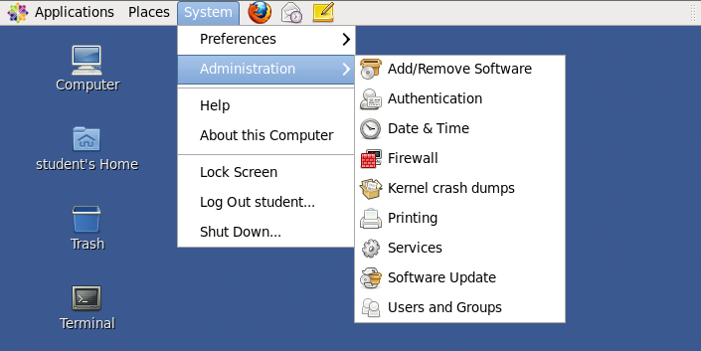

Open the “Users and Groups” tool.

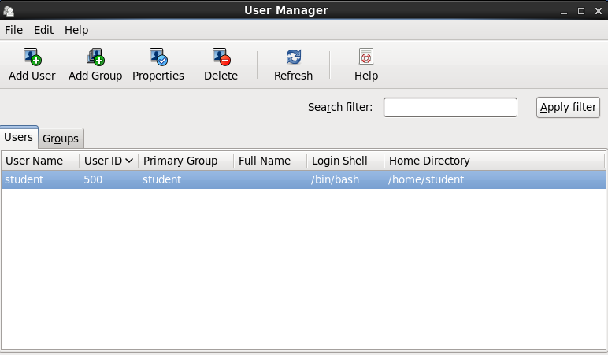

Click on the “Groups” tab.

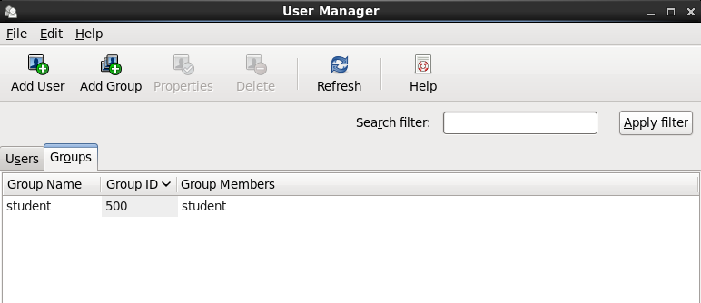

Click on the “Add Group” icon.

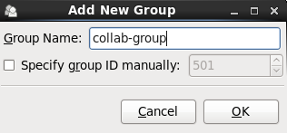

Name your new group. Click “OK”.

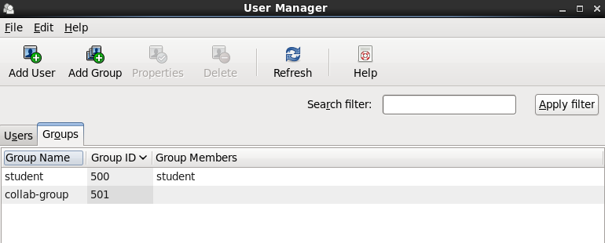

Display new group “collab-group”.

Note: To setup group ownership and the GID bit you can use the file browser “Dolphin”. Install the packages kdebase.
!! Dolphin may not be available on the RHCE test. Be prepared to set all ACL’s from the CLI.

# yum install kdebase # Install dolphin
# dolphin & # Open dolphin.

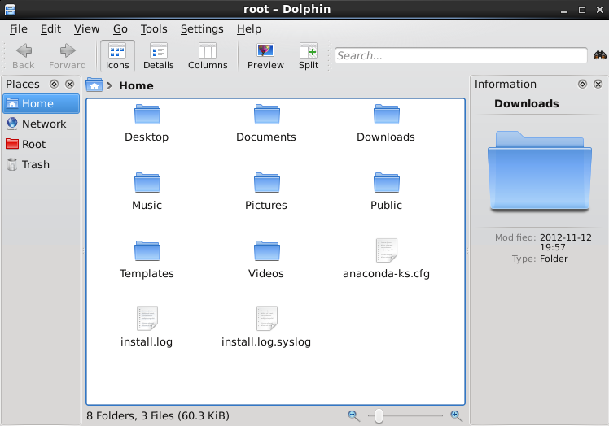

Locate the collaborative directory collab-dir.

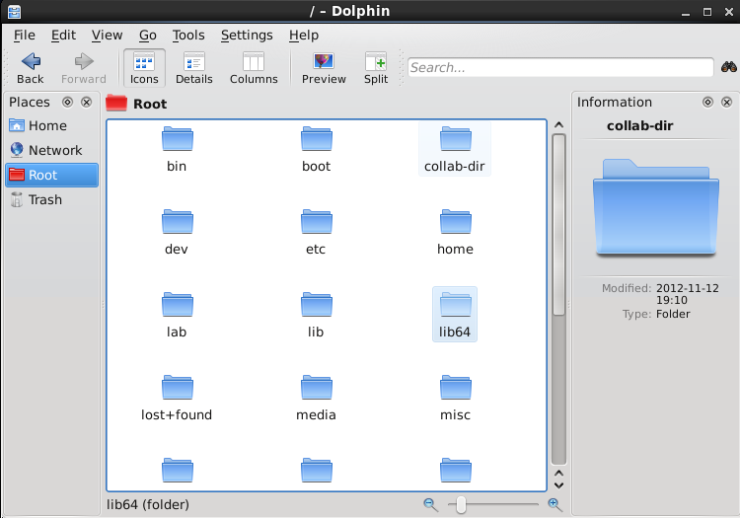

Right click on the directories icon and click on “Properties” from the drop down menu.

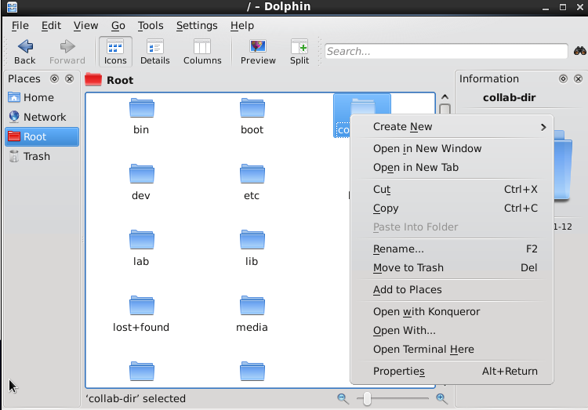

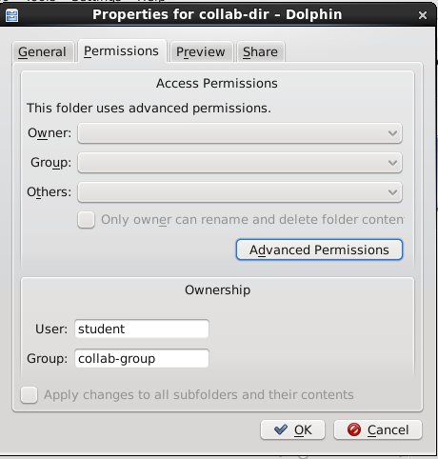

Click on the “Permissions” tab. Then click on “Advanced Permissions”.

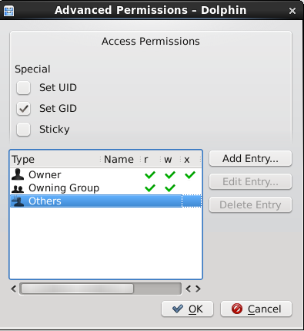

Click on green arrows to remove permission. Click again and the green check appears.
Also we can set the collaborative permissions by setting the Set GID bit. Click “OK” to save.

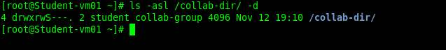

Verify your work, Note the capital “S”. The (GID) bit is set.

1.2 Produce a collaborative directory using the CLI.
# mkdir /collab # Create the collaborative directory.
# groupadd collab-group # Create the collaborative group.
# chmod 2760 /collab # Set GID bit and rwx rw- ---.

Note: Use the getfacl command to view the ACL’s.

1.3 Give rw access to collaborative directory.
# setfacl -m g:collab-group:rwx /collab/ # Set group ACL on the directory. rwx.
# setfacl -m d:g:collab-group:rwx /collab/ # Set ACL (defaults) rule on new files. rwx.
# getfacl /collab/

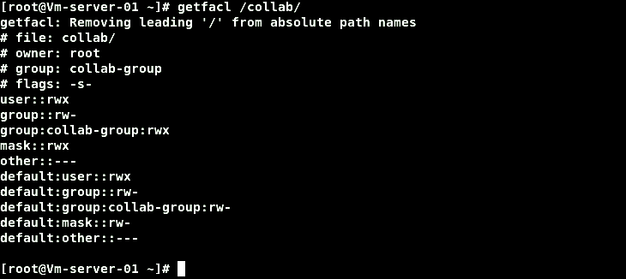

Use the getfacl command again to view the new rules.

Note: Repeat the above 2 commands for any other group(s) that need access to the shared directory.
# chgrp collab-group /collab # Change the directories group owner.

Or.

# chown root:collab-group /collab # Or this way, either will work.

# usermod -aG collab-group <users> # Add users to collaborative group
# as needed.

Note: When creating a new directory in the test, always set the SELinux contexts too!

Flash Card:

# setfacl -m u:tom:rwx /directory Grants rwx perms to user tom on directory “directory”.
# setfacl -m d:u:tom:rwx /directory Set default ACL’s on directory for all new files created for user tom.
# setfacl -m u:tom:--- /directory Deny user tom access.

# setfacl -m g:group-a:rw /directory Grants rw- perms to the group named “group-a”.
# setfacl -m d:g:group-a:rw /directory Set default ACL’s on directory for all new files created
by members of the group “group-a”.

# setfacl -x u:tom /directory Removes ACL for user tom.
# setfacl -x g:group-a /directory Remove ACL for group “group-a”.

# setfacl -m m:rwx /directory Sets mask value, remember the mask is used to limit the permissions available when using the setfacl command.
rwx means no limits. rw- means the setfacl command can’t apply any execute permissions, existing rules are effected
immediately by the new mask value.

# setfacl -R -m u:hugo:rw- /directory Set ACL recursively thru all sub directories for user hugo.
# setfacl -b /directory Removes ALL ACL’s and retains standard permissions.
# setfacl -k /directory Removes default ACL’s only.
# setfacl -x u:hugo /directory Removes only user hugo’s ACL.

ACL Notes. See Appendix E.

2. Iptables.
2.1 Deny all requests from network 192.168.1.0/24. This is a very important task to get right. If you miss this one you
can loose points later in the test.
# iptables -I INPUT -m state --state NEW -s 192.168.1.0/24 -j REJECT --reject-with icmp-host-prohibited
# service iptables save
# service iptables restart

2.2 Setup internet connection sharing.
# echo
# vi /etc/sysctl.conf # Edit /etc/sysctl.conf

net.ipv4.ip_forward = 1 # Change this value to 1.
:wq # Save and quit.
# iptables -t nat -A POSTROUTING -o eth0 -j MASQUERADE # Add the postrouting rule.
# service iptables save
# service iptables restart

2.3 Change default policy on INPUT chain to drop.
# iptables -P INPUT DROP # Set new policy.
# service iptables save # Save your changes.
# service iptables restart # Start it back up.

3. SELinux.
3.1 Set to enforcing.
# sed -i 's/^SELINUX=.*/SELINUX=enforcing/' /etc/selinux/config
# reboot
3.2 Make all test requirements work with SELinux in enforcing mode.
See individual sections for SELinux instructions.
3.3 Install package policycoreutils-python for semanage command.
# yum -y install policycoreutils-python
3.4 Install setroubleshoot to get sealert messages in /var/log/messages.
# yum -y install setroubleshoot

4. Apache.

4.1 Configure virtual hosts.

# yum -y groupinstall “web server” # Install apache.
# yum -y install policycoreutils-python elinks # Install semanage and elinks.
# service httpd start
# chkconfig httpd on

# vi /etc/httpd/conf/httpd.conf

# Uncomment and edit the following lines.
NameVirtualHost *:80

<VirtualHost *:80>

ServerAdmin webmaster@big.example.com # Create a virtual host named big.example.com
DocumentRoot /var/www/html/big.example.com # Point to Document root.
ServerName big.example.com
ErrorLog logs/big.example.com-error_log
CustomLog logs/big.example.com-access_log common

</VirtualHost>

:wq

# httpd -t # Check you config file syntax.
# httpd -S # Verify/check virtual host syntax.

# mkdir /var/www/html/big.example.com
# echo “Hi from BIG EXAMPLE.com” >> /var/www/html/big.example.com/index.html
# service httpd restart

4.2 Setup ssl.

# vi /etc/httpd/conf.d/ssl.conf # Edit ssl config file.

Change: <VirtualHost _default_:443> # Change this line to this.
To: <VirtualHost *:443>
DocumentRoot "/var/www/big.example.com" # Uncomment and edit this line.
ServerName www.big.example.com:443 # Uncomment and edit this line.
:wq # Save your changes.

4.3 Creating password protected directory.

# htpasswd -c /etc/httpd/test myuser1 # Create a user with some password for
# web server access.
# vi /etc/httpd/group # Setup for more than one user.
# create the group file.
design: user1 user2 # Add the user names,
:wq # Save your changes.

# vi /etc/httpd/conf/httpd.conf

<VirtualHost *:80>
<Directory "/var/www/html/help">
AuthType Basic
AuthName "Password Protected"
AuthUserFile /etc/httpd/test
Require User myuser1
</Directory>
</VirtualHost>
:wq

4.4 Home directory access.

# vi /etc/httpd/conf/httpd.conf

Change: #UserDir disabled
To: UserDir public_html
:wq

# mkdir /home/username/public_html
# setfacl -m u:apache:x /home/username
# setfacl -m u:apache:x /home/username/public_html
# setsebool -P httpd_enable_homedirs 1
# echo “Hi from user” >> /home/username/public_html/index.html

Note: User directory /home/user/public_html is accessed via Apache.
The address for access is http://apache.server.com/~username

4.5 Group Managed Directories.

# vi /etc/httpd/conf/httpd.conf

<VirtualHost *:80>
<Directory "/var/www/html/help">
AuthType Basic
AuthName "Password Protected"
AuthUserFile /etc/httpd/test
AuthGroupFile /etc/httpd/group
Require group design
</Directory>
</VirtualHost>
:wq

# groupadd groupname # Create group to work in.
# useradd -G groupname username # Add users to new group.
# mkdir /var/www/group-site # Create web directory.
# chgrp apache.groupname /var/www/group-site # Change directories group ownership.
# chmod 775 /var/www/group-site
# chmod g+s /var/www/group-site

Note: Log in as a user member of the new group. Create new file in the public_html subdirectory.
Check the ownership of the file. Make sure Apache can read that file.

4.6 Deploy a CGI Script.

# vi /var/www/cgi-bin/hello.pl # Create a simple perl script
# called hello.pl.

#!/usr/bin/perl

print “Content-type: text/html\n\n”;
print “Hello, world!”;
:wq

# chmod 755 hello.pl

NOTE: In browser you can type http://192.168.122.50/cgi-bin/hello.pl , if successful; the following
words should show up in the body of the browser.
“Hello world”.

4.7 Manage certificates for each virtual host.

# genkey big.example.com # Create certificate for big ....
# vi /etc/httpd/conf.d/ssl.conf # Edit ssl.conf and edit the following lines.
# Do this for both virtual hosts.
SSLCertificateFile /etc/pki/tls/certs/big.example.com.crt
SLCertificateKeyFile /etc/pki/tls/private/big.example.com.key

:wq # Save your settings.

4.8 SELinux

# chcon -R -t httpd_sys_content_t /var/www/ # Set “Type” context.
# chcon -R -u system_u /var/www/ # Set “User” context.
# semanage fcontext -a -s system_u -t httpd_sys_content_t /var/www/ # Make it persistent.

4.9 IPTables.
# iptables -I INPUT -m state --state NEW -m tcp -p tcp --dport 443 -j ACCEPT # Open https port.
# iptables -I INPUT -m state --state NEW -m tcp -p tcp --dport 80 -j ACCEPT # Open http port.
# service iptables save
# service iptables restart
4.10 Host based security. TCPWrappers.

Httpd does not support TCPWrappers. You can confirm this by using the command “ldd” that prints
shared library dependencies.

# ldd /usr/sbin/httpd | grep libwrap

If the deamon supports TCPWrappers, you will see output similar to the example below using vsftpd.
The recommendation is to use IPTables for host based security.

Host based security using IPTables not TCPWappers.

These IPTables rules restrict access to the 192.168.122.0/25 network. Use the –s or source address parameter.

# iptables -I INPUT -m state --state NEW –s 192.168.122.0/24 -m tcp -p tcp --dport 443 -j ACCEPT
# iptables -I INPUT -m state --state NEW –s 192.168.122.0/24 -m tcp -p tcp --dport 80 -j ACCEPT

# vi /etc/httpd/conf/httpd.conf

Allow <from good ip>
Deny <from all>
Order deny,allow

:wq

4.11 Password protect a directory for a single user.

# vi /etc/httpd/conf/httpd.conf

<Directory "/var/www/html"> # Locate this section.

Options Indexes FollowSymLinks
AllowOverride AuthConfig # Change this line
Order allow,deny
Allow from all
:wq

# service httpd restart

# htpasswd –c /etc/httpd/conf/.passwd_file tom # Create a password file for user tom.

# chown apache:apache /etc/httpd/conf/.passwd_file # Set perms on file for access by apache.
# chmod 0660 /etc/httpd/conf/.passwd_file
# mkdir /var/www/html/protected # Create protected directory.

# vi /var/www/html/protected/.htaccess # Create protected access file.

AuthType Basic # Add these lines.
AuthName "Private Area"
AuthUserFile /etc/httpd/conf/.passwd_file
Require user tom

:wq # Save your settings.

Note: To test, browse to the secure address. A prompt for a user name and password will appear.
Once the correct credentials are given, access is granted.

5. Network services.
5.1 Pretend foo.com is 192.168.4.1 network. Do not allow anyone from that network to anything on the server.
# iptables -I INPUT -m state --state NEW -s 192.168.4.0/24 -j REJECT --reject-with icmp-host-prohibited
5.2. Only allow machines from the same network your exam server is on access to the services you are setting up
for the exam (In addition to any additional networking requirements specific to the service/exam question you
are working on).
# iptables -I INPUT -i eth0 -s 192.168.1.0/24 -j ACCEPT # Accept only traffic from 192.168.1.0 network.
5.3. Join a secret network. (ip alias)
# vi /etc/sysconfig/network-scripts/ifcfg-eth0:0 # Create alias config file.

DEVICE=eth0:0 # Name the device.
ONBOOT=yes # Make is active on boot.
IPADDR=192.168.122.97 # Set the ip address of the alias.
GATEWAY=192.168.122.1 # Set the gateway address.
NETMASK=255.255.255.0 # Set the netmask.

:wq # Save your changes.

# service network restart # Restart the network service.
5.4. Do not respond to ping requests.
# iptables -I INPUT -p icmp -m icmp --icmp-type echo-request -j DROP # Add new rule to drop icmp.
# iptables -D INPUT -p icmp -j ACCEPT # Remove this default rule.
# service iptables save
# service iptables restart

6. DNS.
6.1 Configure a caching-only name server.
# yum -y install bind # Install package bind
# vi /etc/named.conf # Edit binds configuration.
Change to: listen-on port 53 { any; }; # Tells named to accept queries from any
# host on lan.
Change to: allow-query { 192.168.1.0/24; }; # Allows queries on your network.
Add Line: forwarders { 192.168.1.1; }; # forwards DNS requests on to router.
Change Line: dnssec-validation yes; # This means the forwarder needs to
# provide a digital certificate.
to: dnssec-validation no;
# We don't want to request a
# digital certificate
:wq
# from the forwarder.
# service named restart # Restart service
# service named status # Verify status.
# chkconfig named on # Make it persistent.
# vi /etc/resolve # To test, use client host.
# change the nameserver
Change to: nameserver 192.168.1.91 # address to that of the
# DNS server. (1.91)
:wq # Save your changes.
# dig google.com # Test the functionality with the DIG command.
# The output should have the line ";; SERVER: # 192.168.1.91#53(192.168.1.91)"
# This shows this host is responding to DNS requests.

6.2 Configure a caching-only name server to forward DNS queries.

# vi /etc/named.conf

options { # With this configuration, any computer
# that looks to the local
# DNS server is forwarded to DNS servers on the
# IP addresses shown.
listen-on port 53 { 127.0.0.1; };
listen-on-v6 port 53 { ::1; }
directory "/var/named";
forward only;
forwarders {
192.168.122.1; # Forward to this address.
192.168.0.1;
};

};

dump-file “/var/named/data/cache,db”;
statistics-file “/var/named/data/named_stats.txt”;
memstatistics-file “/var/named/data/named_mem_stats.txt”;
allow-query { localhost; 192.168.122.0/24; }; # Allow requests from server and network . # 192.168.122.0.
recursion yes;
:wq

6.3 IPTables.
# iptables -I INPUT -m state --state NEW -m tcp -p tcp --dport 53 -j ACCEPT
# iptables -I INPUT -m state --state NEW -m udp -p udp --dport 53 -j ACCEPT
# service iptables save
# service iptables restart

7. FTP Server.
7.1 Setup an ftp server.
# yum install vsftpd -y # Install vsftpd.
# service vsftpd start # Start the service
# chkconfig vsftpd on # Make it persistent on reboot.
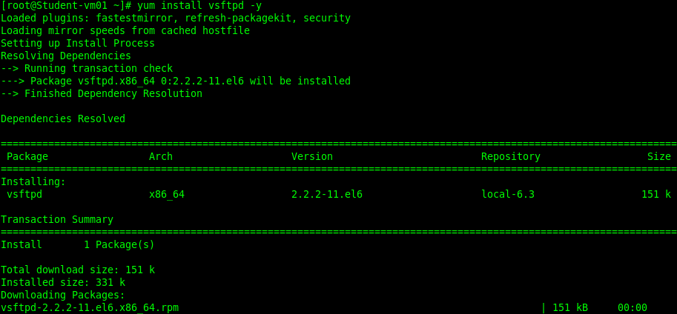
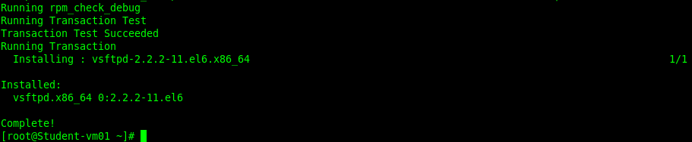

7.2 Configure anonymous-only download.
# vi /etc/vsftpd/vsftpd.conf # Anonymous access is allowed by default.
anonymous_enable=YES # Default is “YES”.

:wq

# service vsftpd restart # Restart service with new configuration

Note: Now you can login as user anonymous and no password to the ftp service and
download files from the /var/ftp/pub directory.

7.3 Configure so users can access their home directories.
# setsebool -P ftp_home_dir 1 # Toggle the SELinux boolean.

7.4 Configure anonymous uploads.

# vi /etc/vsftpd/vsftpd.conf

listen=YES # Default = Yes.
anonymous_enable=YES # Default = Yes.
write_enable=YES # Default = Yes.
anon_upload_enable=YES # Default is commented out.
anon_mkdir_write_enable=YES # Default is commented out.
:wq

# mkdir -p /var/ftpd/pub/upload
# chown ftp:ftp /var/ftpd/pub/upload
# chmod 755 /var/ftpd/pub/upload
# service vsftpd restart

Note: Test upload/download to home directories via ftp. From client, ftp to server.

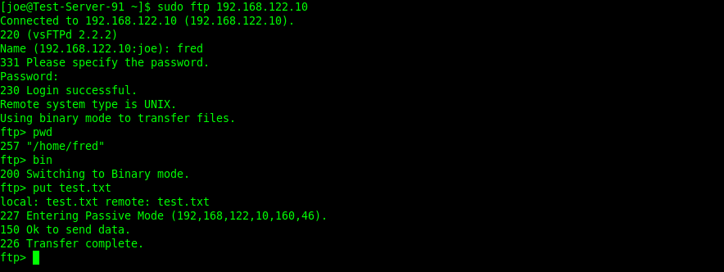

7.5 SELinux.
# setsebool -P allow_ftpd_anon_write 1 # Set SELinux boolean to allow anonymous writes.

7.6 IPTables.
# iptables -I INPUT -m state --state NEW -m tcp -p tcp --dport 21 -j ACCEPT
# service iptables save
# service iptables restart

7.7 TCP Wrappers.

# vi /etc/hosts.allow # Edit hosts.allow.

vsftpd: 192.168.122. 192.168.1. # Allow this network to access vsftpd.
:wq # Save your changes.

# vi /etc/hosts.deny # Edit hosts.deny.

vsftpd: ALL # Deny all not allowed above.
:wq

7.8 User based security.

User based security is controlled by the use of standard unix users.
To deny a users access to ftp, add user name to /etc/vsftpd/ftpusers

# vi /etc/vsftpd/ftpusers

tom

:wq

Note: User tom will be denied ftp access.
If userlist_deny=NO, only allow users in this file.
If userlist_deny=YES (default), never allow users in this file.

# service vsftpd restart

8. User password management.
8.1. Setup a password aging policy.
# chage -m0 -M90 -W7 -I14 -E 2013-01-01 <user(s)>

Note: Use chage on user accounts to -m0 password can be changed anytime. Setup a password expiration policy.
-M90 Maximum days a password is valid. -W7 days before a password must be changed.
-I14 days after password expires the account is locked. -E sets the expiration date to Jan 01 2013.

8.2 Setup aging policy using the GUI.

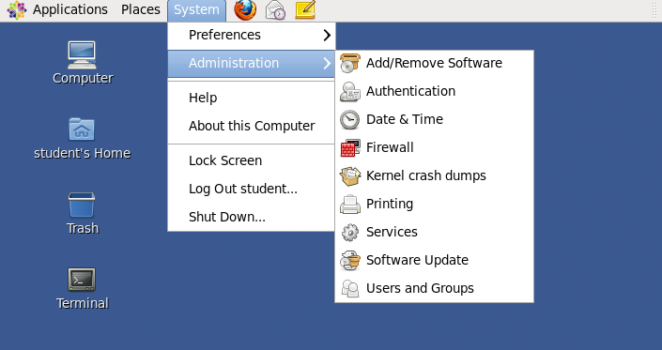

Open the “Users and Groups” tool, Click on System > Administration > Users and Groups

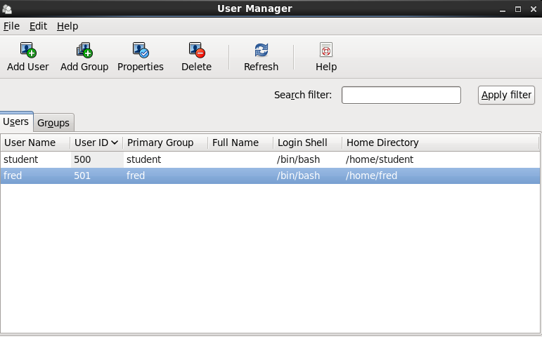

Select user to configure, then click on the “Properties” button.

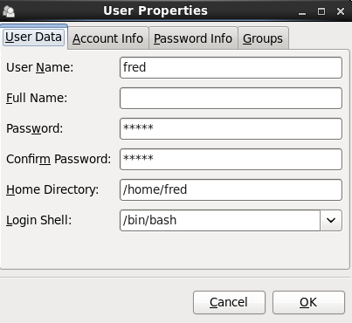

Click on the “Account Info” tab.

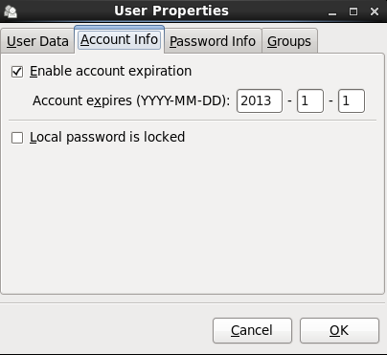

Enable account expiration and enter expiration date.

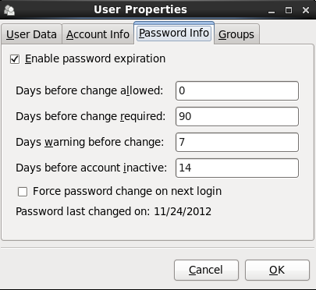

Click on the “Password Info” tab and enter aging settings. Click “OK”.

9. Windows file sharing (Samba). Note: section 9.1 thru 9.6 are all server side configurations.
9.1 Install Samba.

# yum install samba -y # Install samba.
# yum install policycoreutils-python -y # Install semanage if not already installed.
# service smb start
# service nmb start
# chkconfig smb on
# chkconfig nmb on

9.2 Create a samba only user.

# useradd <username> # Add standard unix user.
# passwd <username>
# smbpasswd -a <username> # Add <username> to Samba.
# vi /etc/samba/smbusers # add new user to the smbusers file.

<username> = samba user <username>

:wq # Save your changes.

# vi /etc/samba/smb.conf

[accounts]

valid users = <username> # Add this line in the share directive.
:wq

# service smb restart

9.3 Create a samba shared folder.

# /mkdir /share/protected # Create directory to share.

# vi /etc/samba/smb.conf # Create new samba config directive.

[myshare]
comment = /share/protected
path = /share
public = no
writable = yes
valid users = <username> # Limit access to one user.

:wq

9.35 Share home directories.

# vi /etc/samba/smb.conf

[homes]
comment = Home Directories
browseable = no
writable = yes
valid users = %S
create mask = 0770
directory mask = 0770

:wq

9.36 Create a directory suitable for group collaboration.

# mkdir /groupdir
# vi /etc/samba/smb.conf

[SmallGroup]
comment = Small Share - Few Users
path = /groupdir
read only = No
guest ok = No
browseable = Yes
create mask = 0666
directory mask = 0777
valid users = peter, paul, mary
:wq

# service smb restart

Note: The [SmallGroup] example section is not allowed to have guest or public access, but the resource can be viewed by networked workstations and clients.

Any new directory created in the share will be given the directory permissions of 777, and any new file will have file permissions of 666. The only valid user accounts that can connect to this resource are peter, paul, and mary.

9.4 Auto mount cifs home directory. ( This section is a client side configuration. ) with Autofs.

# vi /etc/auto.master

/cifs /etc/auto.smb --timeout=60

:wq

Note: Now all cifs shares will show up under /cifs: ls /cifs/<server>. Of course /cifs does not exist
Until you make the changes above in /etc/auto.master and restart autofs.

# service autofs restart

Or to use a custom directory.

# vi /etc/auto.master

/test /etc/auto.test --timeout=60

:wq

# vi /etc/auto.test # Create this file with the following line.

test -fstype=cifs,username=user,password=password ://server/test

:wq

# service autofs restart

9.5 SELinux.

# setsebool -P samba_enable_home_dirs 1 # Set SELinux boolean to allow Samba to
# share home directories.
# chcon -R -t samba_share_t /myshare # Set proper SELinux context for /share
# semanage fcontext -a -t samba_share_t /myshare # Make the change persistent.

9.6 Host based security from within the samba configuration. Samba does not support TCPWrappers.

# vi /etc/samba/smb.conf

hosts allow = 127. 192.168.1. 192.168.122.
hosts deny = 0.0.0.0/0
:wq

9.65 Mount share on remote system.

# mount -t cifs -o guest //vm-server-01/tmp /tmp
Or
# mount -t cifs -o username=user,password=password //vm-server-01/share /path_to/mount

9.67 Make it persistent with /etc/fstab

# vi /etc/fstab

//vm-server-01/share /path_to/mount cifs username=user,password=password,_netdev 0 0

:wq

9.68 Hide credentials.

# vi /etc/fstab

//192.168.44.100/share /path_to/mount cifs credentials=/path_to/.creds,_netdev,uid=client_user,gid=users 0 0
:wq

# vi /path_to/.creds

username=user
password=password
:wq

9.7 IPTables.

# iptables -I INPUT -m state --state NEW -m udp -p udp --dport 137:138 -j ACCEPT
# iptables -I INPUT -m state --state NEW -m tcp -p tcp --dport 139 -j ACCEPT
# iptables -I INPUT -m state --state NEW -m tcp -p tcp --dport 445 -j ACCEPT

10. NFS file sharing. Provide network shares to specific clients.

( Server Side Configuration ).

10.1 Install nfs.

# yum groupinstall “nfs file server”
# service nfs start
# chkconfig nfs on

10.2 Configure ports used by nfs.

# vi /etc/sysconfig/nfs # Edit the following lines.

RQUOTAD_PORT=4007 # Rquotad is an RPC server that returns quotas.
LOCKD_TCPPORT=4004 # TCP port rpc.lockd should listen on.
LOCKD_UDPPORT=4006 # UDP port rpc.lockd should listen on.
MOUNTD_PORT=4000 # Port rpc.mountd should listen on.
STATD_PORT=4002 # Port rpc.statd should listen on.
STATD_OUTGOING_PORT=4008

:wq

# service nfs restart
# netstat -anp } grep 400* # Confirm the port assignment.

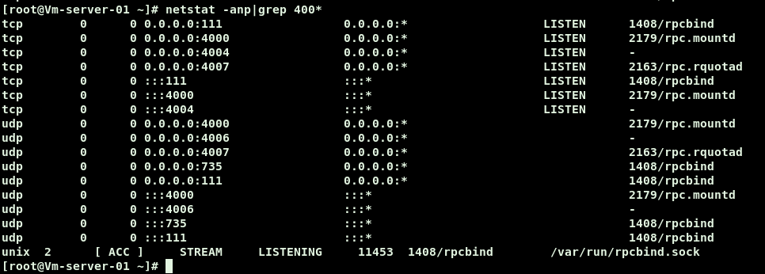

NOTE: The ports used above are arbitrary. They should be kept close to make the iptables rules easier later.

10.3 Create directory to export.

# mkdir /myshare # Create directory to export.
# vi /etc/exports # Tell nfs what and how to export /myshare.

/myshare 192.168.122.0/24(rw,sync,no_root_squash) # Share will be available to members of the # network 192.168.166.0
:wq # Save your changes.

Note: Some examples of entries in /etc/exports.

/myshare 192.168.1.100(ro,sync) # Export /myshare as read only to one client.
/myshare 192.168.1.0/255.255.255.0(ro,sync) # Export only to network 192.168.1.0.
/myshare 192.168.1.0/24(ro,sync) # Same as above.
/myshare *(ro,sync) # Export to all read only
/myshare *.example.com(rw,sync) # Export to “example.com” read/write.
# chmod a+w /myshare
# service rpcbind restart
# service nfs restart
# service nfslock restart
# exportfs -a

# nfsstat # To check nfs activity.
10.4 Provide network shares suitable for group collaboration.

# mkdir /groupdir # Create the group directory.
# chmod 2755 /groupdir # Set SUID bit .

Note: Remember the SUID bit causes scripts in the group directory to run as if started by the scripts owner instead of the actual user that started it.

# vi /etc/exports # Add the new directory to exports.
/groupdir *(rw,sync) # Export to all.

:wq # Save your changes.

# service nfs restart # Restart the service.
# exportfs -rav

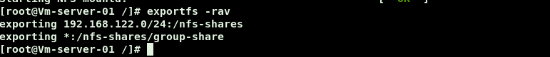
# showmount -e vm-server-01 # Use IP or URL here.

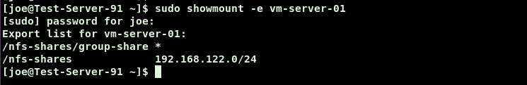

10.5 Configure host based security.

# vi /etc/hosts.allow

mountd portmap : 192.168.122. 192.168.1.
:wq

# vi /etc/hosts.deny

mountd portmap : ALL

:wq

10.6 Configure user based security.

Note: User based security is set using standard unix users and passwords and ACL’s.

10.7 SELinux.

Per Red Hat the NFS booleans have been removed from version 6.3. Version 6.2 will still have
The NFS booleans. Red Hat has also stated that the booleans even in version 6.2 had no real effect
so they were removed in the newer version. I left the command below for reference only.
# setsebool -P nfs_export_all_rw 1 # Set SELinux boolean.

10.8 IPTables.
# iptables -I INPUT -m state --state NEW -m tcp -p tcp --dport 111 -j ACCEPT
# iptables -I INPUT -m state --state NEW -m tcp -p tcp --dport 2049 -j ACCEPT
# iptables -I INPUT -m state --state NEW -m tcp -p tcp --dport 4000:4008 -j ACCEPT
# iptables -I INPUT -m state --state NEW -m udp -p udp --dport 111 -j ACCEPT
# iptables -I INPUT -m state --state NEW -m udp -p udp --dport 2049 -j ACCEPT
# iptables -I INPUT -m state --state NEW -m udp -p udp --dport 4000:4008 -j ACCEPT
# service iptables save
# service iptables restart

Note: Remember you can use IPTables rules to apply host based security. You can do this by using the –s switch followed
by an source ip address or network that will be accepted.

# iptables -I INPUT -m state --state NEW –s 192.168.122.0/24 -m tcp -p tcp --dport 111 -j ACCEPT

( Client Side )

10.9 Auto mount on reboot.
# mkdir /local-mount-point # Create local mount point.
# mount -t nfs nfs-server.com:/myshare /local-mount-point # Test remote connection.
# umount /local-mount-point # Unmount it.
# vi /etc/fstab
server-01.com:/myshare /local-mount-point nfs defaults,_netdev 0 0
:wq

Note: Note the use of _netdev in the config line above. This is very important to use
when mounting a remote file system. What the _netdev setting does is it will cause the actual
mounting to occur after the networking service is up. Otherwise, the mount will fail.
The _netdev parameter should be used when ever mounting a remote file system.
# mount -a # Test your new fstab entry.

10.10 Auto mount NFS home directories (Autofs).

Mount an remote nfs on server 192.168.122.166:/myshare to a local mount point /home/student.
# chkconfig autofs on
# service autofs start

# vi /etc/auto.master

/home /etc/auto.home
:wq

Note: /etc/auto.master contains the high level directory to share, in this case /home.

# vi /etc/auto.home

student - rw student-vm01.com:/myshare

:wq

Note: /etc/auto.home contains the subdirectory to share, in this case /student. When considering both
auto.master and auto.home the full path to the automounted resource is /home/student.

# service autofs restart

Note: You can now cd to /home/student to view files being shared by the NFS server.
By default, when autofs is running, a special directory named /net will exist, but will be empty.
Accessing the the non-existent directory /net/Student-vm01.com will cause automounter to create
that subdirectory and display all the NFS exports available from that NFS server. This is sometimes called
“browsing” the shares.

11. Add swap space.
11.1 Add swap space.
# fdisk -cu /dev/sda # Use fdisk to create a new partition, change
# type to 82.
# mkswap /dev/sda1 # Prep partition for swap.
# swapon /dev/sda1 # Enable the new swap space.
# swapon -s # Confirm the new swap is active.
# vi /etc/fstab
/dev/sda1 swap swap defaults 0 0

:wq
# mount -a # Test.

12. ISCSI storage access (client).

Note: In this example the iscsi target is student.example.com or 192.168.122.10.
12.1 Access and mount on boot an iscsi target.
# yum install iscsi-initiator-utils -y # Install iscsi initiator package.
# chkconfig iscsi on # Make it persistent.
# iscsiadm -m discovery -t sendtargets -p student.example.com # Locate iscsi target server.

# iscsiadm -m node -T iqn.2012-11.com.example:student.example.com.target1 -p 192.168.122.10 –l
# tail /var/log/messages

Note: Tail /var/log/messages to determine what node name was given to the iSCSi export.

# tail –f /var/log/messages

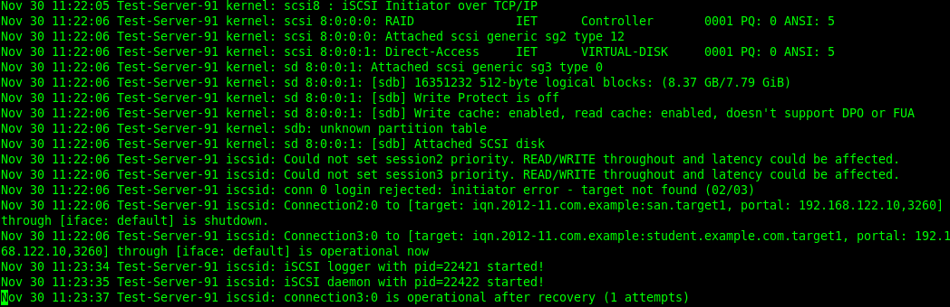

Note: /dev/sdb is the node name assigned to the iSCSi disk. The iscsi connection is persistent..

12.2 Prep the new partition for use.

# fdisk /dev/sdb # Create new partition.
# partx –a /dev/sdb # Tell kernel about it.
# mkfs.ext3 /dev/sdb1 # Create a file system.
# mkdir /iscsidata # Create mount point.
# mount /dev/sdb1 /iscsidata # Mount it to test.
# df –h

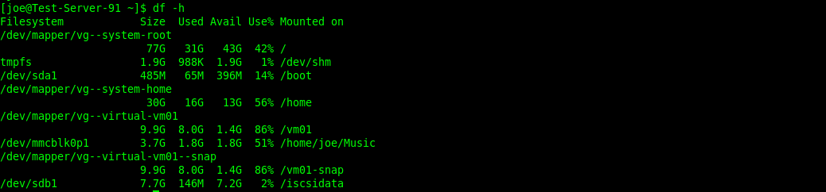

# vi /etc/fstab # Make it persistent on reboot.

/dev/sdb1 /iscsidata ext3 _netdev 0 0

:wq

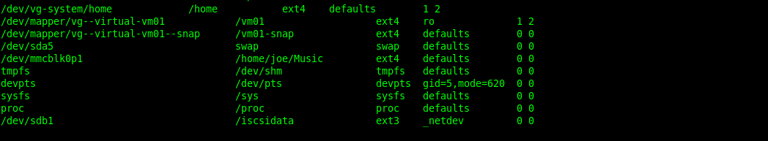

# umount /iscsidata # Unmount the disk.
# mount –a # Test you fstab changes.
# mount

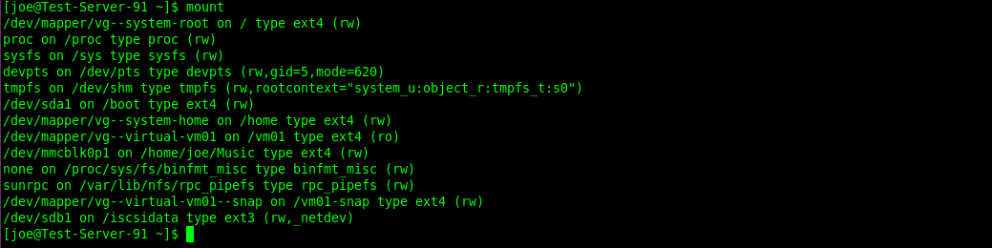

Note: You can see that /dev/sdb1 has been mounted to /iscsidata

13. LVMs.
13.1 Install The Logical Volume Manager GUI tool.

# yum install system-config-lvm

13.2 Grow a Logical Volume ( file system) that is part of a volume group Using the GUI.

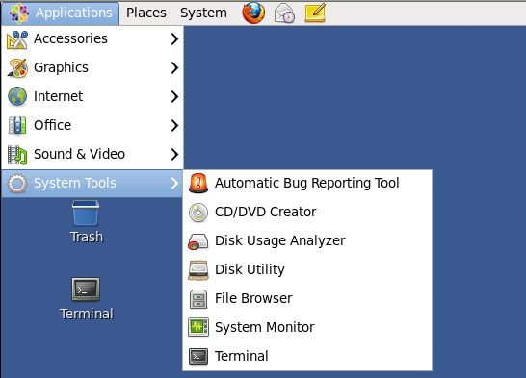

To access the GUI Disk Utility, Select Applications > System Tools > Disk Utility.

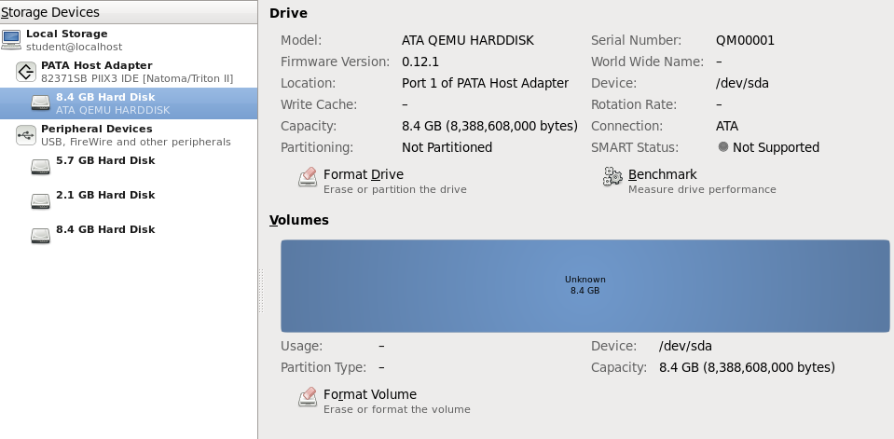

The new drive /dev/sda as it appears in the Disk Utility. You don’t need to format here.

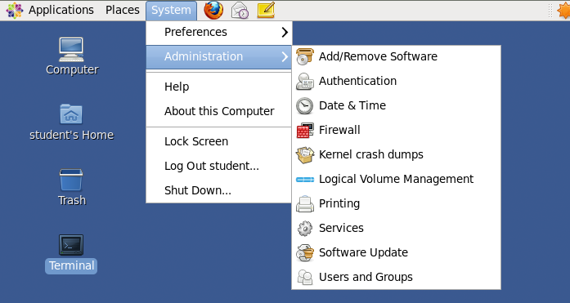

To access the Logical Volume Manager, Click on System > Administration > Logical Volume Management.

13.3 Grow a Logical Volume ( file system) that is part of a volume group Using the CLI.

# fdisk -cu /dev/sda # Create new partition, 8G and make it partition 1.
# partx -a /dev/sda1 # Tell the kernel about the new partition.
# pvcreate /dev/sda1 # Initialize new partition for LVM.

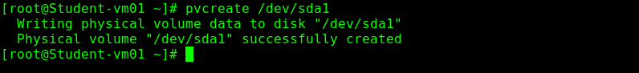
# vgextend vg_student /dev/sda1 # Add new partition to VG "vg_student".

# vgdisplay vg_studentvm01 # Displays free space ( 8G ). NOTE: Optional step.

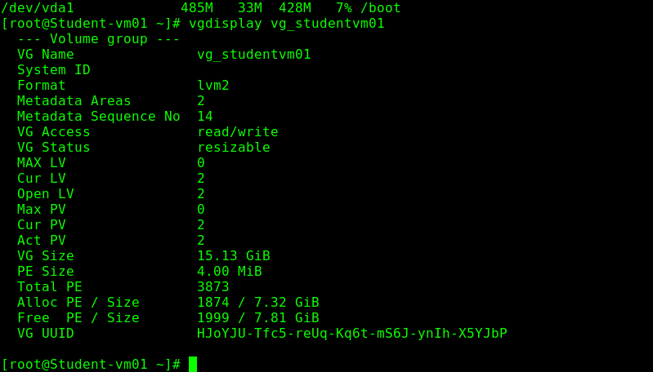
# lvextend -L +7.5G /dev/vg_student/lv_root # Extend lv_root by 7.5G (-L M,G. -l Extents).

# resize2fs -p /dev/vg_student/lv_root # Extend file system. -p shows progress.

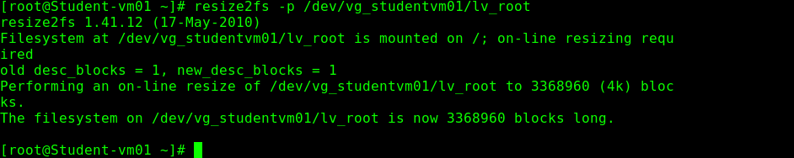
# df -h # To confirm additional space is available.
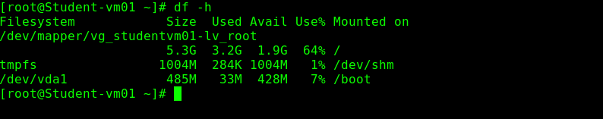

Before.

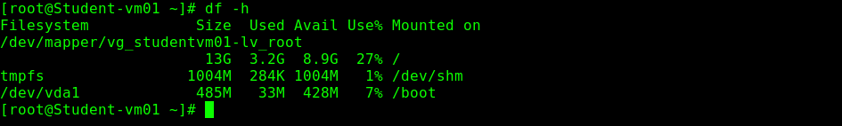

After.

13.4 Create a snapshot using the GUI.
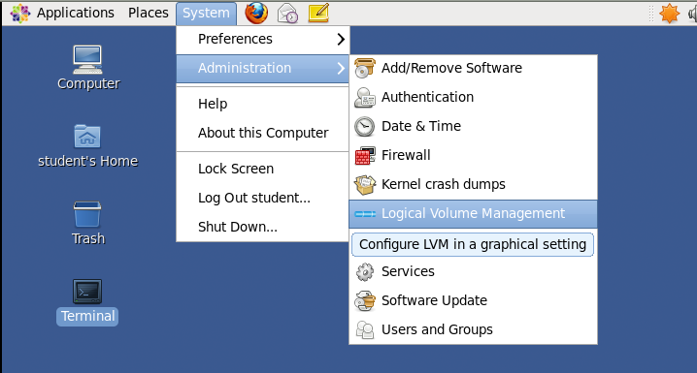

Open the Logical Volume Manager.

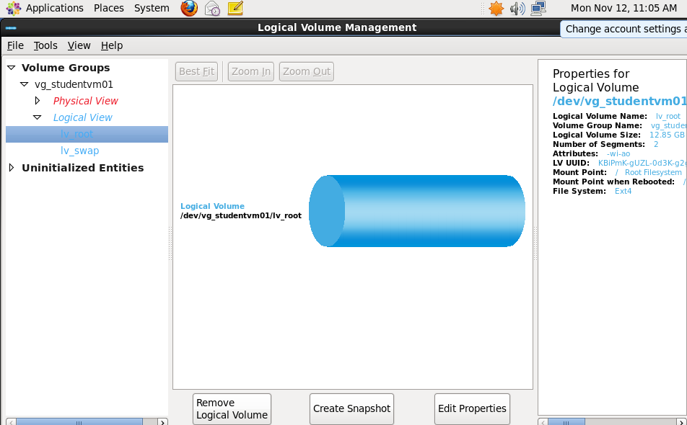

Select the Logical Volume to snapshot. Click on the “Create Snapshot” button.

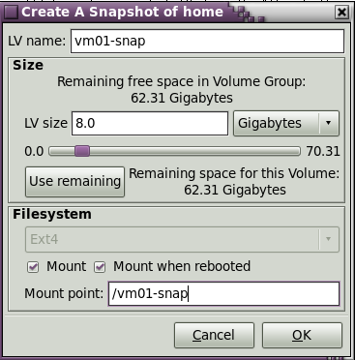

Enter the snapshot’s name in “LV name”. Enter snapshot size in “LV size”. Select mount point and persistence.
Click “OK”.

13.5 Create a snapshot using the CLI.
# mkdir /vm01-snap # Create a mount point.
# lvcreate -s -n root_snap -L 8G /dev/vg-virtual/vg_student/lv_root # Create snapshot and name it root_snap.
# mount -o ro /dev/vg-virtual/vg_student/lv_root /vm01-snap # Mount it read only at /vm01-snap.

13.6 Shrink a file system using the GUI..

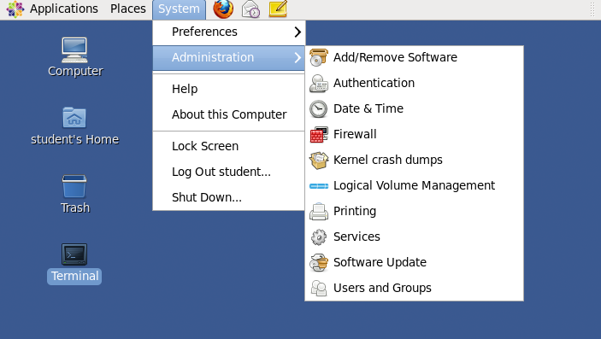

Open the Logical Volume Management tool.

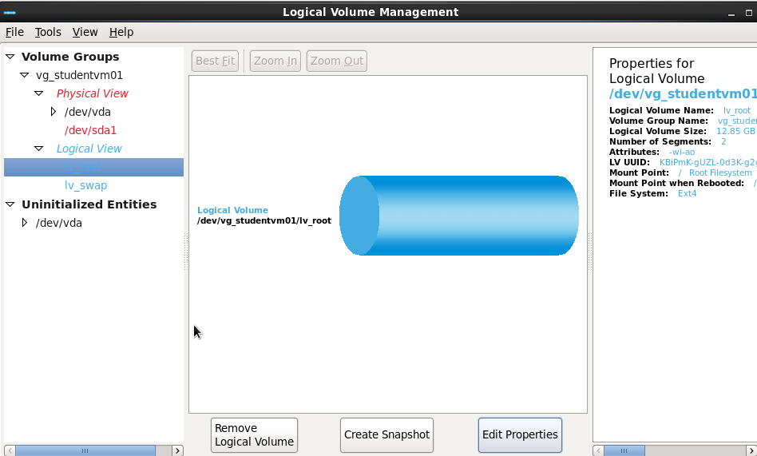

Select the Logical Volume to shrink. Click on the “Edit Properties” button.

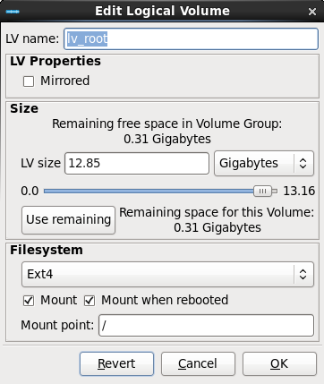

Use “Size” slider bar to adjust the new size. Click “OK”.

13.7 Shrink a file system using the CLI.

Note: If this is the home directory, you will have to reboot to single user mode.
You may not have to unmount the Logical Volume on the test, but be ready to do it anyway.

# umount /dev/vg_group/vol_home # Unmount file system
# e2fsck –f /dev/vg_group/vol1_home # Check the file systems integrity
# resize2fs /dev/vg_group/vol1_home 1500M # Reduce file size to 1.5Gb.
# lvresize –L 1.5G /dev/vg_group/vol1_home # Reduce Logical Volume to 1.5G.
# lvdisplay # Verify the resize.
# mount –a # Remount.

Note: You can use the command lvreduce with the –r switch, this runs the resize2fs and the lvreduce command
at the same time.

# lvreduce –r –L 1.5G /dev/vg_group/vol1_home

13.8 Create new volume group and logical volume using the GUI.

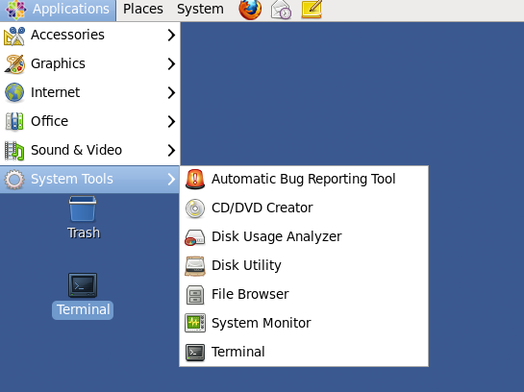

Open the “Disk Utility” and locate the new physical drive.

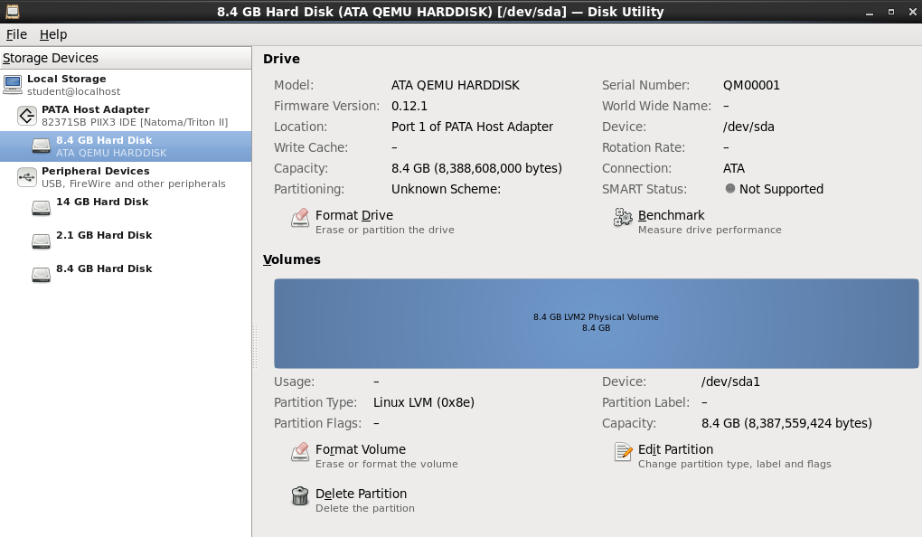

In this case the device is /dev/sda. Do not format volume here.

Open the Logical Volume Management utility.

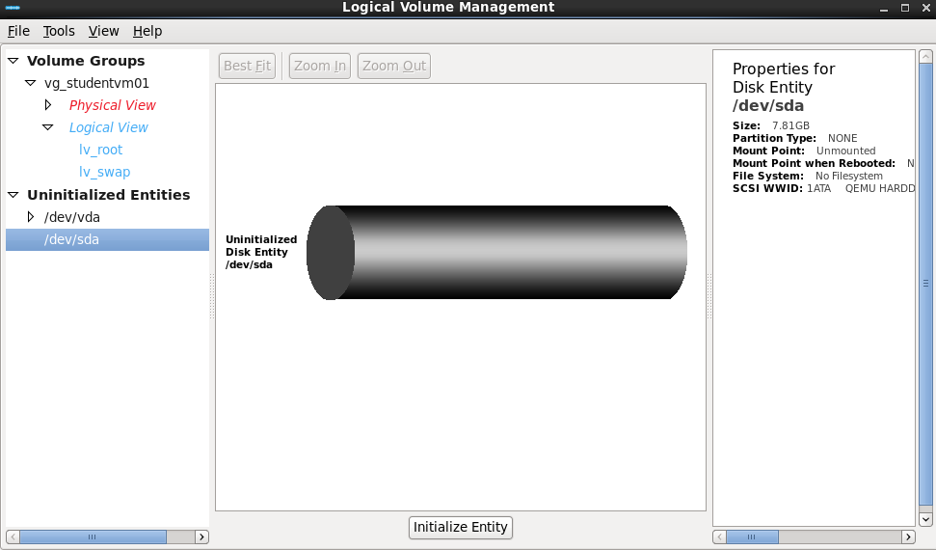

Locate the /dev/sda under “Uninitalized Entities. Click on the “Initialize Entity” button.

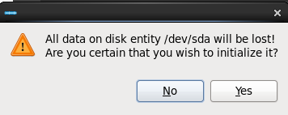

Click “Yes”.

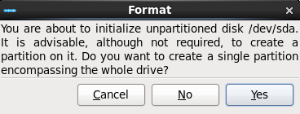

Click “Yes” again.

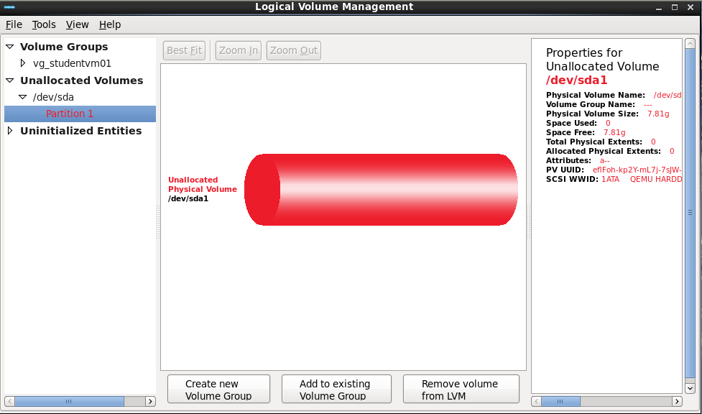

Select “Create new Volume Group”

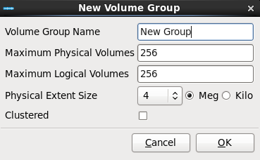

Enter the Volume Group Name, The other settings can remain except for the “Physical Extent Size”.
Note: This is where the size of the “Physical Extents” is set. The default size is 4 Meg.

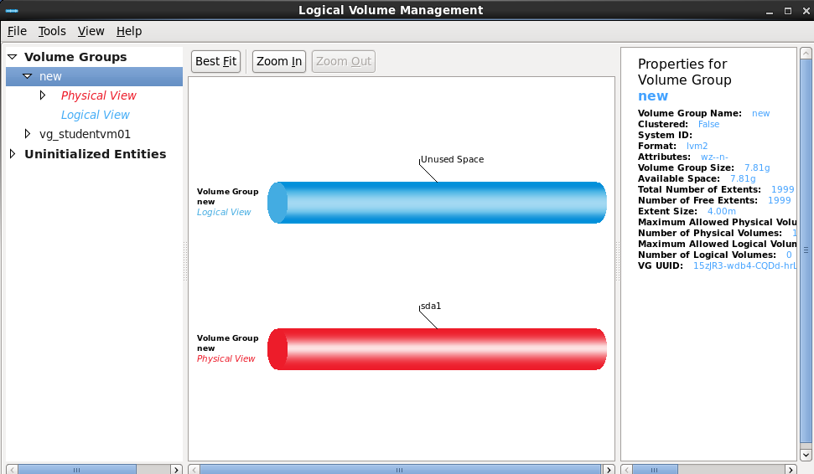

Note the new Volume Group named “new” on /dev/sda1.

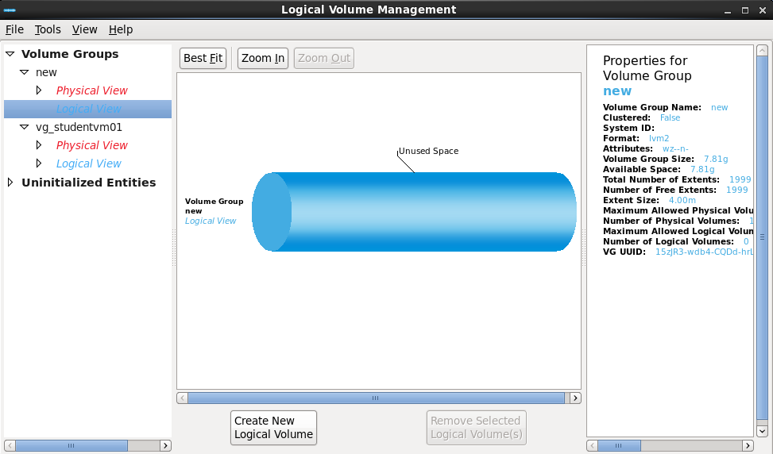

Select the “Logical View” on the Volume Group “new”. Click “Create New Logical Volume”.

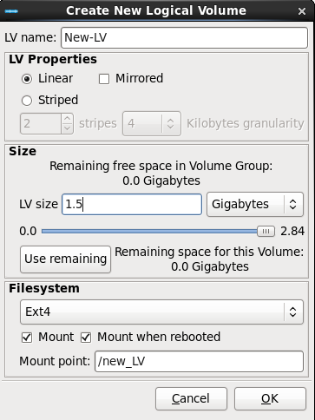

Name the new Logical Volume. Select Properties and Size. Select the file system type. Click “OK”.

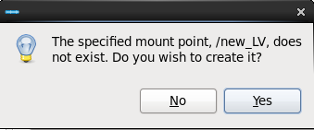

Click “Yes” to create the persistent mount point.
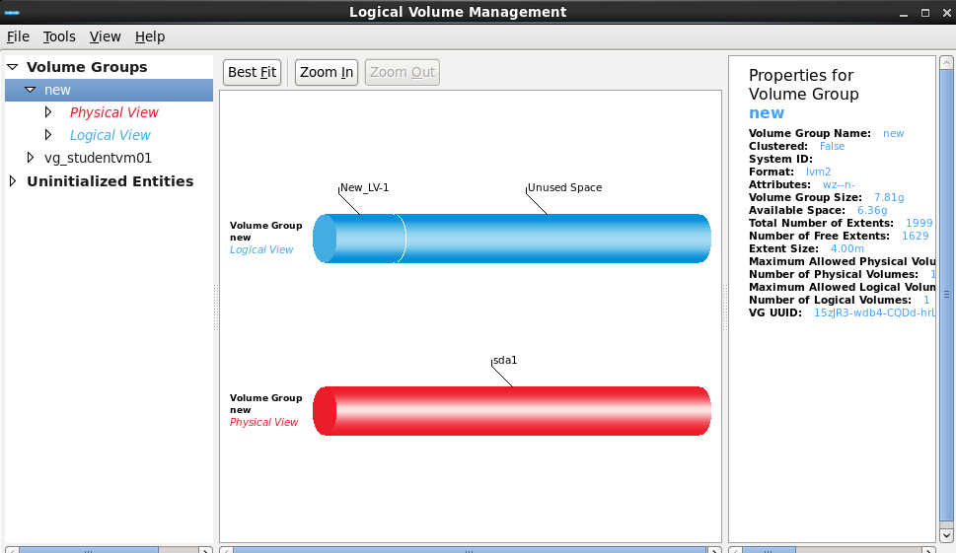

Now you can see the new Logical Volume “New_LV-1”.

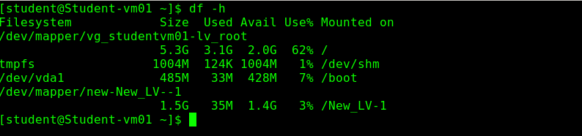

The command df –h shows the new Logical Volume is active and mounted at /New_LV-1.

13.9 Create new volume group and logical volume using the CLI.

# fdisk /dev/sda # Create a partition type 83 Linux.
# pvcreate /dev/sda1 # Initialize partition for LVM.

# vgcreate my_group /dev/sda1 # The groups name is “my_group”

# vgdisplay # Display the groups details.

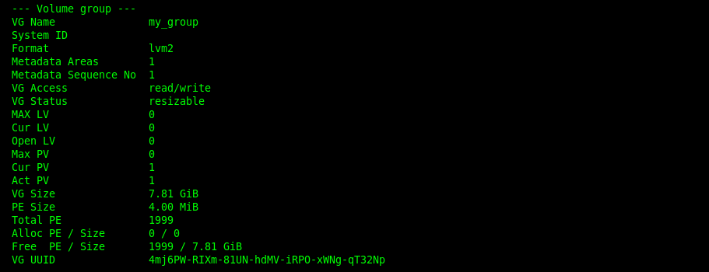

Note: Note the Alloc (Allocated) PE / Size (Physical Extents). In this case, there are none allocated.
And the Free PE / Size is the same as the total 1999.

Create a Logical Volume named “lvm01” using half the available extents in the group “my_group”.

# lvcreate -l1000 -n lvm01 my_group # Note: -L = M,G. -l Extents

# lvdisplay

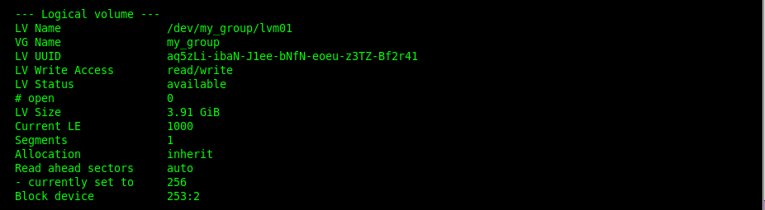

Create the file system.

# mkfs.ext3 /dev/my_group_lvm01

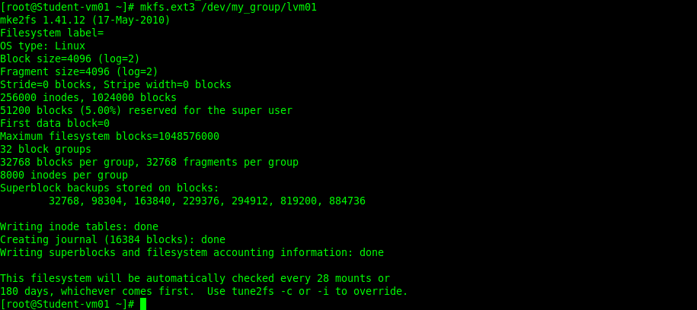

Create mount point and mount.

# mkdir /vm01-data
# mount /dev/my_group/lvm01 /vm01-data
# mount -a # To confirm it mounted.

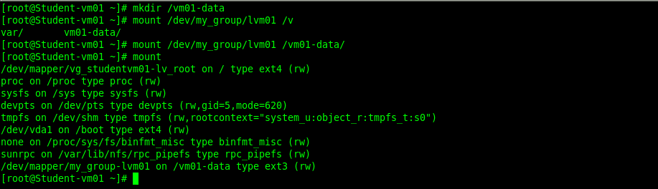

# vi /etc/fstab # Make it persistant.

/dev/my_group/lvm01 /vm01-data ext3 defaults 0 0

:wq

# umount /vm01-data
# mount -a # To confirm it mounted again.

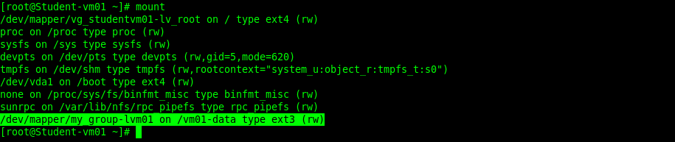

14. LDAP Authentication.

14.1 Configure LDAP auth.

Start the LDAP configuration in the GUI.

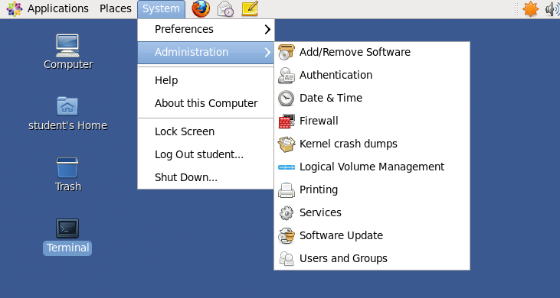

Or start the LDAP configuration utility from the command line.

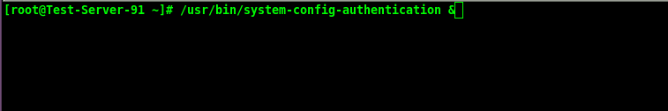

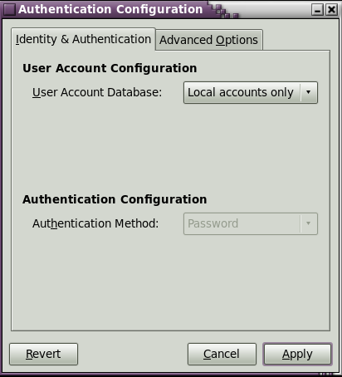

LDAP Search Base DN: dc=example,dc=com .
LDAP Server: ldap://instructor.example.com:389

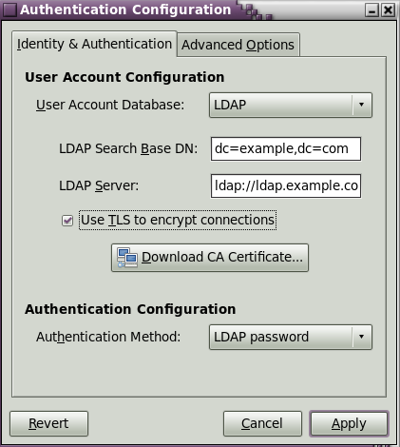

Note: The RHCE test will provide this information.

1. Select LDAP in the User Account Database drop-down menu.
2. Set the information that is required to connect to the LDAP server.

LDAP Search Base DN gives the root suffix or distinguished name (DN) for the user

directory. All of the user entries used for identity/authentication will exist below this parent
entry. For example, ou=users,dc=example,dc=com.
This field is optional. If it is not specified, then SSSD attempts to detect the search base using
the namingContexts and defaultNamingContext attributes in the LDAP server's
configuration entry.

LDAP Server gives the URL of the LDAP server. This usually requires both the hostname
and port number of the LDAP server, such as ldap://ldap.example.com:389.
Entering the secure protocol in the URL, ldaps://, enables the Download CA
Certificate button.

Use T LS to encrypt connections sets whether to use Start T LS to encrypt the
connections to the LDAP server. T his enables a secure connection over a standard port.
Selecting T LS enables the Download CA Certificate button, which retrieves the issuing
CA certificate for the LDAP server from whatever certificate authority issued it. T he CA
certificate must be in the privacy enhanced mail (PEM) format.

Or from the command line.

# authconfig --enableldap --enableldapauth --ldapserver=ldap.example.com --ldapbasedn="dc=example,dc=com" –update

14.2 Mount home directories.
14.3 Kerberos ticketing.
14.4 SELinux.
14.5 IPTables.

15. NTP Server.
15.1 Configure NTP service (Client). # RHEL6 ntpd is installed by default.
# vi /etc/ntp.conf # Edit /etc/ntp.conf

server new.server.com # Add new server address.
:wq # Save your changes.
# service ntpd restart # Restart service.

To test new time server, use command...

# ntpdate -du new.server.com # This will confirm new server is up and running.
15.2 Install and setup an NTP (server).

# yum install ntp
# service ntpd start
# chkconfig ntpd on

To test server, use command ..

# ntpq -pn
This will confirm the server can sync with outside# time sources.

15.3 IPTables.
# iptables -I INPUT -m state –state NEW -m udp -p udp --dport 123 -j ACCEPT

The NTP service has no selinux booleans.

16. SMTP (Mail).

16.1 Install and setup postfix for internet mail and allow to receive from the world.

# yum install postfix # Postfix is installed by default on RHEL-6.
# service postfix start # If it is not installed for the test then install it.
# chkconfig postfix on
# vi /etc/postfix/main.cf # Uncomment/edit the following lines.

myhostname=student-vm01.com # Hostname of mail server. This URL must
mydomain=student-vm01.com # resolve in both client and server.
myorigin=$mydomain
inet_interfaces=all # Uncomment this line.
# inet_interfaces=localhost # Comment this line out.
mydestination=$myhostname,localhost.$mydomain,localhost,$mydomain,

mynetworks=192.168.1.0/24,192.168.122.0/24,127.0.0.0/8 # Allowed networks.
home_mailbox=Maildir/ # Mail goes to /home/user/Maildir/new.
:wq

16.2 Configure an MTA to forward (relay) email through a smart host.

# vi /etc/postfix/main.cf

relayhost = outsider1.example.com # set “relayhost” to point to the smart host.

:wq

16.3 Setup all root mail to go to user admin.

# vi /etc/aliases

root admin # Uncomment/edit this line.
:wq

16.4 IPTables.

# iptables -I INPUT -m state –state NEW -m tcp -p tcp --dport 25 -j ACCEPT
# service iptables save
# service iptables restart

16.5 Configure host-based security.

The recommendation is to use IPTables for host based security.

# iptables –I INPUT –s 172.168.100.0/24 –j DROP # Disallow 172.168.100/24 network.

16.6 User-based security for SMTP.
# vi /etc/postfix/main.cf:

smtpd_sasl_auth_enable = yes
smtpd_sasl_security_options = noanonymous
broken_sasl_auth_clients = yes
smtpd_recipient_restrictions = permit_sasl_authenticated, permit_mynetworks, reject_unauth_destination

:wq

# service saslauthd start
# service saslauthd start
# chkconfig saslauthd on

17. Configure a VNC server.
17.1 Create a VNC server instance for user student.
# yum -y install vinagre tigervnc tigervnc-server
# chkconfig vncserver on # Make service persistent thru reboot.
# vi /etc/sysconfig/vncservers
VNCSERVERS="1:visitor 2:student" # Uncomment/edit the default configuration.
VNCSERVERARGS[1]="-geometry 800x600 " # Set the screen resolution for user #1.
VNCSERVERARGS[2]="-geometry 1024x768 " # Set the screen resolution for user #2.

:wq

Note: If multiple VNC users all use the same screen resolution then just one “VNCSERVERARGS” line is needed.

# su – visitor # Login as user #1.
$ vncpasswd # Set the vnc password for user #1.
$ vncserver # Creates initial config file in home directory.
$ exit
# su – student # Login as user #2.
$ vncpasswd # Set the vnc password for user #2.
$ vncserver # Creates initial config file in home directory.
$ exit

# service vncserver restart # Restart the service.
Note: You can use # netstat -an|grep 5902 on vncserver host, you should see that we are listening on this port.
To test, on remote host # vncviewer student:2
Root cannot configure a VNC password for another user with the vncpasswd command.
This is why you must su to each users account and run the vncpasswd command.

17.2 IPTables for server host.
# iptables -I INPUT -m state --state NEW -m tcp -p tcp --dport 5901 -j ACCEPT # Vncserver port user #1.
# iptables -I INPUT -m state --state NEW -m tcp -p tcp --dport 5902 -j ACCEPT # Vncserver port user #2.
# service iptables save
# service iptables restart

18. Basic bash scripting.
18.1 Create a script that echos “foo” when ran with bar command line option, echos “bar” when foo is the command line option.
Echos usage to standard error.

# vi test.sh

#!/bin/bash

case $1 in
bar)
echo -e "foo\n"
;;
foo)
echo -e "bar\n"
;;
*)
echo -e "Usage: $0 foo|bar\n" >&2
;;
esac
:wq

# chmod 775 test.sh
# ./test.sh # Test your work.

19. Cron.
19.1 Setup a scheduled job.
# crontab -e -u <user>

30 01 * * * /path/to/program-to-run # Add a line like this one.

:wq
19.2 Deny a user access to cron.
# vi /etc/cron.deny

username # Add user to deny.
:wq

20. GRUB.
20.1. Change countdown timer.
# vi /boot/grub/grub.conf
timeout=5 # Change to desired value in seconds.
:wq

20.2 Change default kernel to boot.
# vi /boot/grub/grub.conf
default=0 # Change to point to desired kernel stanza.
# Where 0 is stanza 1 and 1 is stanza 2.
:wq

20.3 Reinstall corrupted grub.
#df -h # Use df -h to display what device is mounted on # /boot.
# grub-install /dev/sda1 # /dev/sda1 is the /boot partition.

21. Yum.
21.1 Reinstall a missing mount (for example) command.

# mount -o remount,rw / # Goto maintenance mode; mount o remount,rw /
# yum whatprovides /bin/mount # Get package that contains binary.
# yum reinstall util-linux-ng # Install missing binary.
# mount –a

21.2 Create yum repository file.

# vi /etc/yum.repos.d/local.repo

[local]
name=Local Repo
baseurl=http://192.168.1.61/rhel-6.2
enable=1
gpgcheck=0
:wq

The actual baseurl will be provided at test time.

21.3 Create a local yum repository. Probably not on test.

Note: httpd should be already installed and working. You will need at least 4Gb disk space available.

# mkdir -p /var/www/html/rhel-6.2 # Create directory to stable packages.
# mount -t iso9660 /dev/sr0 /mnt # Mount Red Hat DVD.
# cp -ar /mnt/* /var/www/html/rhel-6.2 # Copy DVD packages to web directory.

Make sure you have the /etc/yum.repos.d/local.repo file setup with the new repository address. See section 21.2.

# yum clean all
# yum list

22. Remote Logging.

22.1 Configure rsyslog to send all info priority and higher events to a different server using TCP (Client).
# vi /etc/syslog.conf # Add the following line just after #*.kern.
*.info @@192.168.1.91:514 # Send info priority and higher # events to the log server.
:wq
# service rsyslog restart # Restart the logging deamon.
22.2 Configure rsyslog to receive logs from remote host. (Server).
# vi /etc/rsyslog.conf # Un comment the 2 following lines,
$ModLoad imtcp.so # Load module imtcp.so.
$InputTCPServerRun 514 # Enable server to receive via tcp port 514.
:wq
# service rsyslog restart # Restart the logging deamon.
22.3 IPTables. (server).
# iptables -I INPUT -m state --state NEW -m tcp -p tcp --dport 514 -j ACCEPT
# service iptables save
# service iptables restart

23. Encrypting file systems (LUKS).
23.1 cryptsetup command
# lsmod | grep dm_crypt # Check loaded kernel modules.
# modprobe dm_crypt # If you don’t see dm_crypt and dm_mod modules, # use modprobe to load them. Installed by default.
# yum -y install cryptsetup-luks # Install the cryptsetup-luks package.
# fdisk -cu /dev/sda # Create partition using fdisk.
# cryptsetup luksFormat /dev/sda1 # Setup create luks based file system.
# cryptsetup luksOpen /dev/sda1 test # Open the file system and name it "test". # Look for test in /dev/mapper/
# mkfs -t ext4 /dev/mapper/test # Format petition ext4.
# mkdir /test # Create mount point.
# mount /dev/mapper/test /test # Mount the partition. if no errors then unmount.
# umount /test # Unmount it.
# vi /etc/fstab # Make it persistent.

/dev/mapper/test /test ext4 defaults 1 2

:wq
# mount -a # Test your /etc/fstab and remount.
23.2 Automatically enter encryption password on boot. By adding entries to /etc/crypttab
# vi /etc/cryptab

test /dev/sdb1 /root/password # The format is: file-system-name # /dev/name/path/to/password
:wq
23.3 Creating password-key file and adding the key-file to luks.
# vi /root/password # Create the password file in the /root directory.

<password> # Password is in plain text here.
:wq
# chmod 600 /root/password # Restrict access to password file.
# cryptsetup luksAddKey /dev/sdb1 /root/password # Add key file to luks on /dev/sdb1.
# reboot # Reboot to test. The encrypted file system will be
# mounted without being prompted
# for the password on boot up.

24. Setup sshd.
24.1 Set sshd to come up on reboot.
# service sshd start # sshd should be running already.
# chkconfig sshd on # The ssh package is installed by default.
24.2 Allow root ssh login.
# vi /etc/ssh/sshd_config

PermitRootLogin yes # Allow root user to log in remotely.
:wq # Save your changes.
24.3 Configure host-based security.
# vi /etc/hosts.allow # Setup TCPWrappers.
sshd: 192.168.4. # Allow network 192.168.4.0 ssh access.
:wq # Save your changes.

# vi /etc/hosts.deny

sshd: ALL # Deny all SSH not explicitly allowed in hosts.allow

:wq

24.4 User-based security for the service.

# vi /etc/ssh/sshd_config

AllowUsers student jim fred # One method is add the user names.
AllowUsers student@192.168.111.78 # An alternative is to include a source address.

:wq

Note: Other directives that can be used are AllowGroups, DenyUsers, DenyGroups.

24.5 IPTables. Allow ssh connections from 192.168.0.0 thru IPTables.

# iptables -I INPUT -m state --state NEW -s 192.168.0.0/24 -p tcp --dport 22 -j ACCEPT
# service iptables save
# service iptables restart

24.6 Configure key-based authentication.

# ssh-keygen # Generate key.

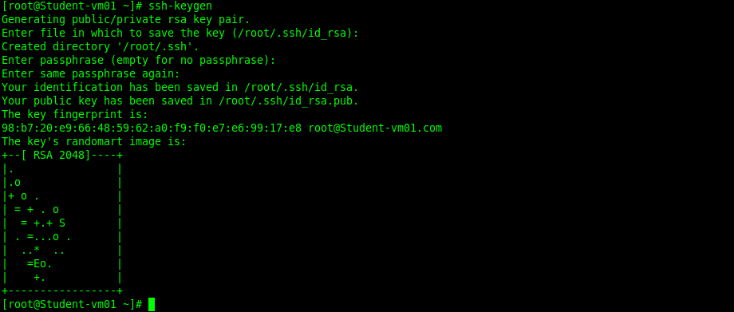

Use ssh-copy-id to copy the public key to a remote system.

# ssh-copy-id –i /root/.ssh/id_rsa.pub root@desktopx

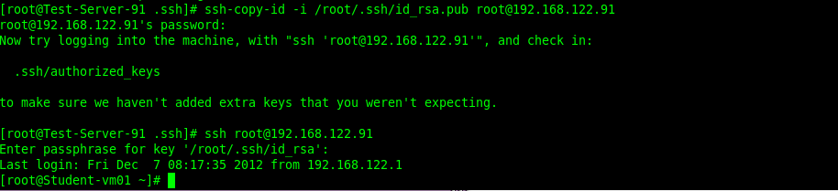

To test, Login as root. No password here only passphrase. #ssh root@192.168.122.91. Enter passphrase.

24.7 Configure additional options described in documentation.

25. System configuration and management.

25.1 Route IP traffic and create static routes.
# route add -net 192.168.3.0 netmask 255.255.255.0 gw 192.168.1.254 # Setup Gateway for network 192.168.3.0.
# route add -host 192.168.3.3 netmask 255.255.255.0 dev eth0 # Add a host.

# vi /etc/sysconfig/network-scripts/route-eth0 # Make it persistent on reboot.

192.168.3.0/255.255.255.0 via 192.168.1.254
192.168.3.3 dev eth0
:wq

# vi /etc/sysconfig/network-scripts/route-eth0.

192.168.3.0/255.255.255.0 via 192.168.1.254
192.168.3.3 dev tun0

:wq

NOTE: The address above are arbitrary. The test will use its own set of address's.

25.2 Use /proc/sys and sysctl to modify and set kernel runtime parameters.

One of the great things about Linux is that you can modify the kernel parameters while the system is running. The kernel has its own virtual file system in /proc/sys. You can do changes in here for testing purposes, as the changes will not be persistent after a reboot.

Here is an example of how to change one of these parameters:

# cat /proc/sys/net/ipv4/ip_forward
0
# echo 1 > /proc/sys/net/ipv4/ip_forward
# cat /proc/sys/net/ipv4/ip_forward
1

We can also use the command sysctl to check and temporarily change the parameters:

# sysctl -a
...
(this will show all parameters...)

To check one:

# sysctl -a | grep ip_forward
net.ipv4.ip_forward = 0

To modify it (until next boot):

# sysctl -w net.ipv4.ip_forward=1
net.ipv4.ip_forward = 1
# sysctl -a | grep ip_forward
net.ipv4.ip_forward = 1

In order to make these parameters persistent we need to use edit the file /etc/sysctl.conf, that will be read at boot time. We can use the -p option that will read /etc/sysctl.conf by default or another file if it's specified as a parameter.

# sysctl -p
net.ipv4.ip_forward = 0
net.ipv4.conf.default.rp_filter = 1
net.ipv4.conf.default.accept_source_route = 0
kernel.sysrq = 0
kernel.core_uses_pid = 1
fs.file-max = 49846

We can eventually make changes permanent in the following manner:

# sysctl -w fs.file-max=50000 >> /etc/sysctl.conf

After reboot we can see that the change is still permanent:

# sysctl -a | grep file-max
fs.file-max = 50000

25.3 Produce and deliver reports on system utilization (processor, memory, disk, and network).

Know how to produce reports using sar, memstat, iostat ect.

# yum install sysstat # Install sar and iostat

Sar usage.

Processor.

Basic processor report: sar or sar -u
Basic report every second for the next 10 seconds: sar 1 10
Load average: sar -q
Per processor statistics: sar -P ALL
Power management (not enabled by default): sar –m

Memory.

Kernel paging: sar -B
Unused memory: sar -r
Swap space: sar –S

Disk.

Disk IO stats (avg): sar -b
Disk IO stats: sar -d (-p to use pretty names)

Network.

Network statistics: sar -n DEV
Network errors: sar -n EDEV

Everything.

All reports simultaneously: sar –A

Iostat usage.

Iostat command reports CPU and I/O statistics. iostat command is used during performance analysis to narrow down the problematic areas in the system.

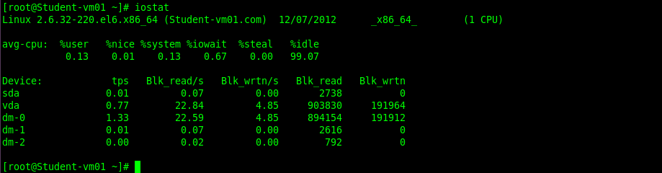

The first line displays general information — Linux kernel version, hostname etc.,

Next two lines displays CPU statistics, in which the first 3 column displays average CPU usage. The 4th column displays the percentage of time the CPU were idle and waited for I/O response. 5th column displays percentage of waiting time of virtual CPU. 6th column displays the percentage of time the CPU is idle.

Remaining line displays the device utilization report. First line in that is headers, such as number of Transfer per second, number of blocks read per second, blocks write per second, total block reads, total block writes.

Execute iostat every 10 seconds for 5 times.

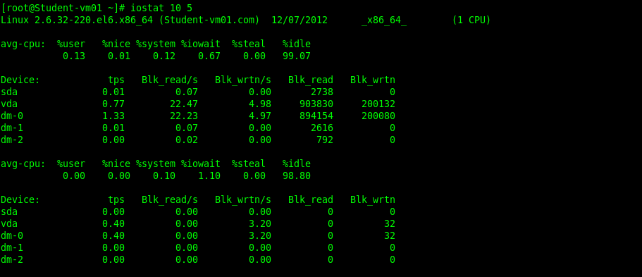

Iostat option -d, displays only the disk I/O statistics.

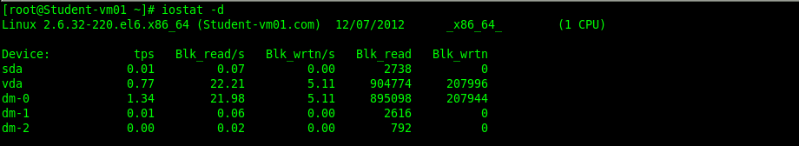

Iostat option -n, displays only the device and NFS statistics as shown below.

Iostat – Display I/O data in MB/second.

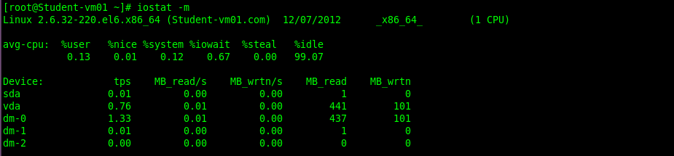

iostat – Display I/O statistics only for a device.

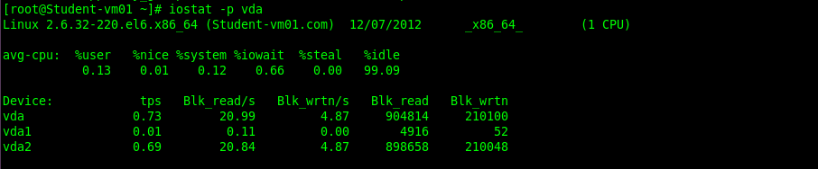

To execute every 2 seconds for a total of 3 times, do the following.

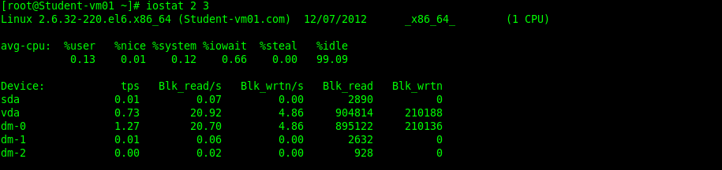

25.4 Configure a system to authenticate using Kerberos.

26. Build a simple RPM that packages a single file.

# yum install rpmbuild rpmdevtools # Install needed packages.
# mkdir /home/student/test_rpm # Create folder to work from.
# cd /home/student/test_rpm
# touch testfile # Create the file to include in the rpm.
# cd /home/student
# tar czvf test_rpm.tgz test_rpm # Create tarball.
# rpmdev-setuptree # create the directory structure needed to
# build the RPM file.
# mv /home/student/test_rpm.tgz /home/student/rpmbuild/SOURCES # Move tar ball
# cd ~/rpmbuild/SPECS
# rpmdev-newspec # This command creates a file
# named “newpackage.spec”.
# vi /home/student/rpmbuild/SPECS/newpackage.spec

Name: test_rpm
Version: 1.0
Release: 1
Summary: test_rpm
License: Free
URL: None
Source: test_rpm.tgz
BuildRoot: /home/student/rpmbuild/BUILDROOT/%{name}-%{version}
%description
Test rpm
%prep
%setup -n test_rpm
%install
rm -rf "$RPM_BUILD_ROOT"
mkdir -p "$RPM_BUILD_ROOT/opt/test_rpm"
cp -R * "$RPM_BUILD_ROOT/opt/test_rpm"
%files
/opt/test_rpm
%clean
rm -rf $RPM_BUILD_ROOT
:wq

# cd /home/student/rpmbuild/SPECS
# rpmbuild -ba -vv newpackage.spec # If done correctly you see the file # /home/student/rpmbuild/RPMS/x86_64/
# test_rpm-1.0-1.x86_64.rpm

# rpm -ivh test_rpm-1.0-1.x86_64.rpm # To test run this command.

Appendix A.

RHCE Objectives.

System configuration and management

- Route IP traffic and create static routes.
- Use iptables to implement packet filtering and configure network address translation (NAT).
- Use /proc/sys and sysctl to modify and set kernel runtime parameters.
- Configure a system to authenticate using Kerberos.
- Build a simple RPM that packages a single file.
- Configure a system as an iSCSI initiator that persistently mounts an iSCSI target.
- Produce and deliver reports on system utilization (processor, memory, disk, and network).
- Use shell scripting to automate system maintenance tasks.
- Configure a system to log to a remote system.
- Configure a system to accept logging from a remote system.

Network Services.

Network services are an important subset of the exam objectives. RHCE candidates should be capable of meeting the following objectives for each of the network services listed below:

- Install the packages needed to provide the service.
- Configure SELinux to support the service.
- Configure the service to start when the system is booted.
- Configure the service for basic operation.
- Configure host-based and user-based security for the service.

HTTP/HTTPS

- Configure a virtual host.
- Configure private directories.
- Deploy a basic CGI application.
- Configure group-managed content.

DNS

- Configure a caching-only name server.
- Configure a caching-only name server to forward DNS queries.
- Note: Candidates are not expected to configure master or slave name servers.

FTP

- Configure anonymous-only download.

NFS
- Provide network shares to specific clients.
- Provide network shares suitable for group collaboration.

SMB

- Provide network shares to specific clients.
- Provide network shares suitable for group collaboration.

SMTP

- Configure a mail transfer agent (MTA) to accept inbound email from other systems.
- Configure an MTA to forward (relay) email through a smart host.

SSH

- Configure key-based authentication.
- Configure additional options described in documentation.

NTP

- Synchronize time using other NTP peers.

Appendix B.

Packages used during RHCE test.

1. policycoreutils-python semanage command.
2. setroubleshoot sealert command.
3. web server apache web server group.
4. elinks apache server testing.
5. bind name server.
6. vsftpd ftp server.
7. samba cifs server.
8. nfs file server nfs file server.
9. iscsi-initiator-utile iscsi client.
10. ntp network time service.
11. postfix mail server deamon. installed by default.
12. tigervnc-server VNC.
13. crtyptsetup-luks LUKS.
14. rpmbuild rpmdevtools Rpm creation.

Packages used in appendix’s.

1. openldap-servers, openldap-clients LDAP server and client.
2. nmap, wirshark LDAP troubleshooting.
3. pam_ldap LDAP configuration.

Appendix C.

Reference: http://spectlog.com/content/Minimal_LDAP_configuration_on_RHEL6_in_stages_and_details

C1. Install and configure an LDAP server.

C1.0 Install the service.

# yum install openldap-servers openldap-clients nss-pam-ldapd -y # Install packages.

# yum install openldap{,-clients,-devel,-servers} nss_ldap pam_ldap nss-pam-ldapd -y

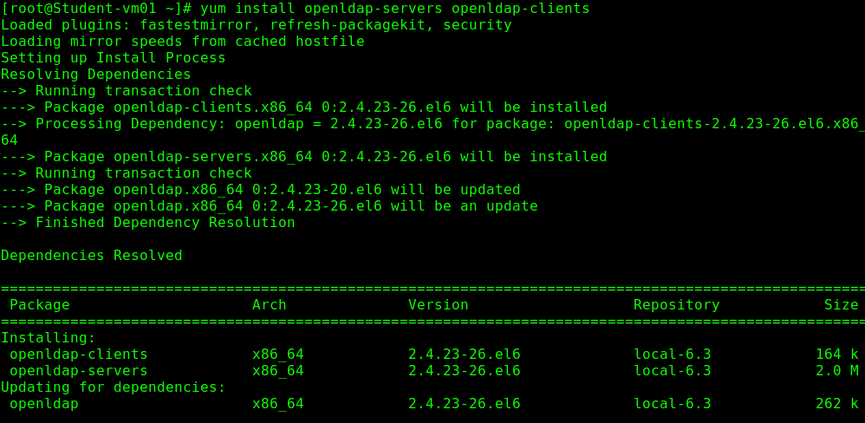
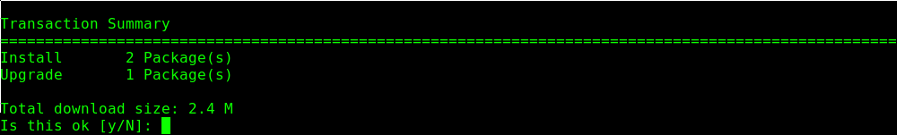
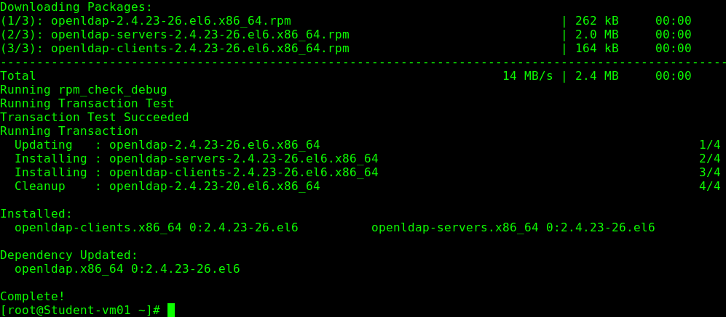

# service slapd start # Make sure service starts.
# chkconfig slapd on # Make it persistent on reboot.
# service slapd stop # Stop the service while we create our configuration.

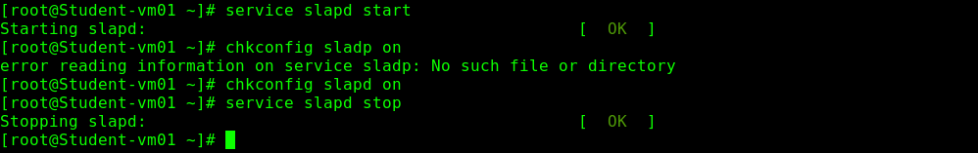

# cp -rf /usr/share/openldap-servers/slapd.conf.obsolete /etc/openldap/slapd.conf

# slappasswd # Generate root password for LDAP cn=config configuration.

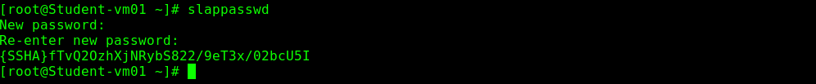

Note: Copy the {SSHA} output, it will be pasted in the slapd.conf file.

# vi /etc/openldap/slapd.conf

#######################################################################

# database definitions

#######################################################################

database bdb
suffix "dc=example,dc=com" # Change: “dc=my-domain,dc=com”.
checkpoint 1024 15
rootdn "cn=admin,dc=example,dc=com" # Change “dc=Manager,dc=my-
# domain,dc=com”.
rootpw {SSHA}R6zJBEcX1ltYDwbWkqYZ8GrrUFQZbKyN # Add this line.
:wq

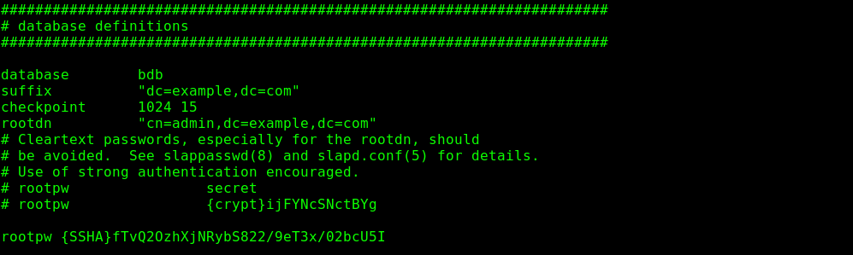

C1.2 Prepare initial content files for LDAP server.
This section provides content of initial LDAP database in LDIF format.

# vi /tmp/example.com.ldif # Create this file with the following content:

# Root entry
dn: dc=example,dc=com
objectclass: dcObject
objectclass: organization
o: Example Company
dc: example
:wq
# vi /tmp/admin.example.com.ldif # Create this file with the following content:
# Admin DN
dn: cn=admin,dc=example,dc=com
objectclass: organizationalRole
cn: admin
:wq
# vi tmp/users.example.com.ldif # Create this file with the following content:
# Base DN for users
dn: ou=users,dc=example,dc=com
changetype: add
objectclass: top
objectclass: organizationalUnit
ou: users
:wq
# vi /tmp/groups.example.com.ldif # Create this file with the following content:
# Base DN for groups
dn: ou=groups,dc=example,dc=com
changetype: add
objectclass: top
objectclass: organizationalUnit
ou: groups
:wq

C1.3 Clean up previous LDAP content and configuration and reinitialize them.

NOTE: This section can be used repeatedly to re-set configuration, re-initialize LDAP content and start over again.

# service slapd stop # Make sure service is not running
# rm -rf /etc/openldap/slapd.d/* # Clean up configuration
# rm -rf /var/lib/ldap/* # Clean up content.
# cp /usr/share/openldap-servers/DB_CONFIG.example /var/lib/ldap/DB_CONFIG

# echo "" | slapadd -f /etc/openldap/slapd.conf # Initialize DB files for content in /var/lib/ldap directory.

Note: This is required, otherwise you will get this error: bdb_db_open: database "dc=example,dc=com": db_open(/var/lib/ldap/id2entry.bdb) failed: No such file or directory (2).

# slaptest -f /etc/openldap/slapd.conf -F /etc/openldap/slapd.d # Convert obsolete configuration file into dynamic # configuration under /etc/openldap/slapd.d # directory.

Note: slaptest converts the obsolete config file slapd.conf into the new format. The new configuration now resides
in /etc/openldap/slapd.d/ .

# slapadd -l /tmp/example.com.ldif # Initialize LDAP DB with initial content:

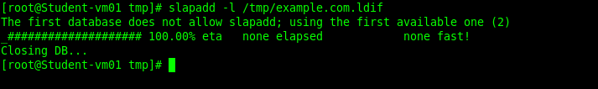

# slapadd -l /tmp/admin.example.com.ldif
# slapadd -l /tmp/users.example.com.ldif
# slapadd -l /tmp/groups.example.com.ldif
# chown -R ldap:ldap /var/lib/ldap # Set permissions:
# chown -R ldap:ldap /etc/openldap/slapd.d

C1.4 Test initial configuration.
# service slapd restart # Start server:
# ldapsearch -x -b 'dc=example,dc=com' # List the content by request from client:

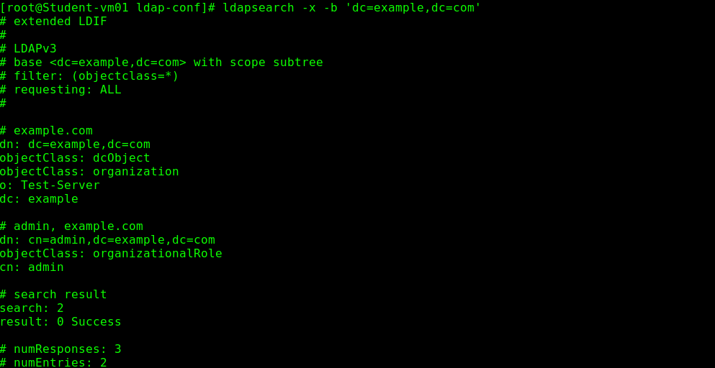

# ldapadd -x -D 'cn=admin,dc=example,dc=com' -W -f users.example.com.ldif # Load the the rest of LDAP database

# ldapadd -x -D 'cn=admin,dc=example,dc=com' -W -f groups.example.com.ldif
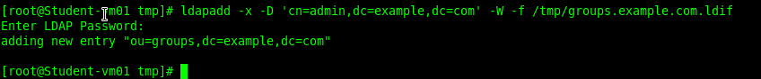

# ldapsearch -x -b 'dc=example,dc=com'
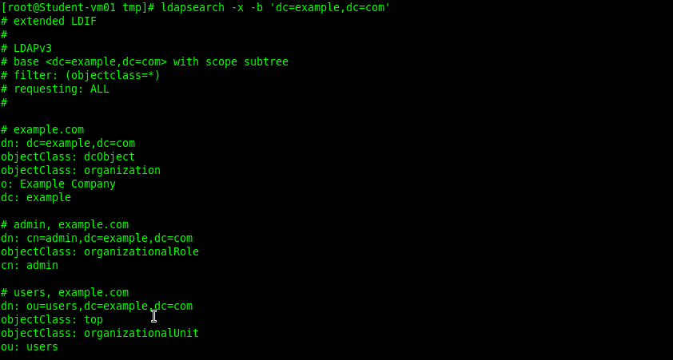
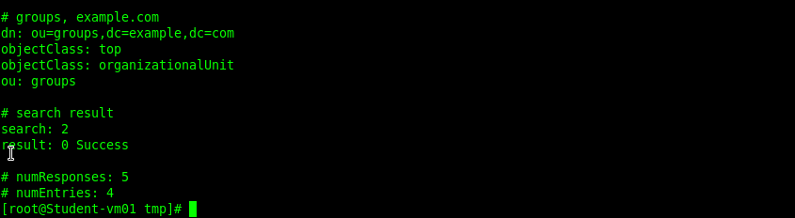

C1.5 Prepare LDIF files and add single test user and group to LDAP.

In regular /etc/passwd and /etc/group files create test user and group for migration.
While it is possible to use existing users and groups from /etc/passwd and /etc/group, it is better to create a special user. RHEL and Fedora have range of UID and GID for automatic selection which is configured in /etc/login.defs file by UID_MIN/UID_MAX and GID_MIN/GID_MAX variables. Choosing UID and GID above the ranges makes it safer to assume that they are not used.

Create user "fred" specifying UID and GID explicitly:
# groupadd --gid 100000 fred
# useradd --uid 100000 --gid 100000 fred
# passwd fred

C1.6 Prepare tools for migration of user and group data to LDAP.
Install tools to migrate user data to LDAP.

# yum install migrationtools –y

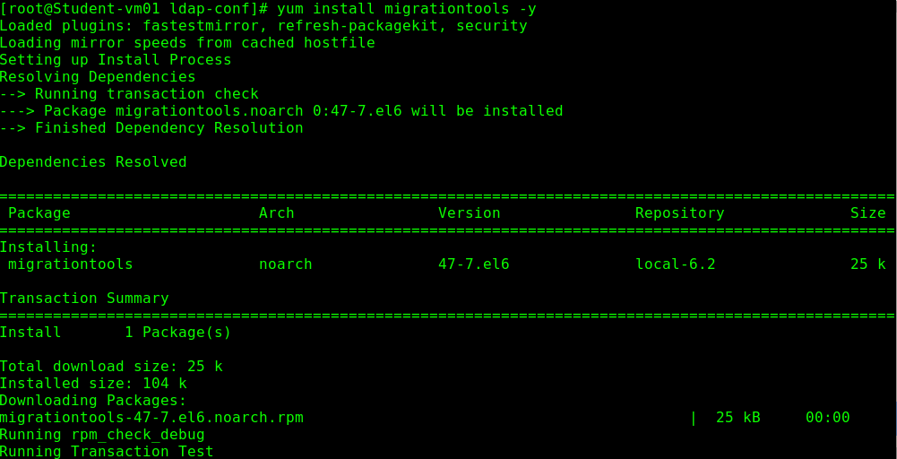
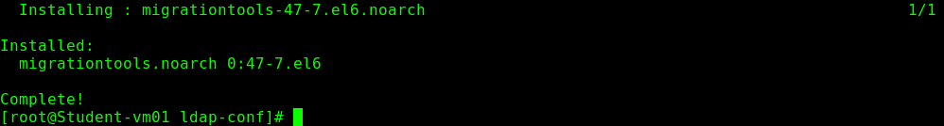

Set defaults used by migration tools in /usr/share/migrationtools/migrate_common.ph file:

# vi /usr/share/migrationtools/migrate_common.ph

$NAMINGCONTEXT{'passwd'} = "ou=users"; # Line 58.
$NAMINGCONTEXT{'group'} = "ou=groups"; # Line 61.

# Default DNS domain
$DEFAULT_MAIL_DOMAIN = "example.com"; # Line 71.
# Default base
$DEFAULT_BASE = "dc=example,dc=com"; # Line 74.

:wq

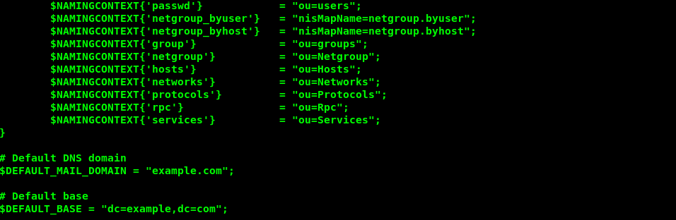

C1.7 Migrate single test user and group from /etc/passwd and /etc/group files into corresponding LDIF format.
Extract single configuration lines from /etc/passwd and /etc/group files for "qwer" user and group.

( Server Side )

# grep fred /etc/passwd > fred.passwd.line
# grep fred /etc/group > fred.group.line

Convert user line into LDIF format.

# /usr/share/migrationtools/migrate_passwd.pl fred.passwd.line fred.passwd.ldif

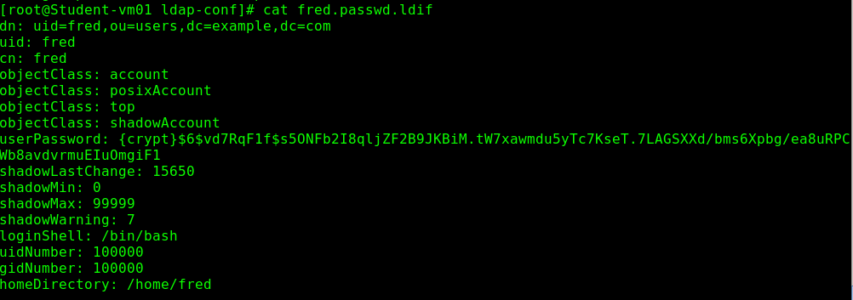

# /usr/share/migrationtools/migrate_group.pl fred.group.line fred.group.ldif

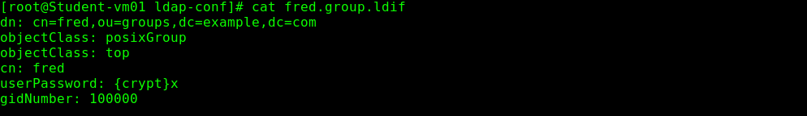

Import it to LDAP database.

# ldapadd -x -D "cn=admin,dc=example,dc=com" -W -f fred.passwd.ldif
# ldapadd -x -D "cn=admin,dc=example,dc=com" -W -f fred.group.ldif
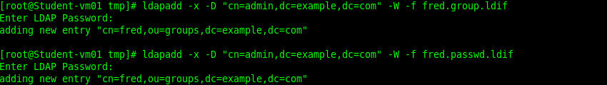

Check the output.

# ldapsearch -x -b 'dc=example,dc=com'

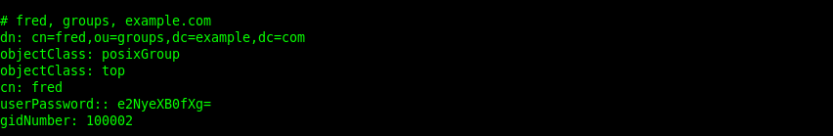

Delete the user leaving its home directory to avoid two sources.

# userdel fred # This will remove the user and the users group.

C1.8 Configure authentication through LDAP without encrypted connection.

( Server Side ).

# ssh root@tester1.example.com # Login to test client machine.

( Client Side ).

# id fred

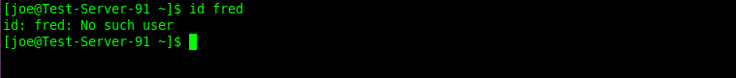

Note: User does not exist yet on this client.

# grep fred /etc/passwd /etc/group

Note: Verify the user “fred” does not exist locally.

Configure LDAP client through /etc/openldap/ldap.conf file (see appropriate section).
Set this flag FORCELEGACY in /etc/sysconfig/authconfig file to use nslcd server which
does not force to use encrypted connection:

# vi /etc/sysconfig/authconfig

FORCELEGACY=yes
:wq

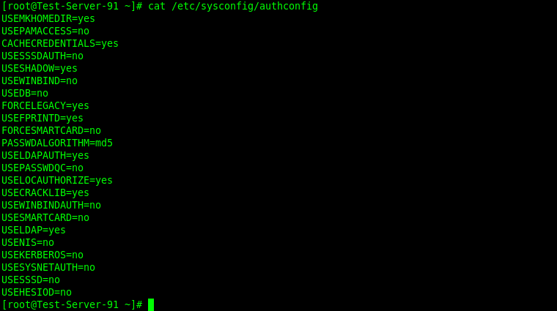

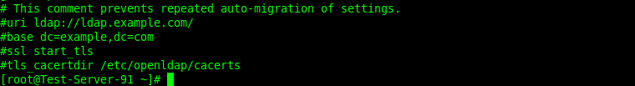

Note: Note contents of /etc/nslcd.conf before using the authconfig command.

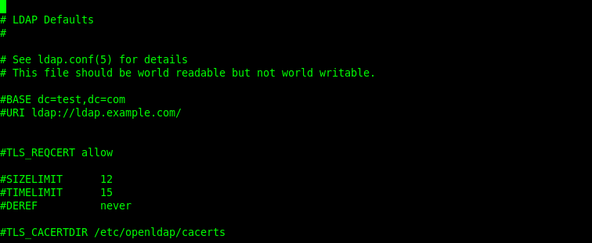

Note: Note contents of /etc/openldap/ldap.conf.

Configure from the command line.

# authconfig --enableldap --enableldapauth --ldapserver=ldap.example.com --ldapbasedn="dc=example,dc=com" --update

Configure from the GUI.

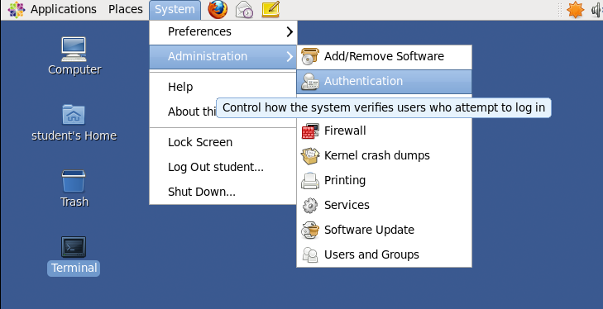

Open the Authentication GUI tools. System > Administration > Authentication.

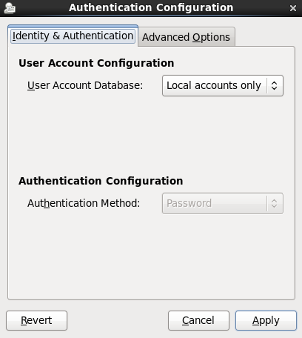

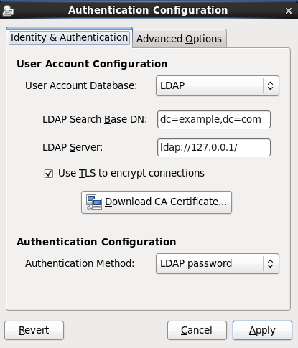

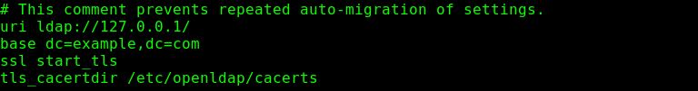

/etc/nslcd.conf

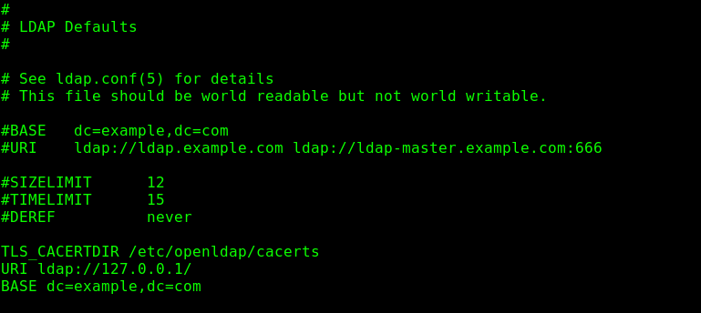

/etc/openldap/ldap.conf

Permissions set on /etc/openldap/ldap.conf should be world readable but not world writable.

Note: Note the contents of /etc/nslcd.conf and the settings in the Authentication tool above
See the same settings in /etc/openldap/ldap.conf. The GUI tool forces the use of TLS although
the command line still allows no TLS. If you specify a secure LDAP server address, ldaps:// in the GUI
tool, you don’t have to use a TLS certificate.

# service nslcd restart

Note: If the command # id fred does not yield results after the autconfig command is used, check /etc/nslcd.conf
Make sure the following 2 lines are commented out, ssl start_tls and tls_cacertdir /etc/openldap/cacerts

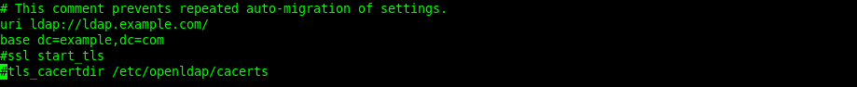

# getent passwd fred # Verify LDAP server is up by retrieving password data for “fred”.

Create home directory for the user on the test client machine. Assuming network mounted home directories are not already configured.

( Client Side ).

# mkdir /home/fred
# chown -R fred:fred /home/fred

Generate password hash (LDAP supports different hashes, use the one provided by its own utility).

( Server Side ).

# slappasswd

Create request (LDIF) in fred.passwd.change.ldif file which modifies the userPassword attribute of user entry:

# vi /tmp/ fred.passwd.change.ldif

dn: uid=fred,ou=users,dc=example,dc=com
changetype: modify
replace: userPassword
userPassword: {SSHA}R6zJBEcX1ltYDwbWkqYZ8GrrUFQZbKyN
:wq

Run the request.

# ldapmodify -D 'cn=admin,dc=example,dc=com' -W -f fred.passwd.change.ldif

Note: If you receive an error like this after running the above command…

ldap_sasl_bind(SIMPLE): Can't contact LDAP server (-1)

Make sure you have the proper entry in /etc/hosts.

192.168.1.61 ldap.example.com ldap.example

( Client Side ).

# vi /etc/nslcd.conf

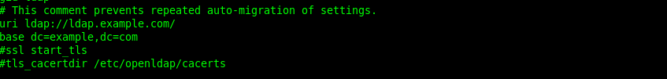

Comment out the last 2 lines, ssl start_tls and tls_cacertdir.

# vi /etc/pam_ldap.conf

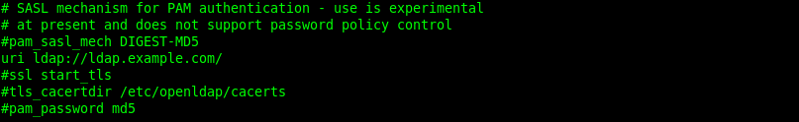

Comment out the last 3 lines, ssl start_tls, tls_cacertdir /etc/openldap.cacerts and pam_password md5.

Note: Don’t forget to consult /var/log/secure on the client if you can’t login in the next step.

Test login in and confirm “fred’s” password has been changed.

# ssh fred@test-server-91.com

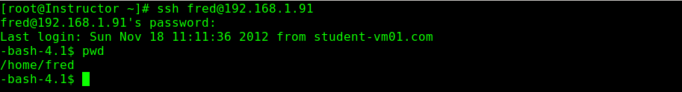

Successful login.

C1.9 Enable encrypted connection

This time LDAP cn=config configuration database is modified dynamically using LDAP
utilities (instead of converting slapd.conf file).

Allow read/write access to dynamic cn=config configuration.

( Server Side ).

# service slapd stop

Enable IPC interface to the server by setting flag SLAPD_LDAPI in /etc/sysconfig/ldap file:

# vi /etc/sysconfig/ldap

SLAPD_LDAPI=yes

# vi /etc/openldap/slapd.d/cn\=config/olcDatabase\=\{0\}config.ldif

olcAccess: {0}to * by dn.exact=gidNumber=0+uidNumber=0,cn=peercred,cn=external,cn=auth manage by * break
:wq

Note: Comment out all lines with attribute olcAccess in /etc/openldap/slapd.d/cn\=config/olcDatabase\=\{0\}config.ldif
and add the the line shown above.

# slaptest -u # Test configuration.
# service slapd start # Start the server.

C1.10 Configure LDAP to use encrypted connection.

# service slapd status # Make sure the LDAP service is running.
# ldapsearch -LLL -Y EXTERNAL -H ldapi:/// -b cn=config dn # Query content of cn=config tree to test connection.

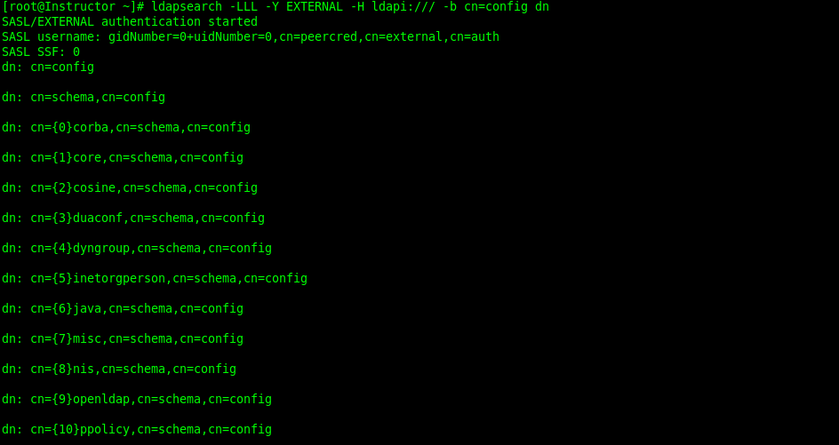

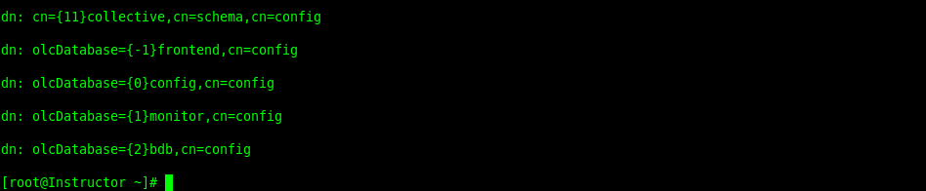

Successful output from ldapi:// server query.

Create request (LDIF) in add.certificate.conf.ldif file which adds properties in LDAP
configuration for certificate and key files:

C1.11 Configure LDAP server to use ldaps:// URI scheme exclusively.

# service slapd stop # Stop the service.

Change /etc/sysconfig/ldap file to enable SLAPD_LDAPS and disable SLAPD_LDAP flags:

# vi /etc/sysconfig/ldap

SLAPD_LDAP=no
SLAPD_LDAPS=yes

:wq

Generate self-signed certificate:

# openssl req -new -x509 -nodes -out /etc/pki/tls/certs/slapdcert.pem -keyout /etc/pki/tls/certs/slapdkey.pem -days 365
# chown -Rf root:ldap /etc/pki/tls/certs/slapdcert.pem /etc/pki/tls/certs/slapdkey.pem
# chmod -Rf 750 /etc/pki/tls/certs/slapdkey.pem

# service slapd start

# vi /tmp/add.certificate.conf.idif

dn: cn=config
changetype: modify
add: olcTLSCertificateFile
olcTLSCertificateFile: /etc/pki/tls/certs/slapdcert.pem
olcTLSCertificateKeyFile: /etc/pki/tls/certs/slapdkey.pem
:wq

# ldapmodify -Y EXTERNAL -H ldapi:/// -f add.certificate.conf.ldif # Send the request to modify
# configuration entities.

#########################################################################################################################
#########################################################################################################################

Stuck Here: Above command has errors.. The dn: line was changed but had the same result.

C1.12 Make corresponding changes on LDAP and test everything.

( Client Side ).

# Modify client to use LDAPS to test clients:

# vi /etc/openldap/ldap.conf

URI ldaps://ldap.example.com
TLS_REQCERT allow
:wq

# ldapsearch -x -b 'dc=example,dc=com' # Check connection by the client.

# yum install nss-pam-ldap # Install the nslcd service.
# service nslcd start
# chkconfig nslcd on
# vi /etc/nslcd.conf # Modify nslcd (LDAP nameservice daemon) # service connects using ldaps:// URI scheme:
tls_reqcert allow
uri ldaps://ldap.example.com/
:wq

# service nslcd restart
# getent passwd qwer # Check credentials returned by LDAP.

C1.13 Test: Trying to use auth configuration with sssd service (instead of nslcd) which does not work.

This section is just a demo test which should fail.

Set this flag FORCELEGACY in /etc/sysconfig/authconfig file to use sssd service instead of nslcd service:

# vi /etc/sysconfig/authconfig

FORCELEGACY=no
:wq

Re-configure by the same command:

# authconfig --enableldap --enableldapauth --ldapserver=ldap.example.com --ldapbasedn="dc=example,dc=com" –update

Make sure the following parameter are set in /etc/sssd/sssd.conf configuration file:

# vi /etc/sssd/sssd.conf

ldap_uri = ldaps://ldap.example.com/

:wq

Try to get credentials returned by LDAP by the same "getent passwd qwer" command. The /var/log/messages will show the following error: sssd[be[default]]: LDAP connection error: error:14090086:Sroutines:
SSL3_GET_SERVER_CERTIFICATE:certificate verify failed.

The problem is that the LDAP certificate is self-signed which can be confirmed by its verification:

# scp root@ldap.example.com:/etc/pki/tls/certs/slapdcert.pem /tmp
# openssl verify /tmp/slapdcert.pem

C1.14 Creating CA certificate to avoid using self-signed LDAP server certificates

Go through the procedure to create CA certificate, create LDAP server certificate and install CA certificate on client machine: Create Certificate Authority (CA) instead of using self-signed Certificates.

Login to LDAP server host:

# ssh ldap.example.com

It is assumed that:
Generated server key file /etc/pki/tls/private/ldap.example.com.key is located on server host (ldap.example.com); Generated server CA-signed certificate file /etc/pki/tls/ldap.example.com.csr is located on CA host (ca.example.com).

Overwrite old LDAP server certificate files with the new one (instead of changing the paths to them in LDAP configuration):

# cp /etc/pki/tls/private/ldap.example.com.key /etc/pki/tls/certs/slapdkey.pem
# scp ca.example.com:/etc/pki/tls/ldap.example.com.csr /etc/pki/tls/certs/slapdcert.pem

Verify certificate to be sure it is not self-signed:

# openssl verify /etc/pki/tls/certs/slapdcert.pem
# service slapd restart

C1.15 Final client configuration: Using sssd service (instead of nslcd) for LDAP authentication.
Note that CA certificate installation for sssd service (and LDAP clients) is simpler than for OpenSSL client utilities.
Simply copy CA certificate into /etc/openldap/cacerts directory where it is expected ( Client Side ).

# scp ca.example.com:/etc/pki/CA/cacert.pem /etc/openldap/cacerts

In order to allow simpler commands for certificate verification, install CA certificate properly for OpenSSL as well:
Create Certificate Authority (CA) instead of using self-signed Certificates.

Get LDAP server certificate and verify it:

# scp ldap.example.com:/etc/pki/tls/certs/slapdcert.pem /tmp/slapdcert.pem
# openssl verify /tmp/slapdcert.pem

Confirm in /etc/sssd/sssd.conf file that sssd service uses the same directory with
certificates and connects via ldaps:// schema:

# vi /etc/sssd/sssd.conf

ldap_tls_cacertdir = /etc/openldap/cacerts
ldap_uri = ldaps://ldap.example.com/
:wq

Make sure once again that FORCELEGACY in /etc/sysconfig/authconfig file is unset:

# vi /etc/sysconfig/authconfig

FORCELEGACY=no
:wq

Re-configure by the same command:

# authconfig --enableldap --enableldapauth --ldapserver=ldap.example.com --ldapbasedn="dc=example,dc=com" –update
# service nslcd restart

Check credentials returned by LDAP:

# getent passwd qwer

C1.16 Troubleshooting.
Run one of these utilities (from wireshark package) on the LDAP server to confirm client connection:

# tethereal -n -x -i eth0 tcp port ldaps
# tethereal -n -x -i eth0 tcp port ldap

This allows to monitor whether connections are made at all, which port is being connected to, whether information is encrypted or not (based on the data dumps).

Use nmap utility to scan server ports from client:

# nmap ldap.example.com

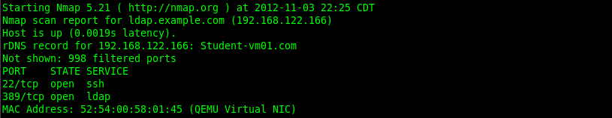
From these points the rest of things should be checked:

a. proper CA and server certificates deployment;
b. firewall configuration;
c. ports (URI schemes) used by server and client configuration;
d. etc.

C1.17 Iptables rules.

Open LDAP ports:

# iptables -I INPUT -m state --state NEW -m udp -p udp --dport 389 -j ACCEPT
# iptables -I INPUT -m state --state NEW -m tcp -p tcp --dport 389 -j ACCEPT

Open LDAPS ports:

# iptables -I INPUT -m state --state NEW -m udp -p udp --dport 636 -j ACCEPT
# iptables -I INPUT -m state --state NEW -m tcp -p tcp --dport 636 -j ACCEPT
# service iptables save
# service iptables restart

C2. Install and set up OpenLDAP client ( Client Side ).

# yum install openldap-clients -y
# vi /etc/openldap/ldap.conf
BASE dc=example, dc=com
URI ldap://ldap.example.com # Or URI ldap://192.168.122.166
:wq
Note: Providing base DN is not necessary as it is dc=example,dc=com by default. However, default URI refers to
localhost which has to be changed.

Appendix D.

D.1 Setup an iSCSI server.

# yum install scsi-target-utils -y
# service tgtd start
# chkconfig tgtd on

Note: Create an LVM Volume named /dev/Vol1/vol1. It does not need to be mounted.

# vi /etc/tgt/targets.conf

<target iqn.2012-11.com.example:student.example.com.target1>

backing-store /dev/Vol1/vol1

</target>

:wq

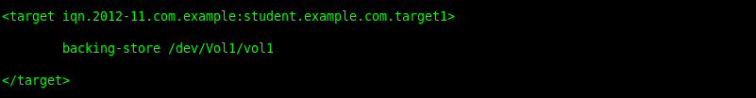

# service tgtd reload

Note: Don’t mount the volume group vie /etc/fstab.

Note: To test iSCSI server use the following command.

# tgt-admin -show

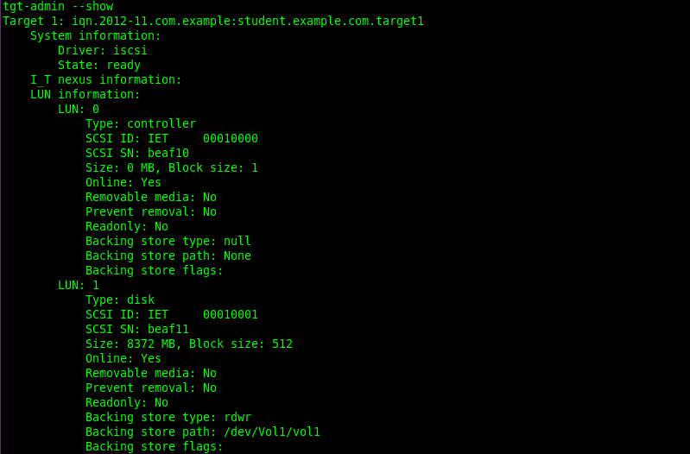

Note: LUN: 1 is our target drive we created earlier. Note the size 8Gb.

D.2 Iptables rules.

# iptables -I INPUT -m state --state NEW -m tcp -p tcp --dport 3260 -j ACCEPT
# iptables -I INPUT -m state --state NEW -m udp -p udp --dport 3260 -j ACCEPT
# iptables -I INPUT -m state --state NEW -m tcp -p tcp --dport 860 -j ACCEPT
# iptables -I INPUT -m state --state NEW -m udp -p udp --dport 860 -j ACCEPT

D.3 Client configuration and connection to iSCSi server.

# yum install iscsi-initiator-utils -y
# chkconfig iscsi on

NOTE: Test connection.

# iscsiadm -m discovery -t sendtargets -p student.example.com

NOTE: Login to iscsi server.

# iscsiadm -m node -T iqn.2012-11.com.example:student.example.com.target1 -p 192.168.122.10 –l

NOTE: Tail /var/log/messages to determine what node name was given to the iSCSi export.

# tail –f /var/log/messages

Note: /dev/sdb is the node name assigned to the iSCSi disk. The new disk is persistent on reboots.

D.4 Prep the new partition for use.

# fdisk /dev/sdb
# partx –a /dev/sdb
# mkfs.ext3 /dev/sdb1
# mkdir /iscsidata
# mount /dev/sdb1 /iscsidata
# df –h

# vi /etc/fstab

/dev/sdb1 /iscsidata ext3 _netdev 0 0

:wq

# umount /iscsidata
# mount -a
# mount

Appendix E

SELinux Trouble shooting.

SELinux decisions, such as allowing or disallowing access, are cached. This cache is known as the Access Vector Cache (AVC). Denial messages are logged when SELinux denies access. These denials are also known as "AVC denials", and are logged to a different location, depending on which daemons are running:

Packages to install.

# yum install audit rsyslog setroubleshoot-server

Daemon Log Location

auditd on /var/log/audit/audit.log
auditd off; rsyslogd on /var/log/messages
setroubleshootd, rsyslogd, and auditd on /var/log/audit/audit.log.

Easier-to-read denial messages also sent to /var/log/messages

If you are running the X Window System, have the setroubleshoot and setroubleshoot-server packages installed, and the setroubleshootd and auditd daemons are running, a warning is displayed when access is denied by SELinux:

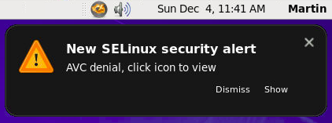

Clicking on 'Show' presents a detailed analysis of why SELinux denied access, and a possible solution for allowing access. If you are not running the X Window System, it is less obvious when access is denied by SELinux. For example, users browsing your website may receive an error similar to the following:

Forbidden

You don't have permission to access file name on this server

For these situations, if DAC rules (standard Linux permissions) allow access, check /var/log/messages and /var/log/audit/audit.log for "SELinux is preventing" and "denied" errors respectively. This can be done by running the following commands as the Linux root user:

# grep "SELinux is preventing" /var/log/messages

# grep "denied" /var/log/audit/audit.log

The following sections describe the top three causes of problems: labeling problems, configuring Booleans and ports for services, and evolving SELinux rules.

On systems running SELinux, all processes and files are labeled with a label that contains security-relevant information. This information is called the SELinux context. If these labels are wrong, access may be denied. If an application is labeled incorrectly, the process it transitions to may not have the correct label, possibly causing SELinux to deny access, and the process being able to create mislabeled files.

A common cause of labeling problems is when a non-standard directory is used for a service. For example, instead of using /var/www/html/ for a website, an administrator wants to use /srv/myweb/. On Red Hat Enterprise Linux 6, the /srv/ directory is labeled with the var_t type. Files and directories created and /srv/ inherit this type. Also, newly-created top-level directories (such as /myserver/) may be labeled with the default_t type. SELinux prevents the Apache HTTP Server ( httpd) from accessing both of these types. To allow access, SELinux must know that the files in /srv/myweb/ are to be accessible to httpd:

# semanage fcontext -a -t httpd_sys_content_t "/srv/myweb(/.*)?"

This semanage command adds the context for the /srv/myweb/ directory (and all files and directories under it) to the SELinux file- context configuration [12]. The semanage command does not change the context. As the Linux root user, run the restorecon command to apply the changes:

# restorecon -R -v /srv/myweb

The matchpathcon command checks the context of a file path and compares it to the default label for that path. The following example demonstrates using matchpathcon on a directory that contains incorrectly labeled files:

$ matchpathcon -V /var/www/html/*

/var/www/html/index.html has context unconfined_u:object_r:user_home_t:s0, should be system_u:object_r:httpd_sys_content_t:s0
/var/www/html/page1.html has context unconfined_u:object_r:user_home_t:s0, should be system_u:object_r:httpd_sys_content_t:s0

In this example, the index.html and page1.html files are labeled with the user_home_t type. This type is used for files in user home directories. Using the mv command to move files from your home directory may result in files being labeled with the user_home_t type. This type should not exist outside of home directories. Use the restorecon command to restore such files to their correct type:

# restorecon -v /var/www/html/index.html

restorecon reset /var/www/html/index.html context unconfined_u:object_r:user_home_t:s0- >system_u:object_r:httpd_sys_content_t:s0

To restore the context for all files under a directory, use the -R option:

# restorecon -R -v /var/www/html/

restorecon reset /var/www/html/page1.html context unconfined_u:object_r:samba_share_t:s0- >system_u:object_r:httpd_sys_content_t:s0
restorecon reset /var/www/html/index.html context unconfined_u:object_r:samba_share_t:s0- >system_u:object_r:httpd_sys_content_t:s0

Refer to Section , “Checking the Default SELinux Context” for a more detailed example of matchpathcon.
How are Confined Services Running?

Services can be run in a variety of ways. To cater for this, you must tell SELinux how you are running services. This can be achieved via Booleans that allow parts of SELinux policy to be changed at runtime, without any knowledge of SELinux policy writing. This allows changes, such as allowing services access to NFS file systems, without reloading or recompiling SELinux policy. Also, running services on non-default port numbers requires policy configuration to be updated via the semanage command.

For example, to allow the Apache HTTP Server to communicate with MySQL, turn the httpd_can_network_connect_db Boolean on:

# setsebool -P httpd_can_network_connect_db on

If access is denied for a particular service, use the getsebool and grep commands to see if any Booleans are available to allow access. For example, use the getsebool -a | grep ftp command to search for FTP related Booleans:

# getsebool -a | grep ftp

allow_ftpd_anon_write --> off
allow_ftpd_full_access --> off
allow_ftpd_use_cifs --> off
allow_ftpd_use_nfs --> off
ftp_home_dir --> off
ftpd_connect_db --> off
httpd_enable_ftp_server --> off
tftp_anon_write --> off

For a list of Booleans and whether they are on or off, run the getsebool -a command. For a list of Booleans, an explanation of what each one is, and whether they are on or off, run the semanage boolean -l command as the Linux root user. Refer to Section 5.6, “Booleans” for information about listing and configuring Booleans.

Port Numbers
Depending on policy configuration, services may only be allowed to run on certain port numbers. Attempting to change the port a service runs on without changing policy may result in the service failing to start. For example, run the semanage port -l | grep http command as the Linux root user to list http related ports:

# semanage port -l | grep http

http_cache_port_t tcp 3128, 8080, 8118
http_cache_port_t udp 3130
http_port_t tcp 80, 443, 488, 8008, 8009, 8443
pegasus_http_port_t tcp 5988
pegasus_https_port_t tcp 5989

The http_port_t port type defines the ports Apache HTTP Server can listen on, which in this case, are TCP ports 80, 443, 488, 8008, 8009, and 8443. If an administrator configures httpd.conf so that httpd listens on port 9876 ( Listen 9876), but policy is not updated to reflect this, the service httpd start command fails:

# service httpd start

Starting httpd: (13)Permission denied: make_sock: could not bind to address [::]:9876
(13)Permission denied: make_sock: could not bind to address 0.0.0.0:9876
no listening sockets available, shutting down
Unable to open logs
[FAILED]

An SELinux denial similar to the following is logged to /var/log/audit/audit.log:

type=AVC msg=audit(1225948455.061:294): avc: denied { name_bind } for pid=4997 comm="httpd" src=9876 scontext=unconfined_u:system_r:httpd_t:s0 tcontext=system_u:object_r:port_t:s0 tclass=tcp_socket

To allow httpd to listen on a port that is not listed for the http_port_t port type, run the semanage port command to add a port to policy configuration [13]:

# semanage port -a -t http_port_t -p tcp 9876

The -a option adds a new record; the -t option defines a type; and the -p option defines a protocol. The last argument is the port number to add.

Applications may be broken, causing SELinux to deny access. Also, SELinux rules are evolving - SELinux may not have seen an application running in a certain way, possibly causing it to deny access, even though the application is working as expected. For example, if a new version of PostgreSQL is released, it may perform actions the current policy has not seen before, causing access to be denied, even though access should be allowed.

For these situations, after access is denied, use audit2allow to create a custom policy module to allow access. Refer to Section “Allowing Access: audit2allow” for information about using audit2allow.

The following sections help troubleshoot issues. They go over: checking Linux permissions, which are checked before SELinux rules; possible causes of SELinux denying access, but no denials being logged; manual pages for services, which contain information about labeling and Booleans; permissive domains, for allowing one process to run permissive, rather than the whole system; how to search for and view denial messages; analyzing denials; and creating custom policy modules with audit2allow.

When access is denied, check standard Linux permissions. As mentioned in Chapter 2, Introduction, most operating systems use a Discretionary Access Control (DAC) system to control access, allowing users to control the permissions of files that they own. SELinux policy rules are checked after DAC rules. SELinux policy rules are not used if DAC rules deny access first.

If access is denied and no SELinux denials are logged, use the ls -l command to view the standard Linux permissions:

$ ls -l /var/www/html/index.html

-rw-r----- 1 root root 0 2009-05-07 11:06 index.html

In this example, index.html is owned by the root user and group. The root user has read and write permissions ( -rw), and members of the root group have read permissions ( -r-). Everyone else has no access ( ---). By default, such permissions do not allow httpd to read this file. To resolve this issue, use the chown command to change the owner and group. This command must be run as the Linux root user:

# chown apache:apache /var/www/html/index.html

This assumes the default configuration, in which httpd runs as the Linux apache user. If you run httpd with a different user, replace apache:apache with that user.

Refer to the Fedora Documentation Project "Permissions" draft for information about managing Linux permissions.
Possible Causes of Silent Denials

In certain situations, AVC denials may not be logged when SELinux denies access. Applications and system library functions often probe for more access than required to perform their tasks. To maintain least privilege without filling audit logs with AVC denials for harmless application probing, the policy can silence AVC denials without allowing a permission by using dontaudit rules. These rules are common in standard policy. The downside of dontaudit is that, although SELinux denies access, denial messages are not logged, making troubleshooting hard.

To temporarily disable dontaudit rules, allowing all denials to be logged, run the following command as the Linux root user:

# semodule -DB

The -D option disables dontaudit rules; the -B option rebuilds policy. After running semodule -DB, try exercising the application that was encountering permission problems, and see if SELinux denials — relevant to the application — are now being logged. Take care in deciding which denials should be allowed, as some should be ignored and handled via dontaudit rules. If in doubt, or in search of guidance, contact other SELinux users and developers on an SELinux list, such as fedora-selinux-list.

To rebuild policy and enable dontaudit rules, run the following command as the Linux root user:

# semodule -B

This restores the policy to its original state. For a full list of dontaudit rules, run the sesearch --dontaudit command. Narrow down searches using the -s domain option and the grep command. For example:

$ sesearch --dontaudit -s smbd_t | grep squid

dontaudit smbd_t squid_port_t : tcp_socket name_bind ;
dontaudit smbd_t squid_port_t : udp_socket name_bind ;

Refer to Section “Raw Audit Messages” and Section , “sealert Messages” for information about analyzing denials.

Manual pages for services contain valuable information, such as what file type to use for a given situation, and Booleans to change the access a service has (such as httpd accessing NFS file systems). This information may be in the standard manual page, or a manual page with selinux prepended or appended.

For example, the httpd_selinux(8) manual page has information about what file type to use for a given situation, as well as Booleans to allow scripts, sharing files, accessing directories inside user home directories, and so on. Other manual pages with SELinux information for services include:

Samba: the samba_selinux(8) manual page describes that files and directories to be exported via Samba must be labeled with the samba_share_t type, as well as Booleans to allow files labeled with types other than samba_share_t to be exported via Samba.

NFS: the nfs_selinux(8) manual page describes that, by default, file systems can not be exported via NFS, and that to allow file systems to be exported, Booleans such as nfs_export_all_ro or nfs_export_all_rw must be turned on.

Berkeley Internet Name Domain (BIND): the named(8) manual page describes what file type to use for a given situation (see the Red Hat SELinux BIND Security Profile section). The named_selinux(8) manual page describes that, by default, named can not write to master zone files, and to allow such access, the named_write_master_zones Boolean must be turned on.

The information in manual pages helps you configure the correct file types and Booleans, helping to prevent SELinux from denying access.

When SELinux is running in permissive mode, SELinux does not deny access, but denials are logged for actions that would have been denied if running in enforcing mode. Previously, it was not possible to make a single domain permissive (remember: processes run in domains). In certain situations, this led to making the whole system permissive to troubleshoot issues.

In Red Hat Enterprise Linux 4 and 5, domain_disable_trans Booleans are available to prevent an application from transitioning to a confined domain, and therefore, the process runs in an unconfined domain, such as initrc_t. Consequently, turning such Booleans on can cause major problems. For example, the following happens if the httpd_disable_trans Boolean is turned on:

The httpd service runs in the unconfined initrc_t domain. Files created by processes running in the initrc_t domain may not have the same labeling rules applied as files created by a process running in the httpd_t domain, potentially allowing processes to create mislabeled files. This causes access problems later on.

Confined domains that are allowed to communicate with httpd_t can not communicate with initrc_t, possibly causing additional failures.

To address these issues, Red Hat Enterprise Linux 6 introduces permissive domains. Permissive domains allow an administrator to configure a single process (domain) to run permissive, rather than making the whole system permissive. SELinux checks are still performed for permissive domains; however, the kernel allows access and reports an AVC denial for situations where SELinux would have denied access.

Permissive domains have the following uses:

They can be used for making a single process (domain) run permissive to troubleshoot an issue without putting the entire system at risk by making it permissive.

They allow an administrator to create policies for new applications. Previously, it was recommended that a minimal policy be created, and then the entire machine put into permissive mode, so that the application could run, but SELinux denials still logged. audit2allow could then be used to help write the policy. This put the whole system at risk. With permissive domains, only the domain in the new policy can be marked permissive, without putting the whole system at risk.

To make a domain permissive, run the semanage permissive -a domain command, where domain is the domain you want to make permissive. For example, run the following command as the Linux root user to make the httpd_t domain (the domain the Apache HTTP Server runs in) permissive:

# semanage permissive -a httpd_t

To view a list of domains you have made permissive, run the semodule -l | grep permissive command as the Linux root user. For example:

# semodule -l | grep permissive

permissive_httpd_t 1.0
permissivedomains 1.0.0

If you no longer want a domain to be permissive, run the semanage permissive -d domain command as the Linux root user. For example:

# semanage permissive -d httpd_t

The SYSCALL message is different for permissive domains. The following is an example AVC denial (and the associated system call) from the Apache HTTP Server:

type=AVC msg=audit(1226882736.442:86): avc: denied { getattr } for pid=2427 comm="httpd" path="/var/www/html/file1" dev=dm-0 ino=284133 scontext=unconfined_u:system_r:httpd_t:s0 tcontext=unconfined_u:object_r:samba_share_t:s0 tclass=file

type=SYSCALL msg=audit(1226882736.442:86): arch=40000003 syscall=196 success=no exit=-13 a0=b9a1e198 a1=bfc2921c a2=54dff4 a3=2008171 items=0 ppid=2425 pid=2427 auid=502 uid=48 gid=48 euid=48 suid=48 fsuid=48 egid=48 sgid=48 fsgid=48 tty=(none) ses=4 comm="httpd" exe="/usr/sbin/httpd" subj=unconfined_u:system_r:httpd_t:s0 key=(null)

By default, the httpd_t domain is not permissive, and as such, the action is denied, and the SYSCALL message contains success=no. The following is an example AVC denial for the same situation, except the semanage permissive -a httpd_t command has been run to make the httpd_t domain permissive:

type=AVC msg=audit(1226882925.714:136): avc: denied { read } for pid=2512 comm="httpd" name="file1" dev=dm-0 ino=284133 scontext=unconfined_u:system_r:httpd_t:s0 tcontext=unconfined_u:object_r:samba_share_t:s0 tclass=file

type=SYSCALL msg=audit(1226882925.714:136): arch=40000003 syscall=5 success=yes exit=11 a0=b962a1e8 a1=8000 a2=0 a3=8000 items=0 ppid=2511 pid=2512 auid=502 uid=48 gid=48 euid=48 suid=48 fsuid=48 egid=48 sgid=48 fsgid=48 tty=(none) ses=4 comm="httpd" exe="/usr/sbin/httpd" subj=unconfined_u:system_r:httpd_t:s0 key=(null)

In this case, although an AVC denial was logged, access was not denied, as shown by success=yes in the SYSCALL message.

This section assumes the setroubleshoot, setroubleshoot-server, dbus and audit packages are installed, and that the auditd, rsyslogd, and setroubleshootd daemons are running. Refer to Section 5.2, “Which Log File is Used” for information about starting these daemons. A number of tools are available for searching for and viewing SELinux denials, such as ausearch, aureport, and sealert.

ausearch

The audit package provides ausearch. From the ausearch(8) manual page: " ausearch is a tool that can query the audit daemon logs based for events based on different search criteria" [14]. The ausearch tool accesses /var/log/audit/audit.log, and as such, must be run as the Linux root user:

Searching For Command
all denials ausearch -m avc
denials for that today ausearch -m avc -ts today
denials from the last 10 minutes ausearch -m avc -ts recent

To search for SELinux denials for a particular service, use the -c comm-name option, where comm-name "is the executable’s name" [15], for example, httpd for the Apache HTTP Server, and smbd for Samba:

# ausearch -m avc -c httpd

# ausearch -m avc -c smbd

Refer to the ausearch(8) manual page for further ausearch options.

aureport
The audit package provides aureport. From the aureport(8) manual page: " aureport is a tool that produces summary reports of the audit system logs" [16]. The aureport tool accesses /var/log/audit/audit.log, and as such, must be run as the Linux root user. To view a list of SELinux denials and how often each one occurred, run the aureport -a command. The following is example output that includes two denials:

# aureport -a

AVC Report
========================================================
# date time comm subj syscall class permission obj event
========================================================
1. 05/01/2009 21:41:39 httpd unconfined_u:system_r:httpd_t:s0 195 file getattr system_u:object_r:samba_share_t:s0 denied 2
2. 05/03/2009 22:00:25 vsftpd unconfined_u:system_r:ftpd_t:s0 5 file read unconfined_u:object_r:cifs_t:s0 denied 4

Refer to the aureport(8) manual page for further aureport options.

sealert
The setroubleshoot-server package provides sealert, which reads denial messages translated by setroubleshoot-server. Denials are assigned IDs, as seen in /var/log/messages. The following is an example denial from messages:

setroubleshoot: SELinux is preventing httpd (httpd_t) "getattr" to /var/www/html/file1 (samba_share_t). For complete SELinux messages. run sealert -l 84e0b04d-d0ad-4347-8317-22e74f6cd020

In this example, the denial ID is 84e0b04d-d0ad-4347-8317-22e74f6cd020. The -l option takes an ID as an argument. Running the sealert -l 84e0b04d-d0ad-4347-8317-22e74f6cd020 command presents a detailed analysis of why SELinux denied access, and a possible solution for allowing access.

If you are running the X Window System, have the setroubleshoot and setroubleshoot-server packages installed, and the setroubleshootd, dbus and auditd daemons are running, a warning is displayed when access is denied by SELinux. Clicking on 'Show' launches the sealert GUI, and displays denials in HTML output:

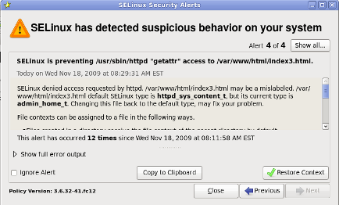

Run the sealert -b command to launch the sealert GUI.

Run the sealert -l \* command to view a detailed analysis of all denials.

As the Linux root user, run the sealert -a /var/log/audit/audit.log -H > audit.html command to create a HTML version of the sealert analysis, as seen with the sealert GUI.

Refer to the sealert(8) manual page for further sealert options.

Raw audit messages are logged to /var/log/audit/audit.log. The following is an example AVC denial (and the associated system call) that occurred when the Apache HTTP Server (running in the httpd_t domain) attempted to access the /var/www/html/file1 file (labeled with the samba_share_t type):

type=AVC msg=audit(1226874073.147:96): avc: denied { getattr } for pid=2465 comm="httpd" path="/var/www/html/file1" dev=dm-0 ino=284133 scontext=unconfined_u:system_r:httpd_t:s0 tcontext=unconfined_u:object_r:samba_share_t:s0 tclass=file

type=SYSCALL msg=audit(1226874073.147:96): arch=40000003 syscall=196 success=no exit=-13 a0=b98df198 a1=bfec85dc a2=54dff4 a3=2008171 items=0 ppid=2463 pid=2465 auid=502 uid=48 gid=48 euid=48 suid=48 fsuid=48 egid=48 sgid=48 fsgid=48 tty=(none) ses=6 comm="httpd" exe="/usr/sbin/httpd" subj=unconfined_u:system_r:httpd_t:s0 key=(null)

{ getattr }

The item in braces indicates the permission that was denied. getattr indicates the source process was trying to read the target file's status information. This occurs before reading files. This action is denied due to the file being accessed having the wrong label. Commonly seen permissions include getattr, read, and write.
comm="httpd"

The executable that launched the process. The full path of the executable is found in the exe= section of the system call ( SYSCALL) message, which in this case, is exe="/usr/sbin/httpd".
path="/var/www/html/file1"

The path to the object (target) the process attempted to access.
scontext="unconfined_u:system_r:httpd_t:s0"

The SELinux context of the process that attempted the denied action. In this case, it is the SELinux context of the Apache HTTP Server, which is running in the httpd_t domain.
tcontext="unconfined_u:object_r:samba_share_t:s0"

The SELinux context of the object (target) the process attempted to access. In this case, it is the SELinux context of file1. Note: the samba_share_t type is not accessible to processes running in the httpd_t domain.

In certain situations, the tcontext may match the scontext, for example, when a process attempts to execute a system service that will change characteristics of that running process, such as the user ID. Also, the tcontext may match the scontext when a process tries to use more resources (such as memory) than normal limits allow, resulting in a security check to see if that process is allowed to break those limits.

From the system call ( SYSCALL) message, two items are of interest:

success=no: indicates whether the denial (AVC) was enforced or not. success=no indicates the system call was not successful (SELinux denied access). success=yes indicates the system call was successful - this can be seen for permissive domains or unconfined domains, such as initrc_t and kernel_t.

exe="/usr/sbin/httpd": the full path to the executable that launched the process, which in this case, is exe="/usr/sbin/httpd".

An incorrect file type is a common cause for SELinux denying access. To start troubleshooting, compare the source context ( scontext) with the target context ( tcontext). Should the process ( scontext) be accessing such an object ( tcontext)? For example, the Apache HTTP Server ( httpd_t) should only be accessing types specified in the httpd_selinux(8) manual page, such as httpd_sys_content_t, public_content_t, and so on, unless configured otherwise.

Denials are assigned IDs, as seen in /var/log/messages. The following is an example AVC denial (logged to messages) that occurred when the Apache HTTP Server (running in the httpd_t domain) attempted to access the /var/www/html/file1 file (labeled with the samba_share_t type):

hostname setroubleshoot: SELinux is preventing httpd (httpd_t) "getattr" to /var/www/html/file1 (samba_share_t). For complete S ELinux messages. run sealert -l 84e0b04d-d0ad-4347-8317-22e74f6cd020

As suggested, run the sealert -l 84e0b04d-d0ad-4347-8317-22e74f6cd020 command to view the complete message. This command only works on the local machine, and presents the same information as the sealert GUI:

$ sealert -l 84e0b04d-d0ad-4347-8317-22e74f6cd020

Summary:

SELinux is preventing httpd (httpd_t) "getattr" to /var/www/html/file1
(samba_share_t).

Detailed Description:

SELinux denied access to /var/www/html/file1 requested by httpd.
/var/www/html/file1 has a context used for sharing by different program. If you
would like to share /var/www/html/file1 from httpd also, you need to change its
file context to public_content_t. If you did not intend to this access, this
could signal a intrusion attempt.

Allowing Access:

You can alter the file context by executing chcon -t public_content_t
'/var/www/html/file1'

Fix Command:

chcon -t public_content_t '/var/www/html/file1'

Additional Information:

Source Context unconfined_u:system_r:httpd_t:s0
Target Context unconfined_u:object_r:samba_share_t:s0
Target Objects /var/www/html/file1 [ file ]
Source httpd
Source Path /usr/sbin/httpd
Port <Unknown>
Host hostname
Source RPM Packages httpd-2.2.10-2
Target RPM Packages
Policy RPM selinux-policy-3.5.13-11.fc12
Selinux Enabled True
Policy Type targeted
MLS Enabled True
Enforcing Mode Enforcing
Plugin Name public_content
Host Name hostname
Platform Linux hostname 2.6.27.4-68.fc12.i686 #1 SMP Thu Oct
30 00:49:42 EDT 2008 i686 i686
Alert Count 4
First Seen Wed Nov 5 18:53:05 2008
Last Seen Wed Nov 5 01:22:58 2008
Local ID 84e0b04d-d0ad-4347-8317-22e74f6cd020
Line Numbers

Raw Audit Messages

node=hostname type=AVC msg=audit(1225812178.788:101): avc: denied { getattr } for pid=2441 comm="httpd" path="/var/www/html/file1" dev=dm-0 ino=284916 scontext=unconfined_u:system_r:httpd_t:s0 tcontext=unconfined_u:object_r:samba_share_t:s0 tclass=file

node=hostname type=SYSCALL msg=audit(1225812178.788:101): arch=40000003 syscall=196 success=no exit=-13 a0=b8e97188 a1=bf87aaac a2=54dff4 a3=2008171 items=0 ppid=2439 pid=2441 auid=502 uid=48 gid=48 euid=48 suid=48 fsuid=48 egid=48 sgid=48 fsgid=48 tty=(none) ses=3 comm="httpd" exe="/usr/sbin/httpd" subj=unconfined_u:system_r:httpd_t:s0 key=(null)

Summary

A brief summary of the denied action. This is the same as the denial in /var/log/messages. In this example, the httpd process was denied access to a file ( file1), which is labeled with the samba_share_t type.
Detailed Description

A more verbose description. In this example, file1 is labeled with the samba_share_t type. This type is used for files and directories that you want to export via Samba. The description suggests changing the type to a type that can be accessed by the Apache HTTP Server and Samba, if such access is desired.
Allowing Access

A suggestion for how to allow access. This may be relabeling files, turning a Boolean on, or making a local policy module. In this case, the suggestion is to label the file with a type accessible to both the Apache HTTP Server and Samba.
Fix Command

A suggested command to allow access and resolve the denial. In this example, it gives the command to change the file1 type to public_content_t, which is accessible to the Apache HTTP Server and Samba.
Additional Information

Information that is useful in bug reports, such as the policy package name and version ( selinux-policy-3.5.13-11.fc12), but may not help towards solving why the denial occurred.
Raw Audit Messages

The raw audit messages from /var/log/audit/audit.log that are associated with the denial. Refer to Section 8.3.6, “Raw Audit Messages” for information about each item in the AVC denial.

8.3.8. Allowing Access: audit2allow

Do not use the example in this section in production. It is used only to demonstrate the use of audit2allow.

From the audit2allow(1) manual page: " audit2allow - generate SELinux policy allow rules from logs of denied operations" [17]. After analyzing denials as per Section 8.3.7, “sealert Messages”, and if no label changes or Booleans allowed access, use audit2allow to create a local policy module. After access is denied by SELinux, running the audit2allow command presents Type Enforcement rules that allow the previously denied access.

The following example demonstrates using audit2allow to create a policy module:

1.

A denial and the associated system call are logged to /var/log/audit/audit.log:

type=AVC msg=audit(1226270358.848:238): avc: denied { write } for pid=13349 comm="certwatch" name="cache" dev=dm-0 ino=218171 scontext=system_u:system_r:certwatch_t:s0 tcontext=system_u:object_r:var_t:s0 tclass=dir

type=SYSCALL msg=audit(1226270358.848:238): arch=40000003 syscall=39 success=no exit=-13 a0=39a2bf a1=3ff a2=3a0354 a3=94703c8 items=0 ppid=13344 pid=13349 auid=4294967295 uid=0 gid=0 euid=0 suid=0 fsuid=0 egid=0 sgid=0 fsgid=0 tty=(none) ses=4294967295 comm="certwatch" exe="/usr/bin/certwatch" subj=system_u:system_r:certwatch_t:s0 key=(null)

In this example, certwatch ( comm="certwatch") was denied write access ( { write }) to a directory labeled with the var_t type ( tcontext=system_u:object_r:var_t:s0). Analyze the denial as per Section 8.3.7, “sealert Messages”. If no label changes or Booleans allowed access, use audit2allow to create a local policy module.

2.

With a denial logged, such as the certwatch denial in step 1, run the audit2allow -w -a command to produce a human-readable description of why access was denied. The -a option causes all audit logs to be read. The -w option produces the human-readable description. The audit2allow tool accesses /var/log/audit/audit.log, and as such, must be run as the Linux root user:

~]# audit2allow -w -a
type=AVC msg=audit(1226270358.848:238): avc: denied { write } for pid=13349 comm="certwatch" name="cache" dev=dm-0 ino=218171 scontext=system_u:system_r:certwatch_t:s0 tcontext=system_u:object_r:var_t:s0 tclass=dir

Was caused by:
Missing type enforcement (TE) allow rule.

You can use audit2allow to generate a loadable module to allow this access.

As shown, access was denied due to a missing Type Enforcement rule.

3.

Run the audit2allow -a command to view the Type Enforcement rule that allows the denied access:

# audit2allow -a

#============= certwatch_t ==============
allow certwatch_t var_t:dir write;

Important

Missing Type Enforcement rules are usually caused by bugs in SELinux policy, and should be reported in Red Hat Bugzilla. For Red Hat Enterprise Linux, create bugs against the Red Hat Enterprise Linux product, and select the selinux-policy component. Include the output of the audit2allow -w -a and audit2allow -a commands in such bug reports.

4.

To use the rule displayed by audit2allow -a, run the audit2allow -a -M mycertwatch command as the Linux root user to create custom module. The -M option creates a Type Enforcement file ( .te) with the name specified with -M, in your current working directory:

# audit2allow -a -M mycertwatch

******************** IMPORTANT ***********************
To make this policy package active, execute:

semodule -i mycertwatch.pp

# ls
mycertwatch.pp mycertwatch.te

Also, audit2allow compiles the Type Enforcement rule into a policy package ( .pp). To install the module, run the semodule -i mycertwatch.pp command as the Linux root user.
Important

Modules created with audit2allow may allow more access than required. It is recommended that policy created with audit2allow be posted to an SELinux list, such as fedora-selinux-list, for review. If you believe their is a bug in policy, create a bug in Red Hat Bugzilla.

If you have multiple denials from multiple processes, but only want to create a custom policy for a single process, use the grep command to narrow down the input for audit2allow. The following example demonstrates using grep to only send denials related to certwatch through audit2allow:

# grep certwatch /var/log/audit/audit.log | audit2allow -M mycertwatch2

******************** IMPORTANT ***********************
To make this policy package active, execute:

# semodule -i mycertwatch2.pp

Refer to Dan Walsh's "Using audit2allow to build policy modules. Revisited." blog entry for further information about using audit2allow to build policy modules.

[12] Files in /etc/selinux/targeted/contexts/files/ define contexts for files and directories. Files in this directory are read by restorecon and setfiles to restore files and directories to their default contexts.

[13] The semanage port -a command adds an entry to the /etc/selinux/targeted/modules/active/ports.local file. Note: by default, this file can only be viewed by the Linux root user.

[14] From the ausearch(8) manual page, as shipped with the audit package in Red Hat Enterprise Linux 6.

[15] From the ausearch(8) manual page, as shipped with the audit package in Red Hat Enterprise Linux 6.

[16] From the aureport(8) manual page, as shipped with the audit package in Red Hat Enterprise Linux 6.

[17] From the audit2allow(1) manual page, which is available when the policycoreutils-sandbox package in Red Hat Enterprise Linux 6 is installed.

Appendix E.

Access Control Lists (ACLs, pronounced “ackkls”) can provide greater control over file permissions when traditional UNIX file permissions are not enough. UNIX file protection provides read, write, and execute permissions for three user classes: owner, group, and other. An ACL provides better file security by enabling you to define file permissions for the owner, owner's group, others, specific users, and groups. It also enables you to define default permissions for each of these categories.
For example, you might have two groups that need permission to access a file, one to read it and one to write to it. Alternatively, you might have a file that you wanted everyone in a group to be able to read, so you would give group read permissions on that file. Suppose that you want only two people in the group to be able to write to that file. With standard UNIX permissions, you cannot give write permission to only two members of a group. You can, however, set up an ACL for that file to grant only two people in the group write permissions on that file.
ACLs are extensions to standard UNIX file permissions. The ACL information is stored and associated with each file individually.

ACL Commands
You define an ACL for a file or directory by using the ACL commands and options listed in Table 18-8.
Table 18-8 ACL Commands and Options
Command/Option | Description
getfacl | Displays ACL entries.
-a | Displays the filename, owner, group, and ACL of the file.
-d | Displays the filename, owner, and group of the file. The information is displayed even if the file does not have an ACL.
setfacl | Sets, adds, modifies, and deletes ACL entries.
-s acl_entries | Sets the ACL for the file, removing all old entries and replacing them with the newly specified ACL.
-m acl_entries | Adds one or more new ACL entries to the file or modifies one or more existing ACL entries for the file. If an entry already exists, the specified permissions replace the current permissions. If no entry exists, a new entry is created.
-d acl_entries | Deletes one or more entries from the file. You cannot delete entries for the file owner, the owning group, and other. Note that deleting an entry does not necessarily have the same result as removing all permissions from the entry.
-f acl_file | Specifies a file containing the ACL entries to be used as arguments to the setfacl command.
-r | Recalculates permissions for the ACL mask. Permissions specified in the mask are ignored and replaced by the maximum permissions needed to give access to any additional user, owning group, and additional group entries in the ACL.
Each ACL entry consists of the following fields, which are separated by colons:
<entry-type>:[<UID>] | [<GID>]:<perms>
Table 18-9 explains each of the elements of the syntax for ACL commands.
Table 18-9 ACL Argument Syntax
Argument | Description
<entry-type> | Type of ACL entry on which to set file permissions. For example, <entry_type> can be user (the owner of a file) or mask (the ACL mask).
<UID> | Username or identification number.
<GID> | Group name or identification number.
<perm> | Permissions set for the <entry-type>. Permissions can be set symbolically using the characters r, w, x, and - or by using octal values from 0 to 7.

NOTE: ACLs are supported in UFS file systems only. If you restore or copy files with ACL entries in the /tmp directory, which is usually mounted as a TMPFS file system, the ACL entries are lost. If you need to temporarily store UFS files containing ACLs, use the /var/tmp directory instead.

ACL Permissions for Files
You can set the following permissions for UFS files:
• u[ser]::<perm> Sets the permissions for the owner of the file.
• g[roup]::<perm> Sets the permissions for the owner's group.
• o[ther]::<perm> Sets the permissions for users other than the owner or members of the owner's group.
• m[ask]::<perm> Sets the ACL mask. The mask entry indicates the maximum permissions allowed for users other than the owner and for groups. Using the mask is a quick way to change permissions on all of the users and groups. For example, the mask:r-- and mask:4 entry indicates that users and groups cannot have more than read permissions, even though they may have write/execute permissions.
• u[ser]:<UID> | <username>:<perm> Sets the permissions for a specific user.
• g[roup]:<GID> | <groupname>:<perm> Sets the permissions for a specific group.

ACL Permissions for Directories
You can set default ACL entries on a directory that apply to files subsequently created within the directories. Files created in a directory that has default ACL entries will have the same ACL entries as the directory.
When you set default ACL entries for specific users and groups on a directory for the first time, you must also set default ACL entries for the owner, owner's group, others, and the mask.

• d[efault]:u[ser]::<perm> Sets the default permissions for the owner of the directory.
• d[efault]:g[roup]::<perm> Sets the default permissions for the owner's group.
• d[efault]:o[ther]::<perm> Sets the default permissions for users other than the owner or members of the owner's group.
• d[efault]:m[ask]::<perm> Sets the default ACL mask.
• d[efault]:u[ser]:<UID>:<perm> Sets the default permissions for a specific user.
• d[efault]:g[roup]:<GID>:<perm> Sets the default permissions for a specific group.

Determining If a File Has an ACL
You can determine if a file has an ACL in one of two ways:
• By using the ls -l command
• By using the getfacl command
When you use the ls -l command, any file that has an ACL displays a plus (+) sign to the right of the mode field.

NOTE: If you define an ACL for a file and do not specify any additional users or groups, the plus sign is not displayed to the right of the mode field even though the file has a basic ACL. The plus sign is displayed only if additional users or groups are included in the ACL.

In the following example, the file foo has an ACL and at least one entry in the list:
# ls -l foo
-rwxrw—+ 1 winsor staff 0 Oct 3 14:22 foo
castle
When you use the getfacl <filename> command with no options, the ACL information for the file is displayed in the following format:
# file: filename
# owner: uid
# group: gid
user::perm
user:uid:perm
group::perm
group:gid:perm
mask:perm
other:perm
default:user::perm
default:user:uid:perm
default:group::perm
default:group:gid:perm
The ACL for the file foo in the following example gives the owner of the file rwx permissions and user ray read-only permissions:
# getfacl foo

# file: foo
# owner: winsor
# group: staff
user::rwx
user:ray:r-- #effective:r--
group::rw- #effective:rw-
mask:rw-
other:---
#

NOTE: You can use the getfacl command to display permissions on any UFS file or directory in the same format. The file does not need to have an ACL.

For comparison, the following example shows the output of the ls -l and getfacl commands for the file bar, which does not have an ACL.
# ls -l bar
-rwxrw— 1 winsor staff 0 Oct 3 14:22 bar
# getfacl bar

# file: bar
# owner: winsor
# group: staff
user::rwx
group::rw- #effective:rw-
mask:rw-
other:—
#

Setting ACL File Permissions
Use the setfacl command to set ACL permissions on a file. You can set the permissions for a file or a group of files from a command line or by listing the permissions in a file and using the file as an argument to the setfacl command. You can specify the permissions with the following syntax:
u[ser]::<perm>
u[ser]:uid:<perm>
g[roup]::<perm>
g[roup]:gid:<perm>
m[ask]:<perm>
o[ther]:<perm>
d[efault]:u[ser]::<perm>
d[efault]:u[ser]:uid:<perm>
d[efault]:g[roup]::<perm>
d[efault]:g[roup]:gid:<perm>
d[efault]:m[ask]:<perm>
d[efault]:o[ther]:<perm>

NOTE: You can use either octal or symbolic values to set permissions.
On a command line, use a comma to separate each permission statement. In an ACL file, put each statement on a separate line. The statements do not need to be in any particular order

Setting Permissions for a File from a Command Line
To set ACL permissions from a command line, you must specify at least the basic set of user, group, other, and mask permissions. Type the following command to set ACL permissions: setfacl -s u::<perm>,g::<perm>,o:<perm>, m:<perm>, [u:<UID>:<perm>], [g:<GID>:<perm>
You can set users by using either their username or their UID number. Note that before you can use the username argument, the user account must already exist in the Passwd database or in the local /etc/passwd file. You can assign permissions to any UID by number, regardless of whether a user account exists.
In the same way, you can set group names by using either the group name or the GID number.
The following example assigns all of the permissions to the user, restricts group permissions to read-only, and denies permissions to other. The default mask sets read-write permissions, and user ray is assigned read-write permissions to the file foo.
First, take a look at the current permissions for the file:
# ls -l foo
-rw-rw-rw- 1 winsor staff 0 Oct 3 14:22 foo
Then set permissions for user, group, owner, and the mask and add one user to the ACL:
# setfacl -s u::rwx,g::r—,o:—,mask:rw-,u:ray:rw- foo
Using octal values, as shown in the following example, gives you the same result:
# setfacl -s u::7,g::4,o:0,mask:6,u:ray:6 foo
Next, verify that the permissions have been set and that the file has an ACL:
# ls -l foo
-rwxrw— + 1 winsor staff 0 Oct 3 14:22 foo
As you can see, the permissions for the file are changed and the plus sign after the permission field shows that the file has an ACL. Last, use the getfacl command to verify that everything has been set correctly:
# getfacl foo

# file: foo
# owner: winsor
# group: staff
user::rwx
user:ray:rw- #effective:rw-
group::rw- #effective:rw-
mask:rw-
other:—
#
The getfacl command always displays ACL permissions symbolically, regardless of how you specify the values from the command line.

Using an ACL Configuration File to Set Permissions
You can create an ACL configuration file that contains a list of the permissions you want to set and then use that filename as an argument to the setfacl -s command.

NOTE: You can use a configuration file only with the -s option to the setfacl command.

Use the following steps to set up the ACL configuration file:
1. Use any editor to create a file.
2. Edit the file to include the permissions you want to set, putting each statement on a separate line. Be sure to include permissions for user, group, other, and mask as a minimum set.
3. Save the file by using any filename you choose.
4. Type setfacl -f <acl_filename> <filename1> [<filename2>] [<filename3>] and press Return.
5. Type getfacl <filename1> [<filename2>] [<filename3>] and press Return to verify that the permissions are set correctly.

NOTE: If you make typographical errors in the configuration file, the command might return a prompt without displaying any error messages. If you make syntax errors, the setfacl command might display an error message. Be sure to use the getfacl command to check that the permissions are set properly.

In the following example, the owner has rwx permissions, group has rw-, other has —, and the mask is rw-. Three users with different permissions are also granted access to the file. The acl_file (named anything) contains the following access list:
u::rwx
g::rw-
o:—
m:rw-
u:ray:rwx
u:des:rw-
u:rob:r—
Once you have set up the ACL for the file named anything, you can use the setfacl -f option to assign those same permissions to one more file. In the following example, the file named anything is used as the argument to the -f option to change ACLs for the files foo and bar so that they match the file anything:
# setfacl -f anything foo bar
# getfacl foo bar

# file: foo
# owner: winsor
# group: staff
user::rwx
user:ray:rwx #effective:rwx
user:des:rw- #effective:rw-
user:rob:r— #effective:r—
group::rw- #effective:rw-
mask:rw-
other:—

# file: bar
# owner: winsor
# group: staff
user::rwx
user:ray:rwx #effective:rwx
user:des:rw- #effective:rw-
user:rob:r— #effective:r—
group::rw- #effective:rw-
mask:rw-
other:—
#

Adding and Modifying ACL Permissions
You can add and modify ACL permissions for a file that already has an ACL or for any existing UFS file or directory by using the setfacl -m command. Arguments to the setfacl -m command use the same syntax and structure as arguments to the setfacl -s command.
Because each file already has a default owner, group, other, and mask setting, you can use the setfacl -m command on any UFS file without first using the setfacl -s command to specify an owner, group, other, or mask setting. If the file already has the permissions you want to use, you can simply use the setfacl -m command to modify (and create) the ACL for any file or directory.
When you use the -m option, if an entry already exists for a specified UID or GID, the permissions you specify replace the current permissions. If an entry does not exist, it is created.
Type the following syntax to add and modify permissions for a file or files and press Return:
setfacl -m <acl_entry_list><filename1> [<filename2>] [<filename3>]
In the following example, permissions for user ray are modified from rwx to rw- for the file foo.
# setfacl -m u:ray:rw- foo
# getfacl foo

# file: foo
# owner: winsor
# group: staff
user::rw-
user:ray:rw- #effective:rw-
group::rw- #effective:rw-
mask:rw-
other:rw-

Deleting an ACL Entry
Use the setfacl -d command to delete an ACL entry. To delete the entry, you can specify the entry type and the UID or GID. You do not need to include the permissions as part of the argument to the -d option.
Type the following syntax to delete an ACL entry and then press Return:
setfacl -d<entry_type>:<UID> | <GID> <filename1> [<filename2>] [<filename3>]
In the following example, user ray is deleted from the ACL of the file foo.
# setfacl -d u:ray foo
# getfacl
usage: getfacl [-ad] file ...
# getfacl foo

# file: foo
# owner: winsor
# group: staff
user::rw-
group::rw- #effective:rw-
mask:rw-
other:rw-

Copying ACL File Permissions
You can copy ACL file permissions from one file to another without specifying them on the command line by piping the output of getfacl <filename> to another file by typing the following syntax and pressing Return:
getfacl <filename1> | setfacl -f - <filename2>
In the following example, the ACL for file foo is used as the template for the ACL for file bar.
First, verify that the files have different ACL permissions:
# getfacl foo bar

# file: foo
# owner: winsor
# group: staff
user::rw-
user:ray:rwx #effective:rw-
group::rw- #effective:rw-
mask:rw-
other:rw-

# file: bar
# owner: winsor
# group: staff
user::rw-
group::rw- #effective:rw-
mask:rw-
other:rw-
Then list the ACL using the getfacl command and pipe the output to the setfacl -f command. The dash (-) tells the setfacl command to use the output from the file specified for the getfacl command as input to the second file.
# getfacl foo | setfacl -f - bar
Finally, use the getfacl command to verify that both files now have the same ACL permissions:
# getfacl foo bar

# file: foo
# owner: winsor
# group: staff
user::rw-
user:ray:rwx #effective:rw-
group::rw- #effective:rw-
mask:rw-
other:rw-

# file: bar
# owner: winsor
# group: staff
user::rw-
user:ray:rwx #effective:rw-
group::rw- #effective:rw-
mask:rw-
other:rw-
#

